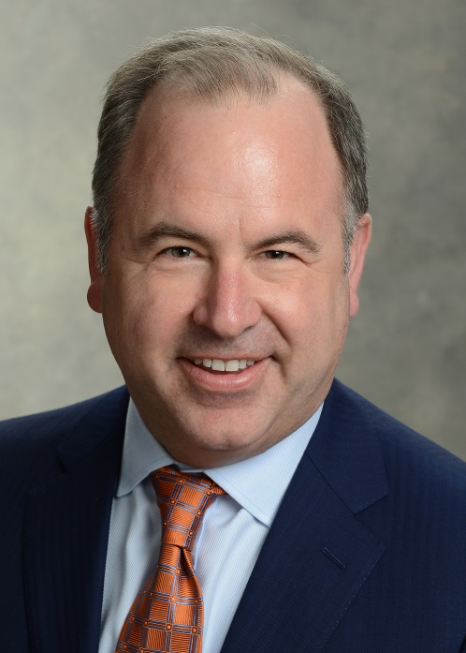
Michael F. Consedine serves as the NAIC's Chief Executive Officer. As CEO, he principally focuses on strategic planning, policy development, and implementation in the areas of state, federal, and international affairs and relations. He advocates for NAIC members and represents their interests before federal and international policymakers, state government associations, and consumer and industry groups. Consedine is also responsible for management of the NAIC’s Executive Office and staff.
Consedine currently serves as an Executive Committee Member on the IAIS and speaks frequently on both domestic and international insurance matters.
Before joining the NAIC in January 2017, Consedine served as the Global Head of Government and Policy Affairs at Aegon, where he led government relations in Europe, the Americas, and Asia. Concurrently, Consedine was Senior Vice President, Deputy General Counsel, and Executive Director of Government Affairs of Aegon’s U.S. subsidiary, Transamerica. In this role, he oversaw all aspects of the company's state and federal government relations activities.
Consedine has spent his entire career in the insurance industry as an attorney, regulator, and executive. Most notably, he served as the Insurance Commissioner for the Commonwealth of Pennsylvania from 2011 to 2015. While Commissioner, he was elected by his peers to serve as an officer of the NAIC as Secretary-Treasurer, Vice President, and President-Elect. He served on several NAIC committees focused on both international and domestic matters.
In November 2011, the U.S. Treasury Department named him as one of the first members of the Federal Advisory Committee on Insurance, which advises the Federal Insurance Office on domestic and international policy. Consedine acted as the NAIC's representative to the U.S.-EU Insurance Dialogue Steering Committee, which was tasked with resolving mutual recognition/equivalency between the two biggest markets in the world.
Earlier in his career, Consedine was a Partner at Saul Ewing LLP and was Vice-Chair of its Insurance Practice Group.
Consedine also serves on the board of directors of the National Insurance Producer Registry, as well as informally advising InsurTech and RegTech start-ups.

