**Life Actuarial (A) Task Force/ Health Actuarial (B) Task Force**

**Amendment Proposal Form\***

1. Identify yourself, your affiliation and a very brief description (title) of the issue.

American Academy of Actuaries, Life Reserves Work Group

Addition of language to clarify the definition of individually underwritten life insurance and the applicability of Principle-Based Reserve (PBR) requirements for group insurance contracts with individual risk selection issued under insurance certificates.

2. Identify the document, including the date if the document is “released for comment,” and the location in the document where the amendment is proposed:

January 1, 2020 version of the Valuation Manual used.

3. Show what changes are needed by providing a red-line version of the original verbiage with deletions and identify the verbiage to be deleted, inserted or changed by providing a red-line (turn on “track changes” in Word®) version of the verbiage. (You may do this through an attachment.)

See Appendix

4. State the reason for the proposed amendment? (You may do this through an attachment.)

Individual insurance certificates issued under a group contract which utilize an individual risk selection process, pricing, premium rate structures and product features are similar to individual life insurance policies. They are currently excluded from VM-20 because they are filed under a group contract, but they should be subject to VM-20 due to this similarity. See Appendix.

* This form is not intended for minor corrections, such as formatting, grammar, cross–references or spelling. Those types of changes do not require action by the entire group and may be submitted via letter or email to the NAIC staff support person for the NAIC group where the document originated.

NAIC Staff Comments:

|  |  |  |  |
| --- | --- | --- | --- |
| **Dates:** Received | Reviewed by Staff | Distributed | Considered |
| 3/19/19 |  |  |  |
| **Notes:** APF 2019-33 | | | |

W:\National Meetings\2010\...\TF\LHA\

**Appendix**

***Issue***

Certain contracts issued under a master group contract require individual risk selection in order to qualify for issuance of the group insurance certificate and do not require continued membership in the group in order to maintain coverage. The certificates have similar acquisition approaches, provisions, certificate-holder rights, pricing and risk classification, and are managed in a similar manner as individual ordinary life insurance contracts. These individual certificates should follow the same reserve requirements as other individual life contracts of the same product type. Therefore, a change is needed within the *Valuation Manual* to bring these individual certificates into scope of VM-20.

Six changes are recommended:

1. Within the Reserve Requirements section (Section II), change the minimum reserve requirements to also apply to group life contracts which, other than the difference between issuing a policy and issuing a group certificate, have the same or mostly similar contract provisions, risk selection process and underwriting as individual ordinary life contracts;
2. Within the Reserve Requirements section (Section II), add a transition period for individual group certificates issued on or before 1/1/2024;
3. Within the Reserve Requirements section (Section II), add language to Subsection 1.D and the corresponding footnote to include premiums from group life contracts which have individual certificates that were issued using individual risk selection processes;
4. Add new paragraph, VM-20 Section 1.B (and reformat to make current paragraph Section 1.A) to clarify group life certificates issued using individual risk selection processes, including a definition and requirements to be met, are subject to the requirements of VM-20;
5. Add guidance note after first sentence in VM-20 Section 2.A.1 that group life certificates that meet the definition for individual risk selection process use the same VM-20 Reserving Categories as defined in Section 2;
6. Draft referral to the NAIC Blanks (E) Working Group, to revise the VM-20 Reserves Supplement, Part 2 to report premiums for total Group Life and Group Life with certificates subjected to an individual risk selection process and which meet all of the conditions as defined in VM-20 Section 1.B separately.

***VM Changes 1, 2 and 3 – II. Reserve Requirements***

1. **II. Reserve Requirements**

This section provides the minimum reserve requirements by type of product, as set forth in the seven subsections below, as follows:

(1) Life Insurance Products

(2) Annuity Products

(3) Deposit-Type Contracts

(4) Health Insurance Products

(5) Credit Life and Disability Products

(6) Riders and Supplemental Benefits

* 1. (7) Claim Reserves

All reserve requirements provided by this section relate to business issued on or after the operative date of the *Valuation Manual*. All reserves must be developed in a manner consistent with the requirements and concepts stated in the Overview of Reserve Concepts in Section I of the *Valuation Manual*.

**Guidance Note:** The terms “policies” and “contracts” are used interchangeably.

**Subsection 1: Life Insurance Products**

1. This subsection establishes reserve requirements for all contracts issued on and after the operative date of the *Valuation Manual* that are classified as life contracts as defined in SSAP No. 50 in the AP&P Manual, with the exception of annuity contracts and credit life contracts. Minimum reserve requirements for annuity contracts and credit life contracts are provided below in subsection 2 and subsection 5, respectively.
2. Minimum reserve requirements for variable and nonvariable individual life contracts—excluding guaranteed issue life contracts, preneed life contracts, industrial life contracts, and policies of companies exempt pursuant to the life PBR exemption in paragraph D below—are provided by VM-20, Requirements for Principle-Based Reserves for Life Products, except for election of the transition period in subsection 1.F below. For this purpose, joint life policies are considered individual life.
3. Minimum reserve requirements for group life contracts with individual certificates which meet all the requirements in VM-20 Section 1.B are provided by VM-20, except for election of the transition period in subsection 1.F below.
4. Minimum reserve requirements of VM-20 are considered principle-based valuation requirements for purposes of the *Valuation Manual*.
5. Minimum reserve requirements for life contracts not subject to VM-20 are those pursuant to applicable requirements in VM-A and VM-C. For guaranteed issue life contracts issued after Dec. 31, 2018, mortality tables are defined in VM Appendix M – Mortality Tables (VM-M), and the same table shall be used for reserve requirements as is used for minimum nonforfeiture requirements as defined in VM-02, Minimum Nonforfeiture Mortality and Interest.
6. A company may elect to establish minimum reserves pursuant to applicable requirements in VM-A and VM-C for:
   1. Business described in subsection 1.C above and issued on or after the operative date of the Valuation Manual and prior to 1/1/2024.
   2. Business not described subsection 1.C otherwise subject to VM-20 requirements and issued during the first three years following the operative date of the Valuation Manual.

A company electing to establish reserves using the requirements of VM-A and VM-C may elect to use the 2017 Commissioners’ Standard Ordinary (CSO) Tables as the mortality standard following the conditions outlined in VM-20 Section 3. If a company during the three years elects to apply VM-20 to a block of such business, then a company must continue to apply the requirements of VM-20 for future issues of this business.

1. Life PBR Exemption
2. A company meeting the condition in subsection G.2 below may file a statement of exemption for ordinary life insurance policies including group life insurance certificates subject to an individual risk selection process and meeting all the conditions in VM-20 Section 1.B , except for policies in subsection G.3 below, issued directly or assumed during the current calendar year, that would otherwise be subject to VM-20. Such a statement must be filed with the domiciliary commissioner prior to July 1 of that year certifying that condition subsection G.2 was met based on premiums from the prior calendar year annual statement. The statement of exemption must also be included with the NAIC filing for the second quarter of that year.

The domiciliary commissioner may reject such statement prior to Sept. 1 and require the company to follow the requirements of VM-20 for the ordinary life policies covered by the statement.

2. Condition for Exemption:

a. The company has less than $300 million of ordinary life premiums1, and if the company is a member of an NAIC group of life insurers, the group has combined ordinary life premiums1 of less than $600 million.

3. Policies Excluded from the Life PBR Exemption:

a. Universal life with secondary guarantee (ULSG) policies with a secondary guarantee that does not meet the VM-01, Definitions for Terms in Requirements, definition of a “non-material secondary guarantee.”

4. Each exemption, or lack of an exemption, applies only to policies issued or assumed in the current year, and it applies to all future valuation dates for those policies. The minimum reserve requirements for the ordinary life policies subject to the exemption are those pursuant to applicable methods required in VM-A and VM-C using the mortality as defined in VM-20 Section 3.C.1 and VM-M Section 1.H.

***Footnote change***

1 Premiums are measured as direct plus reinsurance assumed from an unaffiliated company from the ordinary life line of business reported in the prior calendar year life/health annual financial statement, Exhibit 1, Part 1, Column 3, “Ordinary Life Insurance”. Premiums should also include the premiums from group life insurance certificates that were subject to an individual risk selection process and meet all the conditions as defined in VM-20 Section 1.B (For a statement of exemptions filed for calendar year 2022 and beyond, the premiums for these group life certificates were reported in the prior calendar year life/health annual financial statement, VM-20 Reserves Supplement, Part 2, if applicable). Premiums should exclude~~ing~~ premiums for guaranteed issue policies and preneed life contracts and exclude amounts that represent the transfer of reserves in force as of the effective date of a reinsurance assumed transaction and are reported in Exhibit 1 Part 1, Column 3 as ordinary life insurance premium. Preneed and guaranteed issue life insurance policies are ~~is~~ as defined in VM-01.

***VM Change 4 – VM-20: Requirements for Principle-Based Reserves for Life Products***

**VM-20: Requirements for Principles-Based Reserves for Life Products**

### **Section 1: Purpose**

1. These requirements establish the minimum reserve valuation standard for individual life insurance policies issued on or after the operative date of the *Valuation Manual* and subject to a principle-based valuation with an NPR floor under Model #820. These requirements constitute the Commissioners Reserve Valuation Method (CRVM) for policies of individual life insurance.

B. If all of the following requirements are met, individual life certificates under a group contract are included in the requirements of VM-20.

(i) An individual risk selection process, defined below, is used to obtain group life insurance coverage;

(ii) The individual certificates utilize premiums or cost of insurance schedules and charges based on the individual applicant’s issue age, duration from underwriting, coverage amount and risk classification and there is a stated or implied schedule of maximum gross premiums or net cash surrender value required in order to continue coverage in force for a period in excess of one year;

(iii) The group master contract is designed, priced, solicited, and managed similar to individual ordinary life insurance policies rather than specific to the group as a whole;

(iv) The individual certificates have similar acquisition approaches, provisions, certificate-holder rights, pricing, and risk classification as individual ordinary life insurance contracts.(v) The group master contract and individual certificates are issued on or after the operative date of the *Valuation Manual* and subject to a principle-based valuation with an NPR floor under Model #820.

An individual risk selection process is based on characteristics of the insured(s) beyond sex, gender, age, tobacco usage, and membership in a particular group. This may include, but is not limited to, completion of an application (beyond acknowledgement of membership to the group, sex, gender and age), questionnaire(s), on-line health history or tele-interview to obtain non-medical and medical or health history information, prescription history information, avocations, usage of tobacco, family history, or submission of fluids such as blood, Home Office Specimens (HOS), or oral fluid. The resulting risk classification is determined based on the characteristics of the individual insured(s) rather than the group, if any, of which it is a member (e.g., employer, affinity, etc.). The individual certificate holder is charged a premium rate based solely on the individual risk selection process and not on membership in a specific group.

***Guidance Note:*** The use of evidence of insurability does not by itself constitute an individual risk selection process. Use of information obtained from a census or question(s) regarding gender, occupation, age, income and/or tobacco usage solely for purposes of determining a rate classification does not by itself qualify a group as having used an individual risk selection process. Group insurance where the underwriting based on the characteristics of the group and census data but where some individuals are subjected to individual risk selection as a result of compensation level, age, an existing medical condition or impairment, late entry into the group, failure of the group to meet minimum participation requirements or voluntary buy-up of increased coverage does not meet the definition of an individual risk selection process.

***VM Change 5 - VM-20: Requirements for Principle-Based Reserves for Life Products***

**Section 2: Minimum Reserve**

1. All policies subject to these requirements shall be included in one of the VM-20 Reserving Categories, as specified in Section 2.A.1, Section 2.A.2 and Section 2.A.3 below.

***Guidance Note: Since Group Insurance subject to an individual risk selection process and meeting all the requirements, as defined by Section 1.B is subject to VM-20 requirements, Section 2.A shall apply- meaning that any such contracts will be included in one of the VM-20 Reserving Categories defined by Section 2.A.1, Section 2.A.2, and 2.A.3. All requirements in VM-31 which apply to a VM-20 Reserving Category shall apply to any group insurance subject to Individual Underwriting Selection that has been included in that VM-20 Reserving Category.***

The company may elect to exclude one or more groups of policies from the stochastic reserve calculation and/or the deterministic reserve calculation. When excluding a group of policies from a reserve calculation, the company must document that the applicable exclusion test defined in Section 6 is passed for that group of policies. The minimum reserve for each VM-20 Reserving Category is defined by Section 2.A.1, Section 2.A.2 and Section 2.A.3, and the total minimum reserve equals the sum of the Section 2.A.1, Section 2.A.2 and Section 2.A.3 results below, defined as:



### ***VM Change 6 – VM-20 Reserves Supplement, Part 2: Life PBR Exemption***

Refer to NAIC Blanks (E) Working Group, request for modification to the supplemental report for the Life PBR Exemption, to show the premiums for the group life that utilized an individual risk selection process and meets all of the requirements in VM-20 Section 1.B. as these premiums are currently grouped together with other Group Insurance in Exhibit 1. As there are other instances where the ordinary life premiums are not included in the determination of the Life PBR Exemption (e.g., for guaranteed issue policies), it may be useful to request addition of the breakdown of premiums used to determine the exemption.

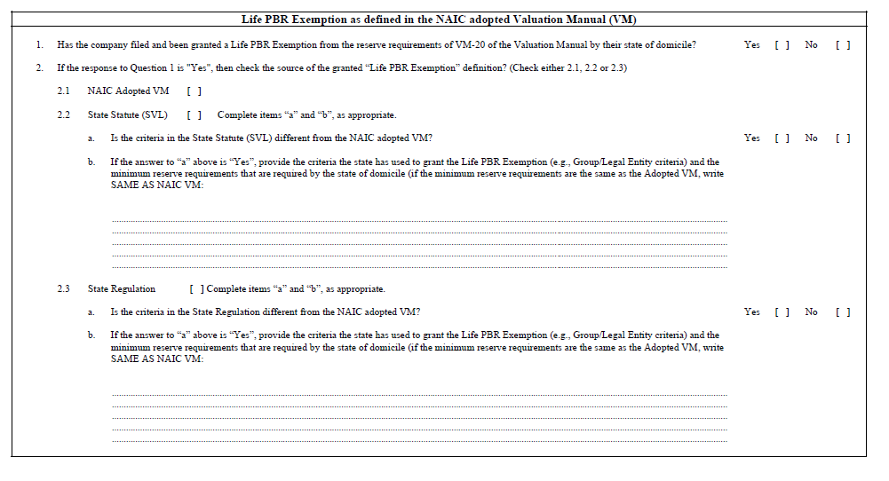

Possible insertion between questions 1 and 2 for disclosure of premiums used in the determination of eligibility for the Life PBR exemption, split by ordinary life and group subject to an individual risk selection process and meeting all of the requirements in VM-20 Section 1.B.