**Life Actuarial (A) Task Force/ Health Actuarial (B) Task Force**

**Amendment Proposal Form\***

1. Identify yourself, your affiliation and a very brief description (title) of the issue.

Identification:

PBR Staff of Texas Department of Insurance

Title of the Issue:

APF to fix language that is hard to follow.

2. Identify the document, including the date if the document is “released for comment,” and the location in the document where the amendment is proposed:

Section 3.F.9.h.ii

January 1, 2022 NAIC *Valuation Manual*

3. Show what changes are needed by providing a red-line version of the original verbiage with deletions and identify the verbiage to be deleted, inserted or changed by providing a red-line (turn on “track changes” in Word®) version of the verbiage. (You may do this through an attachment.)

**VM-31 Section 3.F.9.h.ii:**

ii. Documentation that the implied volatility scenarios generated do not result in a lower TAR than that obtained by assuming that the implied volatility – at all ITM levels – at a given time step in a given scenario is equal to the realized volatility of the underlying asset scenario over the same time period as required by VM-21 Section 8.D.3.

4. State the reason for the proposed amendment? (You may do this through an attachment.)

VM-31 Section 3.F.9.h.ii: Sentence is confusing and doesn’t make sense grammatically. Revised based on the parallel language in VM-21, which this VM-31 reporting item is intended to verify:

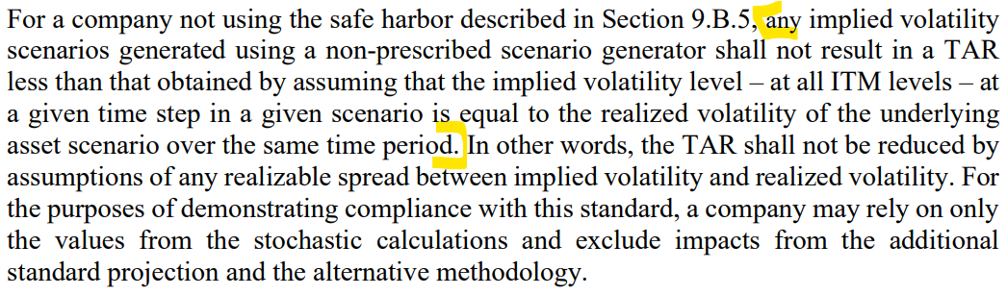

* This form is not intended for minor corrections, such as formatting, grammar, cross–references or spelling. Those types of changes do not require action by the entire group and may be submitted via letter or email to the NAIC staff support person for the NAIC group where the document originated.

NAIC Staff Comments:

|  |  |  |  |
| --- | --- | --- | --- |
| **Dates:** Received | Reviewed by Staff | Distributed | Considered |
| 1/31/2022 | RM |  |  |
| **Notes:** APF 2022-02 | | | |

W:\National Meetings\2010\...\TF\LHA\