Life Actuarial (A) Task Force/ Health Actuarial (B) Task Force
Amendment Proposal Form*

1. Identify yourself, your affiliation, and a very brief description (title) of the issue.

Identification:
Rachel Hemphill, Texas Department of Insurance

Title of the Issue:
Update the Life PBR Exemption as needed due to changes made to the annual statement blanks.

2. Identify the document, including the date if the document is “released for comment,” and the location in the document where the amendment is proposed:

Valuation Manual Section II, Subsection 1.G

January 1, 2025 NAIC Valuation Manual

3. Show what changes are needed by providing a red-line version of the original verbiage with deletions and identify the verbiage to be deleted, inserted, or changed by providing a red-line (turn on “track changes” in Word®) version of the verbiage. (You may do this through an attachment.)

Valuation Manual Section II, Subsection 1.G

Exemption premium is determined as follows:
- The amount reported in the prior calendar year life/health annual statement, Exhibit 1, Part 1, Column 2 (“Individual Life”), line 20.1; plus
- The portion of the amount in the prior calendar year life/health annual statement, Exhibit 1, Part 1, Column 2 (“Individual Life”), line 20.2 assumed from unaffiliated companies; minus
- Amounts included in either (a) or (b) that are associated with industrial policies, credit life policies, guaranteed issue insurance policies and/or preneed life insurance policies; minus
- Amounts included in either (a) or (b) that represent transfers of reserves in force as of the effective date of a reinsurance assumed transaction; plus
- Amounts of premium for individual life certificates issued under a group life certificate that meet the conditions defined in VM-20, Section 1.B, and that are not included in either (a) or (b).

Guidance Note:
Definitions of industrial life insurance, preneed, and guaranteed issue life insurance policy are in VM-01. The definition of credit life insurance is in Section II, Subsection 5.B.

4. State the reason for the proposed amendment? (You may do this through an attachment.)

This APF is to coordinate with Blanks updates that have been made. Specifically, in Exhibit 1, Part 1 there is now an “individual” column rather than an “ordinary” column and the separate industrial and credit life columns were removed, by BWG 2022-14.
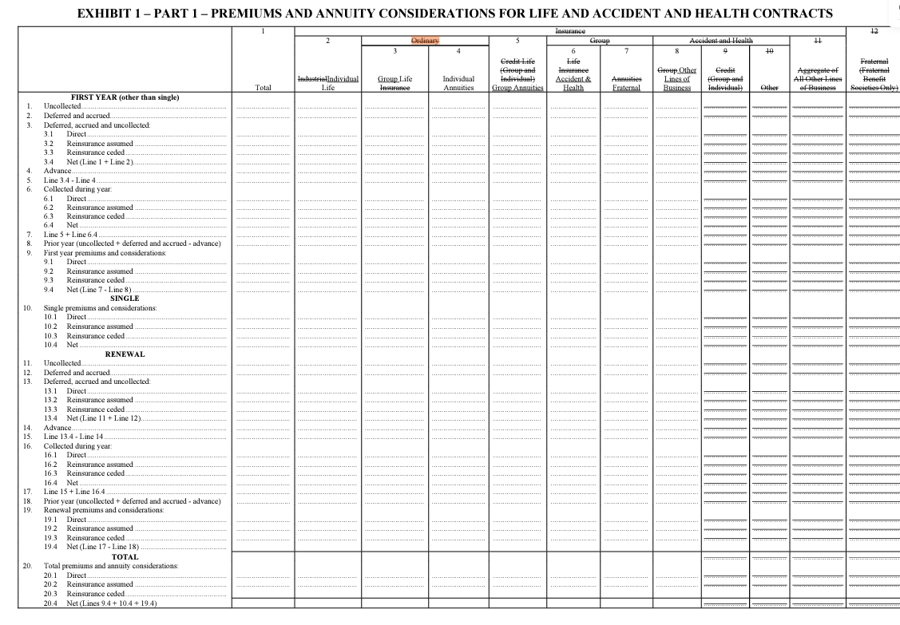

Dates: Received | Reviewed by Staff | Distributed | Considered
7/23/2024 | A.F.
Notes: APF 2024-11

