Date: 7/1/24

Virtual Meeting

Accelerated Underwriting (A) Working Group
Thursday, July 11, 2024
12:00 – 1:00 p.m. ET / 11:00 a.m. – 12:00 p.m. CT / 10:00 – 11:00 a.m. MT / 9:00 – 10:00 a.m. PT

ROLL CALL
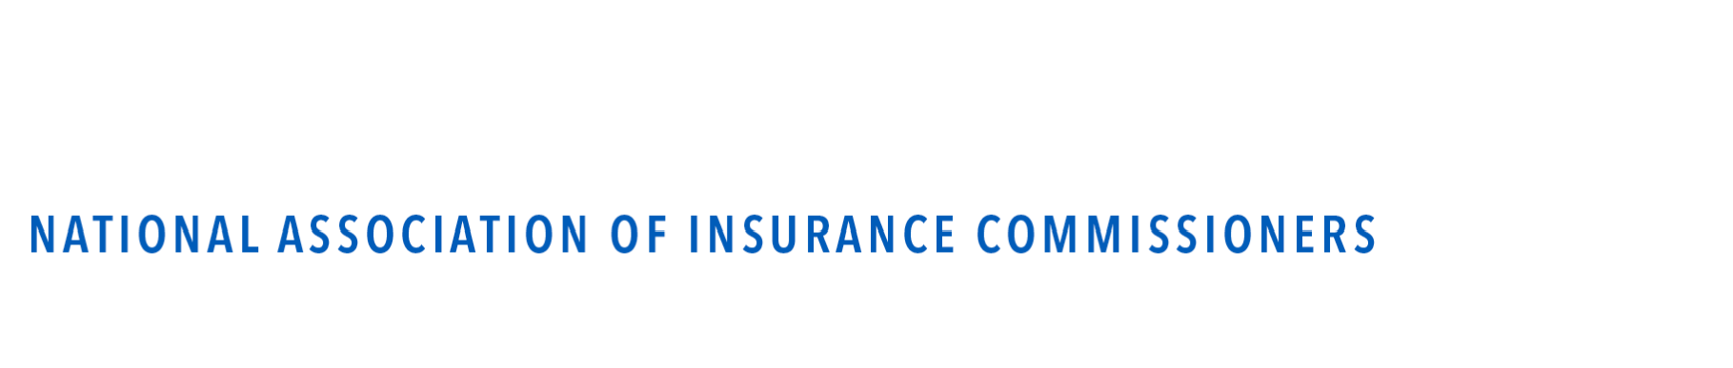
Nathan Houdek, Chair | Wisconsin | Maggie Reinert/ Megan VanAusdall | Nebraska
Grace Arnold, Vice Chair | Minnesota | Ross Hartley | North Dakota
Jason Lapham | Colorado | Daniel Bradford | Ohio
Russ Gibson | Iowa | Matt Gendron | Rhode Island
Cynthia Amann | Missouri | David Hippen | Washington

NAIC Support Staff: Jennifer R. Cook

AGENDA

- Consider adoption of April 3 and June 13 Working Group minutes—Nathan Houdek (WI)

- Discuss comments received on accelerated underwriting guidance document and referral
—Nathan Houdek (WI)

- Any Other Matters

- Adjournment

