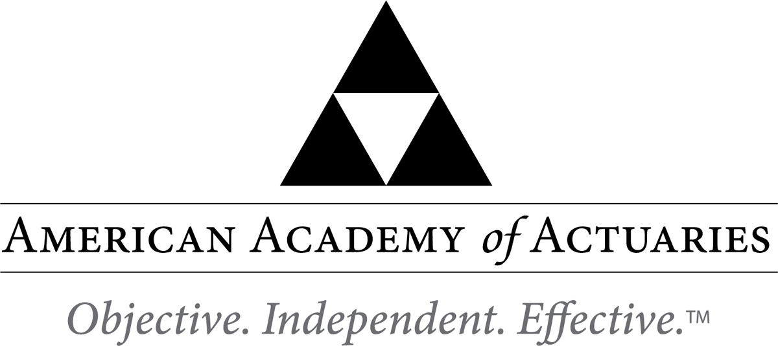

August 27, 2020

Ms. Kris DeFrain
Director, Research and Actuarial Department
National Association of Insurance Commissioners

Sent via email

Re: Actuarial Opinion (C) Working Group’s Exposure of Financial Analysis Handbook and Financial Examiners Handbook Excerpts for written comment

Dear Ms. DeFrain,

On behalf of the Committee on Property and Liability Financial Reporting (COPLFR) of the American Academy of Actuaries, I appreciate this opportunity to provide comments on the excerpted proposed changes to the Financial Analysis Handbook and Financial Examiners Handbook (hereinafter referred to as “FAH” or “FEH,” respectively), issued by the National Association of Insurance Commissioners (NAIC) for public comment.

Our only comments pertain to the FEH, in particular items 1 and 3, which are restated below for reference:

1. Are individuals within the insurer’s actuarial function suitable for their respective roles? Do they possess the necessary competence and integrity for their positions?
a. Does the insurer’s appointed actuary maintain an Accepted Actuarial Designation and otherwise meet the definition of a Qualified Actuary, as stated in the NAIC Statement of Actuarial Opinion Instructions?
b. If the company has an internal actuarial function, is it appropriate for the company’s size, complexity, and lines of business written?
i. Do those within the company’s actuarial function have the appropriate knowledge, experience and background to function in the roles assigned to them?
ii. Does the organizational chart provide evidence of appropriate lines of reporting for the actuarial function?
c. If the company outsources its actuarial function, does the actuary have the appropriate knowledge, experience and background to function in the assigned role and what oversight is the company performing?
……

3. Does the insurer have appropriate segregation of duties between its actuarial function and executive management to ensure that:
a. Recorded reserves reflect an appropriate actuarial estimate (P&C and Health).
b. The company books the actuary’s best estimate each year (P&C).
c. If the company’s recorded reserves differ from the actuary’s best estimate, the rationale for such deviation is appropriately documented and presented to the board of directors (P&C).
d. The company’s appointed actuary has submitted a report to the Board of Directors on reserve adequacy (All Lines)?

With respect to item 1.c., the NAIC may also wish to ask a similar question regarding the outsourced (external) actuarial function as being asked of the internal actuarial function in item 1.b. In particular, “is it appropriate for the company’s size, complexity, and lines of business written?” In other words, the NAIC may wish to consider whether the outsourced (external) actuarial function has adequate resources given the company’s size and complexity.

We believe that item 3.b., “The company books the actuary’s best estimate each year (P&C),” is outdated. According to paragraph 12 of the NAIC Statement of Statutory Accounting Principles (SSAP) No. 55, Unpaid Claims, Losses and Loss Adjustment Expenses, “management shall record its best estimate of its liabilities for unpaid claims, unpaid losses, and loss/claim adjustment expenses.” There is no requirement for the company to book the actuary’s best estimate. Therefore, we recommend that it be changed to something like “The company is informed by the actuarial estimates in determining management’s best estimate each year (P&C)”.

We note that the excerpted Current Reserves/Claims Handling (P&C) Examination Repository table of risks has wording that is appears to be consistent with our recommendation (i.e., “Actuarial analysis relied upon by the insurer’s management in determining carried reserves…”). However, the NAIC might consider revising the phrase “relied upon by management” to “considered by management”.

With respect to item 3.c., we further recommend changing the phrase “actuary’s best estimate” to “actuary’s point estimate,” so as not to confuse the term “best” as it pertains to management’s recorded reserves.

We appreciate your consideration of these questions and comments.

Sincerely,

Kathleen C. Odomirok, MAAA, FCAS
Chairperson, COPLFR
American Academy of Actuaries

The American Academy of Actuaries is a 19,500 member professional association whose mission is to serve the public and the U.S. actuarial profession. For more than 50 years, the Academy has assisted public policymakers on all levels by providing leadership, objective expertise, and actuarial advice on risk and financial security issues. The Academy also sets qualification, practice, and professionalism standards for actuaries in the United States.

