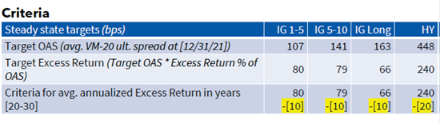
The Corporate Asset Classes were calibrated to the above targets during the second Field Test. At that time, both the Treasury and equity models were using approximations of the final model, not the actual code. For example, the Treasury model was using an approximation to the Generalized Fractional Floor (GFF), not the built-in Dynamic GFF that is being used for the final GOES scenarios. Several SMEs noticed that the released GOES scenarios no longer aligned with these targets.
As a result, Conning has made some adjustments to offset the impact of moving to the final GOES framework. In particular, the multipliers used to scale up the Income return from the GEMS targets (see GEMS Corporate Model Targets and Parameterization) have been reduced. In order to ensure that these new parameters will also be resilient to changes in the initial conditions, Conning tested these new parameters across a series of different initial conditions including:
- Sept 2024: roughly average initial Treasury Yield and Corporate Spreads
- Dec 2023: relatively low Corporate spreads
- Mar 2020: relatively low Yields and very elevated Spreads
This is the comparison of results for the High Yield Asset Class:
Target | Mar-2020 | Dec-2023 | Sept-2025
OAS | 466 bps | 444 bps | 448 bps
Excess Return | 291 bps | 233 bps | 240 bps

The other Asset Classes showed a similar pattern, although smaller magnitude of differences.

