Health Care Bills: Explanation of Benefits

After you receive medical care, your health insurer will send you information about your claim in an Explanation of Benefits or EOB. The EOB is not a bill. It’s the insurer’s explanation of how the costs of services are shared between you and the insurer.

What does an EOB tell me?

An EOB tells how much each provider charged, how much the health insurer paid, and how much you owe each provider. Be sure to compare the “owed” amounts on the EOB with amounts on bills from your providers and what you’ve already paid.

What does an EOB look like?

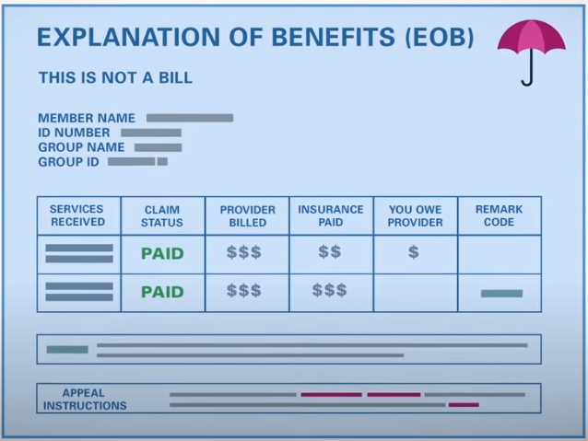

Not all EOBs look alike, but here are a few things to look for on your EOB.

- Information about the person who received the services. This includes the health insurance ID number and the member name, sometimes identified as “patient.” If it’s your insurance, the EOB often refers to the patient as “self.” If the insurance is through your spouse or your parent, then their name will be on the EOB.
- A list of services received, including the dates you received them. There also may be billing codes. (See companion guide Health Care Bills: Codes and Claims.) If those aren’t on the EOB, there should be notes about how to get the codes if you need or want them.
- Information about the provider or facility. This will name the person (doctor, nurse practitioner, psychologist, physical therapist) or facility (laboratory, hospital) that provided the service.
- The amount the provider or facility billed the insurer.
- The “allowed” amount. This is the amount the insurer will pay the provider for the health care you received. The allowed amount is negotiated between the provider and the insurer. If the allowed amount is less than the billed amount, you’ll owe the difference.
- The amount the insurer paid for each service.
- The amount you owe the provider. This may include money you paid during your visit.
- Information about denials and other details or notes. The insurer may use codes to explain denial reasons and notes. You should see an explanation of the codes on the EOB.
How else is an EOB helpful?
An EOB is an important tool to help you track how much you’ve spent out-of-pocket for covered health care costs. That helps you know how far along you are in meeting your deductible and out-of-pocket limit for the year. If you’ve reached your out-of-pocket limit and you’re asked to pay for services, you should contact your insurer right away.
You’ll also find instructions on your EOB to file a grievance or appeal if the insurer denies coverage for services or only pays part of the claim.
Who receives an EOB?
Usually, the insurer sends the EOB to the primary person on the health plan. If an employer provides the insurance, the employee usually receives the EOB, including EOBs for a spouse and dependents on the plan.
You may ask the insurer to send your EOBs to a different address for confidential services or if the information on an EOB would put you in danger.

