Draft: 10/15/21

Comments are being requested on this draft document on or before Monday, Nov. 15, 2021. Comments should be sent by email only to Jolie Matthews at jmatthews@naic.org.

DRAFT

National Association of Insurance Commissioners (NAIC)
Special Committee on Race and Insurance – Workstream 5 (Health)
Principles for Data Collection

RECOMMENDS that state insurance departments and all health insurance companies promote, consider, and uphold the following principles according to their respective roles; and

RECOGNIZES that providers, consumers, patients, HHS/CMS, and state health care professional licensing boards and commissioners all play an important role in providing and sharing demographic data and committing to culturally competent patient care through training and that collective work is necessary to ensure consequential change across the entire healthcare delivery system.

THIS DOCUMENT is intended to establish consistent high-level guiding principles for the collection and treatment of data on race, ethnicity, and other demographic characteristics in the business of health insurance. These principles are guidance and do not carry the weight of law or impose any legal liability. This guidance can serve to inform state insurance departments and health insurance companies of recommendations aimed at addressing disparities in health insurance and health care. While this guidance begins with the premise that robust and accurate data collection must be a priority of state insurance regulators and the regulated health insurance companies, it also recognizes that consequential change must occur across the entire healthcare delivery system and HHS/CMS, providers, patients and licensing boards all must work together in order to fully and successfully execute the following Principles.

Data Collection

- Upon the completion of a strategy and framework for the collection of demographic data developed in coordination between HHS, state insurance departments, and state sister agencies, health insurance companies should, where national industry standards exist and have been adopted across the healthcare ecosystem (providers, payers, and others) enable processes to collect, maintain, protect, and report on, at minimum, enrollee data on race, ethnicity, preferred language, sex assigned at birth, gender identity, sexual orientation, and disability. This Principle recognizes that data on sensitive demographic attributes such as race, ethnicity, preferred language, sex assigned at birth, gender identity, sexual orientation, and disability must be collected in a trusted relationship. Efforts to obtain and use such data will require rebuilding eroded trust in the healthcare and social services systems. Given the high level of trust patients have in their caregivers, healthcare providers may be better situated to collect these data during the course of care. Health insurance companies have an important opportunity at enrollment and/or through care management relationships to collect key self-reported data.

- Health insurance companies should utilize industry-wide best practice in terms of data collection strategies and survey language that has been consumer-tested and is widely recognized for increased accuracy and responsiveness. (The Appendix provides specific language for health insurance company consideration and also directs companies to other widely recognized sources for data collection integrity.) This Principle recognizes the work that is currently underway to develop evidence-based, stakeholder driven demographic data standards. Through the convening of multi-stakeholder groups improvements to data collection to ensure providers and consumers can accurately report how they identify, if they chose. Stakeholders must analyze the comfort level of consumers to determine whether questions are culturally or linguistically appropriate.
- he disclosure of demographic data by prospective insureds and enrollees must always be voluntary and based on self-identification or disclosure and be accompanied by a detailed reasoning for why this data is being requested and that it will support efforts to provide equitable care. To ensure that the disclosure of demographic data does not result in the unintended consequence of compelling consumers to report this sensitive information, a “prefer to not answer” option should be included if insureds and enrollees are asked to answer demographic questions, and an “other” option should be considered to help identify additional future data collection categories. This Principle recognizes that self-reporting may lead to potential discrepancies and underreporting, which will impact a state insurance department’s ability to utilize, evaluate, and rely upon this information. Entities should not be required to follow-up with individuals who select “prefer to not answer” as that would violate the respect for a person’s preference to not respond to particular questions.
- To the extent that insurers use staff to collect and/or analyze demographic data, insurers should develop and implement trainings (either in-house or through partnership) or provide guiding resources on how to ask questions about race, ethnicity, and language (REL), and sexual orientation and gender identity (SOGI), including training on how to maintain privacy of this sensitive information.
- Health insurance companies should be encouraged to pursue an accreditation or certification product that addresses how organizations meet diversity, equity and inclusion goals for employees, insureds, and enrollees.
  - State-based exchanges should consider identifying insurers that have achieved an accreditation or certification product that addresses how organizations meet diversity, equity and inclusion goals for employees, insureds, or enrollees as part of the exchanges’ public-facing websites.

- Upon the completion of an engagement strategy with relevant stakeholders and framework for the collection of demographic data about participating providers developed in coordination between state insurance departments and state sister agencies and exploring statewide and nationwide solutions (such as through state medical license boards or through CMS National Plan and Provider Enumeration System) to reduce burdens on providers to provide demographic data to multiple networks, insurers should collect demographic data about participating providers in their networks to monitor diversity within the health care workforce. This Principle recognizes the challenges of self-reporting by providers that may lead to potential discrepancies and underreporting, which will impact an insurers and state insurance department’s ability to utilize, evaluate, and rely upon this information. The disclosure of demographic data by providers must always be voluntary and based on self-identification or disclosure. To promote this principle, a “prefer to not answer” option should be included if providers are asked to answer demographic questions. Entities should not be required to follow-up with individuals who select “prefer to not answer” as that would violate the respect for a person’s preference to not respond to particular questions..

Data Use and Regulation
- Before state insurance departments seek to implement data collection guidance or recommendations, state insurance departments should confirm that neither state nor federal law prohibits an insurer from collecting race, ethnicity, preferred language, sex assigned at birth, gender identity, sexual orientation, and disability. Such clarification should distinguish between the collection of demographic data and the prohibited use of demographic data in rating, underwriting practices, and benefit determinations.
- Health insurance companies should apply HIPAA protections to demographic data, which should be considered HIPAA protected health information (PHI). Health insurance companies should be prohibited from reporting demographic data that would permit the identification of individuals. In these limited circumstances—when privacy protections prevent reporting on disaggregated demographic data—health insurance companies and regulators should clearly state that this is the reason why the data was not reported.
- All existing federal and state privacy laws and statutes shall continue to serve as the standard for any information sharing or analysis. While sharing publicly, both insurers and the Departments should ensure that any demographic information is aggregated and does not identify any single individual.
- State insurance departments and health insurance companies are encouraged to coordinate on legal and ethically acceptable use cases and best practices relative to the use of demographic data within company operations. Acceptable use cases and best practices may include evaluating a company’s governance of evaluating to ensure algorithms are monitored and evaluated so that biases are avoided or corrected; analyzing claims, enrollment, and complaint data to better understand health care disparities or to evaluate the efficacy of programs intended to reduce health care disparities; provider network development and coordination of care; reporting requirements; service quality improvement ; assessing or planning to meet the need for health-related social services and supports, including trauma-informed care; and targeted outreach to underserved populations, among other uses.
- State insurance departments, individually or collectively through the NAIC, should collect and review demographic data from public sources including state and federal demographic databases to better understand the marketplace and efforts and opportunities for the departments to address issues around health equity. This Principle recognizes the challenges with self-reported data accuracy and the potential for discrepancies and underreporting, which will impact the ability of state insurance departments, individually or collectively through the NAIC, to utilize, evaluate, and/or rely upon the consumer and provider demographic data collected by health insurance companies.

Appendix

Recommended Standards for Data Collection
This section provides specific recommendations for data collection standards for race and ethnicity. Though widely recognized for increased accuracy and responsiveness, these standards, examples, and sources are not the sole resources that health insurance companies may use to develop data collection systems and processes. As such, this section also provides a list of resources for data collection related to language, sexual orientation, gender identity, and disability. Health insurance companies should be familiar with long-standing guidance from the U.S. Department of Health and Human Services on Data Collection Standards for Race, Ethnicity, Sex, Primary Language, and Disability Status. All questions should allow for the option to self-identify, including a “choose not to answer” option or a blank, fillable option.

  - On race and ethnicity
    - In preparation for the 2020 Census, the U.S. Census Bureau conducted research to improve the collection of race/ethnicity data and found that providing a combined race/ethnicity question with detailed checkboxes decreased nonresponse and improved accuracy. In addition, as summarized by the State Health Access Data Assistance Center at the University of Minnesota, the research:
      - Reinforced the importance of allowing multiple responses;
      - Suggested that “Mark all that apply” or “Select all that apply” is better than “Select one or more”;
      - Suggested that using “race/ethnicity” terminology is less confusing than using terms like “category,” which can suggest a hierarchy; and
      - Found that data collection is improved when there is a dedicated “Middle Eastern or North African” response category for race (currently classified as “White”).

    - Data should be collected at a granular level to allow for disaggregation, particularly for Asian Americans, Native Hawaiians and Pacific Islanders (AANHPI), Hispanics, and Middle Eastern and Northern African (MENA) populations.

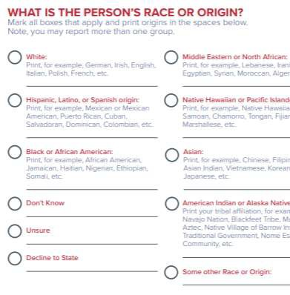
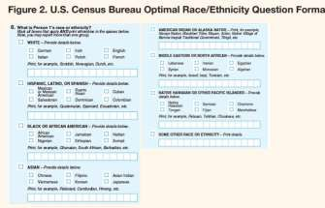

Source: Collection of Race, Ethnicity, Language (REL) Data in Medicaid Applications, State Health Access Data Assistance Center at the University of Minnesota

Source: Policy Recommendations: Health Equity Cannot Be Achieved Without Complete and Transparent Data Collection and the Disaggregation of Data by Asian & Pacific Islander American Health Forum, UnidosUS, National Urban League, National Congress of American Indians, ACCESS

c. Sources

      - 1. Asian & Pacific Islander American Health Forum (2021). Policy Recommendations: Health Equity Cannot be Achieved without Complete and Transparent Data Collection and the Disaggregation of Data. https://www.apiahf.org/wp-content/uploads/2021/02/APIAHF-Policy-Recommendationas-Health-Equity.pdf
  - 2. State Health and Value Strategies (2021). Collection of Race, Ethnicity, Language (REL) Data in Medicaid Applications: A 50-State Review of the Current Landscape. https://www.shvs.org/wp-content/uploads/2021/05/SHVS-50-State-Review-EDITED.pdf
  - 3. US Census Bureau (2017). 2015 National Content Test Race and Ethnicity Analysis Report: A New Design for the 21st Century. https://assets.documentcloud.org/documents/4316468/2015nct-Race-Ethnicity-Analysis.pdf
  - 4. Institute of Medicine (for AHRQ) (2021). Race, Ethnicity, and Language Data: Standardization for Health Care Quality Improvement. https://www.ahrq.gov/research/findings/final-reports/iomracereport/index.html
  - 5. McGee, M.G. (2020). Race, Ethnicity, Language and Disability (REALD) Implementation Guide. https://sharedsystems.dhsoha.state.or.us/DHSForms/Served/le7721a.pdf

  - On preferred language
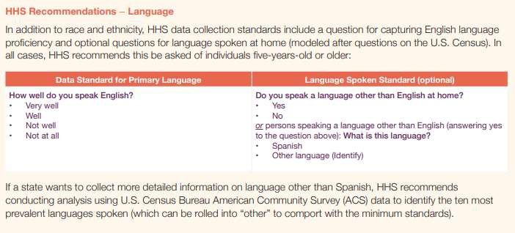
    - The American Community Survey, consistent with recommendations from the Department of Health and Human Services, also captures data on English language proficiency and optional questions for the language spoken at home. These questions are recommended for anyone age 5 years or older.

Source: Collection of Race, Ethnicity, Language (REL) Data in Medicaid Applications, State Health Access

  - On sex, sexual orientation, and gender identity
    - The National Academies of Sciences, Engineering, and Medicine recently convened an expert panel entitled Measuring Sex, Gender Identity, and Sexual Orientation that will culminate in clear guidelines outlining the guiding principles and best practices for collecting sexual orientation and gender identity information. Recommendations will address collection and use of this information in research and non-research surveys, along with medical and other administrative records. These recommendations can help inform data collection by industry.
    - The Williams Institute at the UCLA School of Law has published several reports on best practices for asking questions about sex, sexual orientation, and gender identity. Key practices include:
      - Sexual orientation survey items should be culturally appropriate, relevant, acceptable, and compatible with the respondent’s understanding of the construct that the question is intended to measure. Sexuality can be understood differently in different racial/ethnic populations. It is recommended that surveys assess multiple dimensions of sexuality, such as measures of sexual behavior, sexual attraction, and self-identity. When measuring sexual diversity within racial/ethnic minority groups, researchers might also consider including additional response options for sexual orientation identity terms, such as two- spirit, same gender loving, homosexual, down low, or queer, that may turn out to be more relevant for non-white populations.
ii.
iii.
Conceptually, sexual orientation has three major dimensions – self-identification (gay, lesbian, bisexual, heterosexual, queer, or asexual), sexual behavior or the sex of partners (same sex, different sex, both sexes, neither), and sexual attraction (the sex or gender of people that the respondent feels attracted
to). Surveys should allow for a wide range of responses.
When asking about sex, it is recommended to use a “two-step”
approach. Respondents should be asked what sex they were assigned at birth or what sex is indicated on their birth certificate, and should also be asked how they describe their current gender identity. When describing current gender identity, respondents should be allowed to ‘check all that apply’ or fill in their own descriptor. If a respondent identifies as transgender, a follow-up question should be included to further identify whether male to female, female to male, or transgender gender nonconforming.
    - Sources:
      - The GenIUSS Group. (2014). Best Practices for Asking Questions to Identify Transgender and Other Gender Minority Respondents on Population-Based Surveys. J.L. Herman (ed.). Los Angeles, CA: The Williams
Institute. https://williamsinstitute.law.ucla.edu/wp-content/uploads/Survey-
Measures-Trans-GenIUSS-Sep-2014.pdf
      - Cahill, S., Baker, K., Makadon, H. Do Ask, Do Tell: A Toolkit for Collecting Sexual Orientation and Gender Identity Information in Clinical Settings. Boston, MA: Fenway Institute. https://doaskdotell.org/

      - Brown, T. N. T. and Herman, J. L. (2020). Exploring International Priorities and Best Practices for the Collection of Data about Gender Minorities: A Focus on South America, Report of Meeting. Los Angeles, CA: The Williams
Institute. https://williamsinstitute.law.ucla.edu/wp-content/uploads/WPATH-
English-Mar-2020.pdf
      - The Sexual Minority Assessment Research Team (SMART) (2009). Best Practices for Asking Questions about Sexual Orientation on Surveys. Los Angeles, CA: The Williams Institute. https://williamsinstitute.law.ucla.edu/wp- content/uploads/Best-Practices-SO-Surveys-Nov-2009.pdf
      - Centers for Disease Control and Prevention (2020). Collecting Sexual Orientation and Gender Identity Information. https://www.cdc.gov/hiv/clinicians/transforming-health/health-care- providers/collecting-sexual-orientation.html

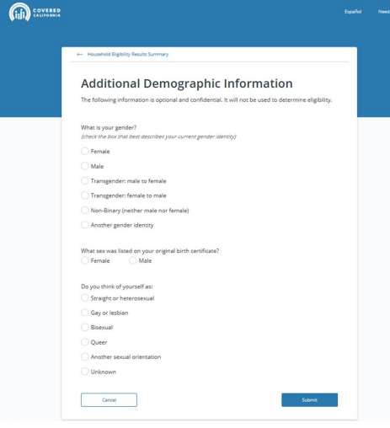
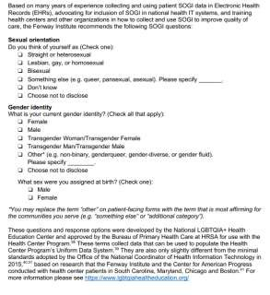

Source: Letter to Dr. Rachel Levine, LGBTQI Inclusion in COVID-19 Data Collection & Vaccination Planning

  - On disability
    - Demographic questions about disability have been asked in the American Community Survey since 1999, with modifications over time. The most recent revisions to these questions were adopted in 2008 and endorsed by the U.S. Department of Health and Human Services, in guidance issued in 2011 pursuant to the requirements of section 4302 the Affordable Care Act. These questions are:
      - Are you deaf or do you have serious difficulty hearing?

      - Are you blind or do you have serious difficulty seeing, even when wearing glasses?
      - Because of a physical, mental, or emotional condition, do you have serious difficulty concentrating, remembering, or making decisions? (5 years old or older)
      - Do you have serious difficulty walking or climbing stairs? (5 years old or older)
      - Do you have difficulty dressing or bathing? (5 years old or older)
      - Because of a physical, mental, or emotional condition, do you have difficulty doing errands alone such as visiting a doctor's office or shopping? (15 years old or older).
    - Additional measures have been developed outside of the American Community Survey, such as the Washington Group Short Set of Questions on Disability. Those questions have been analyzed by the Centers for Disease Control and Prevention.

    - Sources:
      - U.S. Department of Health & Human Services, Office of the Assistant Secretary for Planning and Evaluation. (2011) U.S. Department of Health and Human Services Implementation Guidance on Data Collection Standards for Race, Ethnicity, Sex, Primary Language, and Disability Status. https://aspe.hhs.gov/basic-report/hhs-implementation-guidance-data- collection-standards-race-ethnicity-sex-primary-language-and-disability-status
      - Centers for Disease Control and Prevention. (2020) Disability Datasets: Population Surveys that Include the Standard Disability Questions. https://www.cdc.gov/ncbddd/disabilityandhealth/datasets.html
Kuper, H, Polack, S. Mactaggart, I. How to Measure Disability and Why It Is Important. https://www.futurelearn.com/info/courses/global- disability/0/steps/37579

e) In the event data collection remains low after best practices are implemented, regulators and insurers should engage consumers and consumer advocates, engage navigators /enrollment assisters, develop communications and trainings focused on the importance of demographic data collection, and modify enrollment and renewal interfaces.

