Draft: 12/3/21

DRAFT

National Association of Insurance Commissioners (NAIC)
Special Committee on Race and Insurance – Workstream 5 (Health)
Principles for Data Collection

RECOMMENDS that state insurance departments and all health insurance companies promote, consider, and uphold the following principles according to their respective roles; and

RECOGNIZES that providers, consumers, patients, HHS/CMS, other areas of state government including state health care professional licensing boards and commissioners all play an important role in providing and sharing demographic data and committing to culturally competent patient care through training and that collective work is necessary to ensure consequential change across the entire healthcare delivery system. As this work continues across the healthcare ecosystem, collaboration across these parties and adaptation of approaches to demographic data collection to achieve alignment should be a priority.

THIS DOCUMENT is intended to establish consistent high-level guiding principles for the collection and treatment of data on race, ethnicity, and other demographic characteristics in the business of health insurance. These principles are guidance and do not carry the weight of law or impose any legal liability. This guidance can serve to inform state insurance departments and health insurance companies of recommendations aimed at addressing disparities in health insurance and health care. This guidance begins with the premise that robust and accurate data collection must be a priority of state insurance regulators and the regulated health insurance companies to both quantify existing disparities and evaluate the effectiveness of initiatives to address those disparities.

Throughout this document, “health insurance companies” is intended to include all entities bearing health insurance risk and for which the health products and services provided are regulated by state insurance departments. This will differ by state and includes applicable health maintenance organizations, life insurance, casualty insurance, or other types of entities that offer health insurance products, as well as provider organizations that are regulated by state insurance departments due to the nature of the risk borne.

This document is intended to capture high level principles related to demographic data collection and recognizes that this topic is evolving, and state insurance regulators may need to refine or expand on this work in the future.

Data Collection
- Health insurance companies should be expected to systematically collect, maintain, protect, and report on, at minimum, voluntarily reported enrollee data on race, ethnicity, preferred language, sex assigned at birth, gender identity, sexual orientation, and disability. When collecting, maintaining, and reporting this data, health insurers should aim to align their practices with established national standards that are, where possible, aligned across the healthcare ecosystem consistent with any requirements of the state insurance regulator, if applicable.
- Health insurance companies should utilize industry-wide best practice in terms of data collection strategies and survey language that has been consumer-tested and is widely recognized for increased accuracy and responsiveness. (The Appendix provides specific language for health insurance company consideration and also directs companies to other widely recognized sources for data collection integrity.) This Principle recognizes the work that is currently underway to develop evidence-based, stakeholder driven demographic data standards and that future work should be informed by this ongoing work.
- The disclosure of demographic data by prospective insureds and enrollees must always be voluntary and based on self-identification or disclosure and be accompanied by a detailed reasoning for why this data is being requested and that it will support efforts to provide equitable care. To ensure that the disclosure of demographic data does not result in the unintended consequence of compelling consumers to report this sensitive information, a “prefer to not answer” option should be included if insureds and enrollees are asked to answer demographic questions, and an “other” option should be considered to help identify additional future data collection categories. This Principle recognizes that self-reporting may lead to potential discrepancies and underreporting, which will impact a state insurance department’s ability to utilize, evaluate, and rely upon this information. Entities should not be required to follow-up with individuals who select “prefer to not answer” as that would violate the respect for a person’s preference to not respond to particular questions.
- To the extent that insurers use staff to collect and/or analyze demographic data, insurers should develop and implement trainings (either in-house or through partnership) on how to ask questions about race, ethnicity, and language (REL), and sexual orientation and gender identity (SOGI), including training on how to maintain privacy of this sensitive information.
- Health insurance companies should be encouraged to pursue an accreditation or certification product that addresses how organizations meet diversity, equity and inclusion goals for employees, insureds, and enrollees.
  - State-based exchanges should consider identifying insurers that have achieved an accreditation or certification product that addresses how organizations meet diversity, equity and inclusion goals for employees, insureds, or enrollees as part of the exchanges’ public-facing websites.

NOTE: BELOW ARE FOUR OPTIONS FOR THE WORKSTREAM TO DISCUSS FOR LANGUAGE IN F) BELOW DURING THE MONDAY, DECEMBER 20 MEETING:

Option #1 – Current language:

- Insurers should explore opportunities to collect demographic data about participating providers in their networks to ensure network adequacy requirements are being met and to ensure the provider network addresses the needs of the service area.

Option #2:

f) Health insurers should also collect demographic data regarding providers who participate in their networks, as directed by the insurance regulator.

Option #3:

f) Health insurers should also collect demographic data regarding network providers, consistent with the requirements of their insurance regulator. Workstream 5 will develop a white paper regarding provider networks, including the collection of provider demographic data.

Option #4:

f) The collection of demographic data by insurers about participating providers in their networks represents a significant opportunity to ensure health insurance networks are providing diverse and culturally competent care, and such data collection should be robustly considered. As the collection and use of such data is complex and multi-faceted, NAIC Workstream 5 intends to further explore issues and opportunities related to equity and health insurance networks, network adequacy review, provider directories and cultural competency, including provider demographic data collection and use, in a separate deliverable.

Data Use and Regulation
- Insurance departments must take into consideration any state or federal law that would prohibit or restrict the collection and/or reporting of an insurer from collecting race, ethnicity, preferred language, sex assigned at birth, gender identity, sexual orientation, and disability. Departments should distinguish between the collection of demographic data to be used for specific purposes, such as analysis of health disparities and inequities, from the prohibited use of demographic data in rating, underwriting practices, and benefit determinations. If existing laws prohibit collection of certain demographic data, health insurance companies and regulators should clearly state that this is the reason why the data was not reported.
- Health insurance companies should apply HIPAA protections to demographic data, which should be considered HIPAA protected health information (PHI). Health insurance companies should be prohibited from reporting demographic data that would permit the identification of individuals. In these limited circumstances—when privacy protections prevent reporting on disaggregated demographic data—health insurance companies and regulators should clearly state that this is the reason why the data was not reported.
- All existing federal and state privacy laws and statutes shall continue to serve as the standard for any information sharing or analysis. While sharing publicly, both insurers and the Departments should ensure that any demographic information is aggregated and does not identify any single individual.
- State insurance departments and health insurance companies are encouraged to coordinate on legal and ethically acceptable use cases and best practices relative to the use of demographic data within company operations. Acceptable use cases and best practices may include evaluating algorithms to identify and mitigate disparate impact or bias; analyzing claims, enrollment, and complaint data to better understand health care disparities or to evaluate the efficacy of programs intended to reduce health care disparities; provider network development and coordination of care; reporting requirements; service quality improvement; assessing or planning to meet the need for health-related social services and supports, including trauma-informed care; and targeted outreach to underserved populations, among other uses.
- State insurance departments, individually or collectively through the NAIC, should collect and review demographic data from health insurance companies to better understand the marketplace and efforts and opportunities for health insurance companies to advance and improve services and advance health equity. This Principle recognizes the challenges with self-reported data accuracy and the potential for discrepancies and underreporting, which should be considered for any regulatory use.

Appendix

Recommended Standards for Data Collection
This section provides specific recommendations for data collection standards for race and ethnicity. Though widely recognized for increased accuracy and responsiveness, these standards, examples, and sources are not the sole resources that health insurance companies may use to develop data collection systems and processes. As such, this section also provides a list of resources for data collection related to language, sexual orientation, gender identity, and disability. Health insurance companies should be familiar with long-standing guidance from the U.S. Department of Health and Human Services on Data Collection Standards for Race, Ethnicity, Sex, Primary Language, and Disability Status. All questions should allow for the option to self-identify, including a “choose not to answer” option or a blank, fillable option.

  - On race and ethnicity
    - In preparation for the 2020 Census, the U.S. Census Bureau conducted research to improve the collection of race/ethnicity data and found that providing a combined race/ethnicity question with detailed checkboxes decreased nonresponse and improved accuracy. In addition, as summarized by the State Health Access Data Assistance Center at the University of Minnesota, the research:
      - Reinforced the importance of allowing multiple responses;
      - Suggested that “Mark all that apply” or “Select all that apply” is better than “Select one or more”;
      - Suggested that using “race/ethnicity” terminology is less confusing than using terms like “category,” which can suggest a hierarchy; and
      - Found that data collection is improved when there is a dedicated “Middle Eastern or North African” response category for race (currently classified as “White”).

    - Data should be collected at a granular level to allow for disaggregation, particularly for Asian Americans, Native Hawaiians and Pacific Islanders (AANHPI), Hispanics, and Middle Eastern and Northern African (MENA) populations.

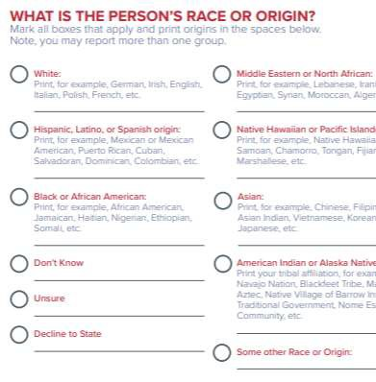
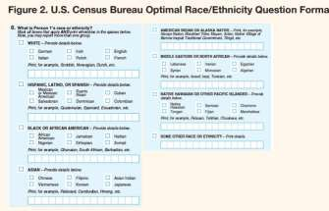

Source: Collection of Race, Ethnicity, Language (REL) Data in Medicaid Applications, State Health Access Data Assistance Center at the University of Minnesota

Source: Policy Recommendations: Health Equity Cannot Be Achieved Without Complete and Transparent Data Collection and the Disaggregation of Data by Asian & Pacific Islander American Health Forum, UnidosUS, National Urban League, National Congress of American Indians, ACCESS

c. Sources

      - 1. Asian & Pacific Islander American Health Forum (2021). Policy Recommendations: Health Equity Cannot be Achieved without Complete and Transparent Data Collection and the Disaggregation of Data. https://www.apiahf.org/wp-content/uploads/2021/02/APIAHF-Policy-Recommendationas-Health-Equity.pdf
  - 2. State Health and Value Strategies (2021). Collection of Race, Ethnicity, Language (REL) Data in Medicaid Applications: A 50-State Review of the Current Landscape. https://www.shvs.org/wp-content/uploads/2021/05/SHVS-50-State-Review-EDITED.pdf
  - 3. US Census Bureau (2017). 2015 National Content Test Race and Ethnicity Analysis Report: A New Design for the 21st Century. https://assets.documentcloud.org/documents/4316468/2015nct-Race-Ethnicity-Analysis.pdf
  - 4. Institute of Medicine (for AHRQ) (2021). Race, Ethnicity, and Language Data: Standardization for Health Care Quality Improvement. https://www.ahrq.gov/research/findings/final-reports/iomracereport/index.html
  - 5. McGee, M.G. (2020). Race, Ethnicity, Language and Disability (REALD) Implementation Guide. https://sharedsystems.dhsoha.state.or.us/DHSForms/Served/le7721a.pdf

  - On preferred language
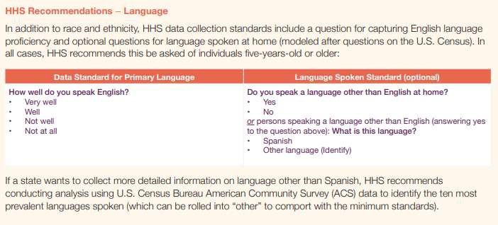
    - The American Community Survey, consistent with recommendations from the Department of Health and Human Services, also captures data on English language proficiency and optional questions for the language spoken at home. These questions are recommended for anyone age 5 years or older.

Source: Collection of Race, Ethnicity, Language (REL) Data in Medicaid Applications, State Health Access

  - On sex, sexual orientation, and gender identity
    - The National Academies of Sciences, Engineering, and Medicine recently convened an expert panel entitled Measuring Sex, Gender Identity, and Sexual Orientation that will culminate in clear guidelines outlining the guiding principles and best practices for collecting sexual orientation and gender identity information. Recommendations will address collection and use of this information in research and non-research surveys, along with medical and other administrative records. These recommendations can help inform data collection by industry.
    - The Williams Institute at the UCLA School of Law has published several reports on best practices for asking questions about sex, sexual orientation, and gender identity. Key practices include:
      - Sexual orientation survey items should be culturally appropriate, relevant, acceptable, and compatible with the respondent’s understanding of the construct that the question is intended to measure. Sexuality can be understood differently in different racial/ethnic populations. It is recommended that surveys assess multiple dimensions of sexuality, such as measures of sexual behavior, sexual attraction, and self-identity. When measuring sexual diversity within racial/ethnic minority groups, researchers might also consider including additional response options for sexual orientation identity terms, such as two- spirit, same gender loving, homosexual, down low, or queer, that may turn out to be more relevant for non-white populations.
      - Conceptually, sexual orientation has three major dimensions – self-identification (gay, lesbian, bisexual, heterosexual, queer, or asexual), sexual behavior or the sex of partners (same sex, different sex, both sexes, neither), and sexual attraction (the sex or gender of people that the respondent feels attracted
to). Surveys should allow for a wide range of responses.
iii. When asking about sex, it is recommended to use a “two-step”
approach. Respondents should be asked what sex they were assigned at birth or what sex is indicated on their birth certificate, and should also be asked how they describe their current gender identity. When describing current gender identity, respondents should be allowed to ‘check all that apply’ or fill in their own descriptor. If a respondent identifies as transgender, a follow-up question should be included to further identify whether male to female, female to male, or transgender gender nonconforming.
    - Sources:
      - The GenIUSS Group. (2014). Best Practices for Asking Questions to Identify Transgender and Other Gender Minority Respondents on Population-Based Surveys. J.L. Herman (ed.). Los Angeles, CA: The Williams
Institute. https://williamsinstitute.law.ucla.edu/wp-content/uploads/Survey-
Measures-Trans-GenIUSS-Sep-2014.pdf
      - Cahill, S., Baker, K., Makadon, H. Do Ask, Do Tell: A Toolkit for Collecting Sexual Orientation and Gender Identity Information in Clinical Settings. Boston, MA: Fenway Institute. https://doaskdotell.org/

      - Brown, T. N. T. and Herman, J. L. (2020). Exploring International Priorities and Best Practices for the Collection of Data about Gender Minorities: A Focus on South America, Report of Meeting. Los Angeles, CA: The Williams
Institute. https://williamsinstitute.law.ucla.edu/wp-content/uploads/WPATH-
English-Mar-2020.pdf
      - The Sexual Minority Assessment Research Team (SMART) (2009). Best Practices for Asking Questions about Sexual Orientation on Surveys. Los Angeles, CA: The Williams Institute. https://williamsinstitute.law.ucla.edu/wp- content/uploads/Best-Practices-SO-Surveys-Nov-2009.pdf
      - Centers for Disease Control and Prevention (2020). Collecting Sexual Orientation and Gender Identity Information. https://www.cdc.gov/hiv/clinicians/transforming-health/health-care- providers/collecting-sexual-orientation.html

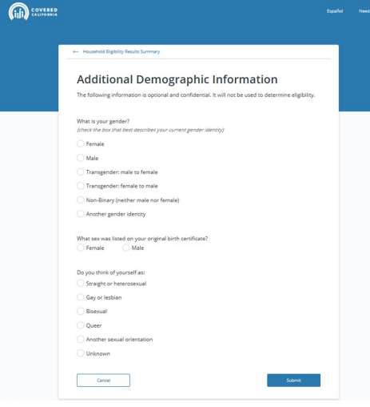
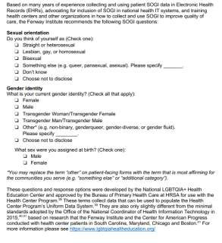

Source: Letter to Dr. Rachel Levine, LGBTQI Inclusion in COVID-19 Data Collection & Vaccination Planning

  - On disability
    - Demographic questions about disability have been asked in the American Community Survey since 1999, with modifications over time. The most recent revisions to these questions were adopted in 2008 and endorsed by the U.S. Department of Health and Human Services, in guidance issued in 2011 pursuant to the requirements of section 4302 the Affordable Care Act. These questions are:
      - Are you deaf or do you have serious difficulty hearing?

      - Are you blind or do you have serious difficulty seeing, even when wearing glasses?
      - Because of a physical, mental, or emotional condition, do you have serious difficulty concentrating, remembering, or making decisions? (5 years old or older)
      - Do you have serious difficulty walking or climbing stairs? (5 years old or older)
      - Do you have difficulty dressing or bathing? (5 years old or older)
      - Because of a physical, mental, or emotional condition, do you have difficulty doing errands alone such as visiting a doctor's office or shopping? (15 years old or older).
    - Additional measures have been developed outside of the American Community Survey, such as the Washington Group Short Set of Questions on Disability. Those questions have been analyzed by the Centers for Disease Control and Prevention.
    - Sources:
      - U.S. Department of Health & Human Services, Office of the Assistant Secretary for Planning and Evaluation. (2011) U.S. Department of Health and Human Services Implementation Guidance on Data Collection Standards for Race, Ethnicity, Sex, Primary Language, and Disability Status. https://aspe.hhs.gov/basic-report/hhs-implementation-guidance-data- collection-standards-race-ethnicity-sex-primary-language-and-disability-status
      - Centers for Disease Control and Prevention. (2020) Disability Datasets: Population Surveys that Include the Standard Disability Questions. https://www.cdc.gov/ncbddd/disabilityandhealth/datasets.html
Kuper, H, Polack, S. Mactaggart, I. How to Measure Disability and Why It Is Important. https://www.futurelearn.com/info/courses/global- disability/0/steps/37579

e) In the event data collection remains low after best practices are implemented, regulators and insurers should engage consumers and consumer advocates, engage navigators /enrollment assisters, develop communications and trainings focused on the importance of demographic data collection, and modify enrollment and renewal interfaces.

