Analysis of the Stochastic Exclusion Ratio Test (SERT) Methodology
The January 21, 2021 exposure of the newly proposed SERT methodology states:
“The methodology used to produce the SERT scenarios is intended to follow the current AAA methodology (add link) except where the AAA methodology appears to differ from the scenario descriptions provided in VM-20 Appendix 1.E.”
Although intended to produce similar results, the new methodology is extremely different in nature, and can introduce potentially significant changes. The current methodology prescribes pre-determined “shocks” to be applied directly to the AAA model (in place of stochastically modeling random shocks). The new methodology targets selected percentiles, at each scenario time step, from the output distribution of 10,000 stochastically simulated scenarios for three key variables (1 Year Treasury, 20 Year Treasury, and U.S. Large Cap equity gross wealth factors).
One advantage of the new methodology is that it can be applied to any underlying stochastic scenario generator, including the existing AAA model. By doing so, we can attribute differences that are solely due to the methodology change, before introducing any changes that are due to a different underlying stochastic scenario generator model or calibration.
The 20 Year and 1 Year Treasury rates in the charts below are based on the current AAA SERT scenarios for a December 2021 valuation date, compared to the targeted percentiles under the new methodology:
- The solid lines represent a selected few of the current Academy Interest Rate Generator (AIRG) SERT scenarios
- The dotted lines represent the targeted percentiles for these scenarios under the new methodology. [Note: The mean is also added, for reference only.] This is what the scenarios would look like if the new methodology were applied to the current AIRG
- Each color pair (solid vs. dotted) corresponds to a single SERT scenario
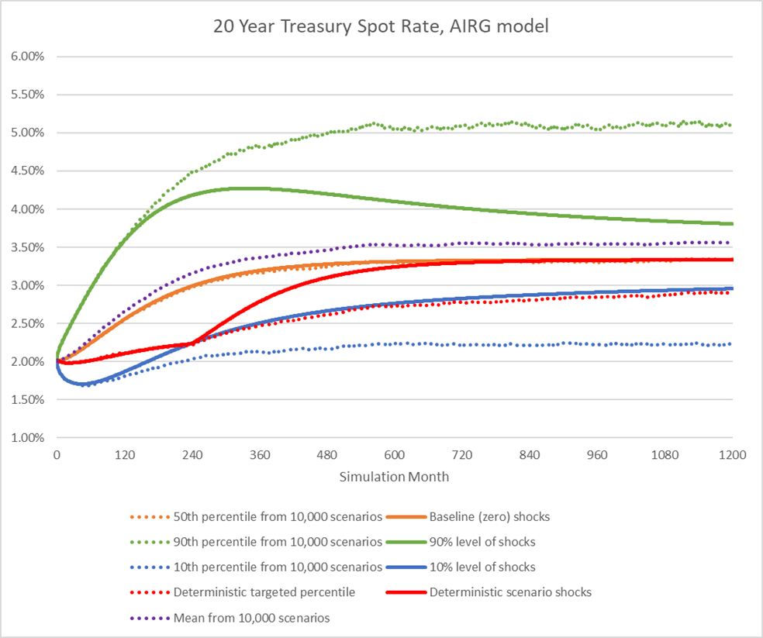
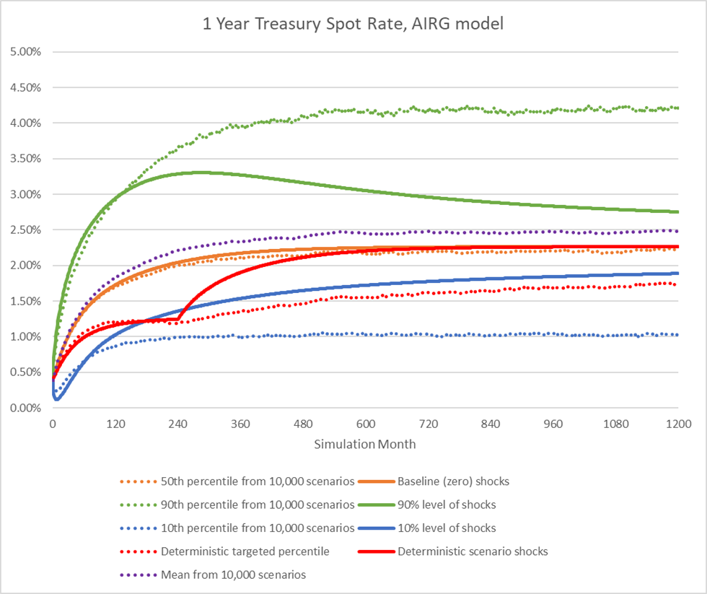

Commentary on the New Methodology
Besides the change in results for some of the SERT scenarios, a conceptually significant issue introduced by the new methodology is that the SERT scenarios can no longer be directly produced by the underlying stochastic economic scenario generator (ESG).
This directly contradicts the rationale stated in Appendix 1, section E, of VM-20, about the current methodology:
“The rationale for this approach is twofold. First, the scenarios should be realistic in that they could be produced by the generator. Second, in some way the likelihood of any scenario occurring can be measured.“
These properties are lost under the new targeted percentile methodology.
This also helps to explain the change in interest rate outcomes visible in the above charts. For example, in terms of the distribution of 20 Year Treasury rates at a given simulation month, large shocks concentrated in early years do not have the same impact as equally large shocks concentrated in later years (although the probability of their accumulated shocks is equivalent). Large shocks in the early years, such as what is prescribed under current methodology in the 90% pop up and 10% pop down scenarios, gradually wear off over time due to mean reversion. This explains why the current SERT scenarios diverge away from the targeted 90% / 10% percentiles and toward the median/mean over time.
The fact that the new ESG cannot natively produce the 16 SERT scenarios also creates an issue of practical concern to the industry, which is that simulating the full set of 10,000 scenarios becomes a prerequisite of producing the 16 SERT scenarios. Blocks of business that regularly pass the SERT might only need to calculate the Deterministic Reserve component of VM-20 for reserving purposes. This requires SERT scenario #12, but not any of the 10,000 stochastic scenarios or any of the other 15 SERT scenarios. Under the old methodology, this single scenario could be generated quickly and natively by the AAA model. Under the new methodology, this scenario becomes time consuming and difficult to produce if the full 10,000 scenarios need to be generated first and then statistically analyzed. This will harm the industry’s ability to dynamically calculate VM-20 reserves in an efficient manner for important purposes such as pricing, business projections, or sensitivity/stress testing for enterprise risk management.
This concern also extends to the Company Specific Market Path (CSMP) scenarios that are optionally allowed to be used for the Additional Standard Projection Amount of VM-21. In fact, the scope of the problem for CSMP is multiplied by 5, because interest rates for these scenarios are currently defined in a similar way as SERT scenario #9, but under 5 different starting interest rate conditions. This would require 5 * 10,000 = 50,000 scenarios to be generated to simply produce the 5 interest rate paths.

Proposed Shock Methodology with a 3-factor CIR Interest Rate Model

It is possible to use the existing AIRG prescribed shock methodology in combination with the new 3-factor CIR interest rate model, but the current vectors of prescribed shocks need to be translated a bit to work with the random drivers (i.e. the 3 factors) in the new model structure. This section explains a proposal for how these shocks can be translated to produce similar looking SERT scenarios out of the 3-factor CIR model.

Under the 3-factor CIR model, we can chart B(T) * - 1/t for each of the three factors to get a general idea of how shocks to the three factors will correspond to Treasury rate impact at various maturities. The following chart is based on the field test 1A scenario set calibration.

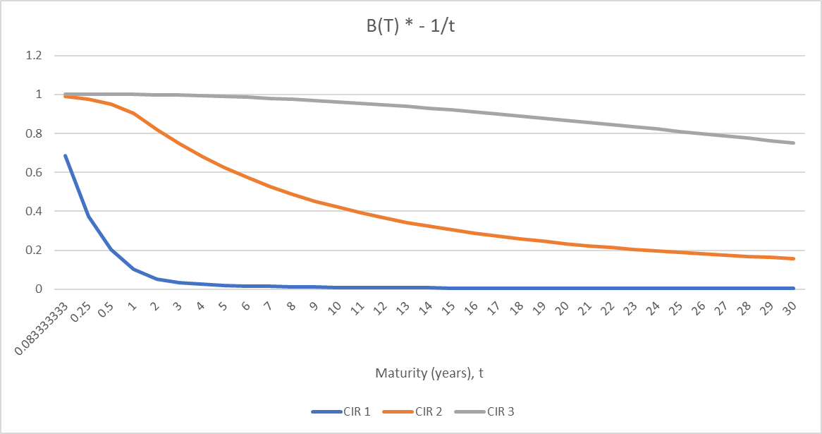

- A shock to CIR factor 3 (the factor roughly associated with level) creates an almost parallel shift to the yield curve. The impact is nearly 100% correlated at shorter maturities, but it wears off a little bit at longer maturities. For the 20 Year maturity, the impact of the shock is about 87% correlated with the change in the resulting 20 Year rate.
- A shock to CIR factor 2 (the factor roughly associated with slope) creates a large shift to the short end of the curve, but the impact decreases with increasing maturities. For the 20 Year maturity, the impact of the shock is only about 23% correlated with the change in the resulting 20 Year rate.
- A shock to CIR factor 3 (the factor roughly associated with “hump” shape) greatly impacts the short end of the curve, but has minimal impact on longer maturities such as the 20 Year rate.

Note that by contrast, the prescribed interest rate shocks for the 20 Year rate in the AIRG model are, by definition, 100% correlated with the impact to the 20 Year rate.

Based on the above analysis, the following is one proposal for prescribed shocks that could potentially be applied to the 3-factor CIR model to produce a similar pattern of projected rates as the SERT scenarios out of the AIRG:

- CIR factor 3 (level) shocks equal to what is currently prescribed for the 20 Year rate in the AIRG. This produces most, but not quite all, of the movement desired for the 20 Year rate.
  - Note: The definition of these vectors of shocks varies by SERT scenario and can be found in the AIRG model.
- CIR factor 2 (slope) shocks that follow the same pattern but are smaller in magnitude than the factor 3 shocks. For each period, the CIR3 shocks for that period are scaled down by a factor of (SQRT(2) – 1) ≈ 0.414. Using CIR2 in this way has a couple of advantages:
  - It adds a little extra impact to the 20 Year rate, making up for the less than 100% correlation from the CIR3 shock.
  - It adds extra impact to the short end of the curve. This is a desirable property, because it tends to produce flatter (potentially inverted) curves in higher rate environments, while producing steeper curves in lower rate environments, consistent with historical observations. It is also consistent with what is done in the original AIRG SERT methodology, where negative shocks are applied to the spread between 20 Year and 1 Year rates, with the intention of producing less steep (potentially inverted) curves when shocks are positive
  - The rationale for the SQRT(2) – 1 scaling is twofold:
    - It is approximately the right magnitude to produce the overall amount of movement that we would like to see in the 20 Year rate.
    - If you consider the shocks to CIR2 and CIR3 to be independent normally distributed random variables with mean of 0 and standard deviation of 1, then the sum of the 2 shocks should be normally distributed with mean of 0 and standard deviation of SQRT(2). So by adding the shocks to CIR3 and CIR2 as 1 + (SQRT(2) – 1) = SQRT(2), it can also be considered consistent with an assumption of independence between the 2 shocks. Note, however, that this is not strictly necessary. If you consider the prescribed shocks to be a single vector of shocks (i.e. 100% to CIR3, with appropriate scaling applied to CIR1 and CIR2 shocks), then from a probability perspective you can apply any scaling factor you want to CIR2 shocks without worrying about independence.
- CIR factor 1 (curvature/shape) shocks are left as 0, since they have minimal impact on the 20 year rate.
  - Note: This can be viewed as applying a scaling factor of 0 to the vector of CIR3 shocks.
- Note: The inverted yield curve scenario #10 needs a different approach than the other 15 scenarios. Shocking only the CIR factor 2 (slope) should produce the desired effect to the 1 Year rates, but would also introduce some movement to the 20 Year rates

The following graphs show what the resulting 20 Year and 1 Year rates look like when applying these defined shocks to the field test 1A calibration. Note that while the overall distribution of rates is very different between the AIRG and the GEMS field test 1A scenarios (due to a change in model and calibration), the pattern of the SERT scenarios and their overall relationship to each other and to the targeted percentiles match well, when compared to the graphs shown previously for the AIRG.
- The dotted lines represent the field test SERT scenarios (scenario set 1A)
- The solid lines represent the SERT scenarios under this proposed shock methodology
