Modifications - Scaling
The basic step for GEMS’ simulation is one week. As a result, there are 4 independent samples per month, whereas the AIRG only has one. Therefore, if we simply apply the AIRG SERT scenario shocks, we will produce too much variability. For example, in SERT #1, we want the first month to be 1.28 standard deviation above expected. If we treat each weeks’ draw as unit normal (i.e. N(0, 1)), then the first month’s distribution would be N(0, 2) since the 4 weeks are independent. So, we want to see a value of 2.56 in this situation. However, if we simply use the 1.28 from the AIRG, the sum will actually be 5.12 = 4 * 1.28 or twice as large. To adjust for this, Conning halved the adjustments from the AIRG. This adjusted factor was applied to State #3. State #2 was adjusted by (SQRT(2) – 1) times this amount, as suggested in the proposal.

Modifications – SERT #10
For the Inverted scenario (i.e. SERT #10), we needed to extend the spirit of the proposed approach since GEMS does not directly model the 1-Year to 20-Year spread, which is what this scenario adjusts. To that end, we looked at the state variables’ impact on the 1- and 20-Year Spot Rates:
State | 1-Year | 20-Year | Difference
#1 | 0.1024 | 0.0051 | 0.0973
#2 | 0.9049 | 0.2347 | 0.6701
#3 | 0.9996 | 0.8678 | 0.1318
Table 1: Impact by State variable on the 1- and 20-Year Spot Rates for the proposed Treasury Parameters

The idea is to increase State #2 to invert the curve, but then offset that with a downward adjustment to State #3 to offset the movement of the 20-Year Yield. The straight math would suggest that the movement of State #3 should be roughly -27% (i.e. – 0.2347 / 0.8678) of the State #2 movement. However, this would only reset the 20-Year Spot Rate, but we’re interested in keeping the 20-Year Par Yield relatively fixed. Since that Yield is impacted by movements in all the Spot Rates at or below the 20-Year point, Conning increased this fraction to -1/3 based on the impact seen in the difference seen in the other SERT scenarios between the 20-Year Par Yield and Spot Rate. The resulting impact on the 1- and 20-Year Yields is shown in the charts below.
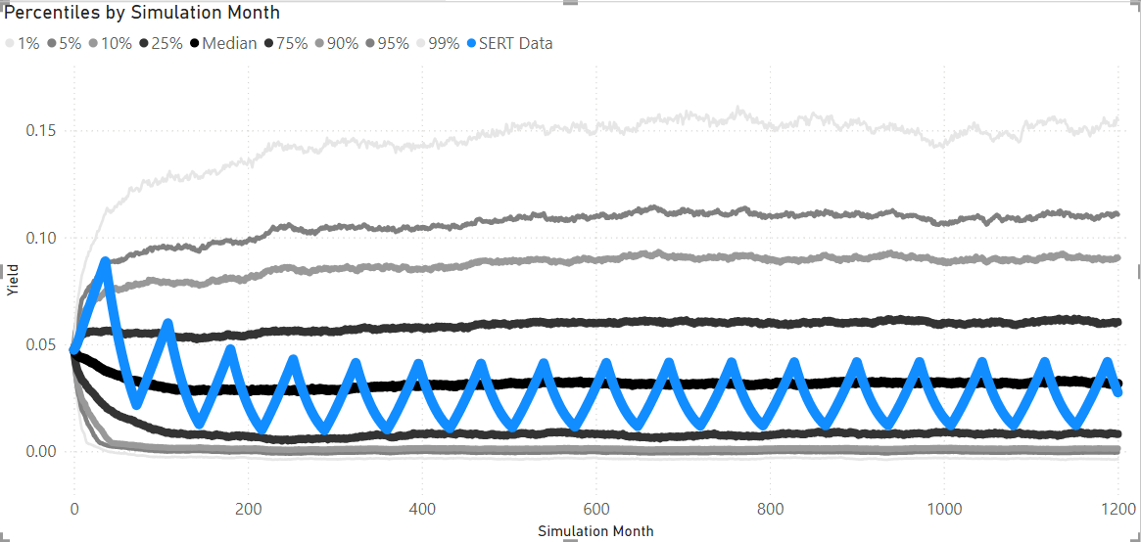
Figure 1: Projected SERT #9 for the 1-Year Par Yield

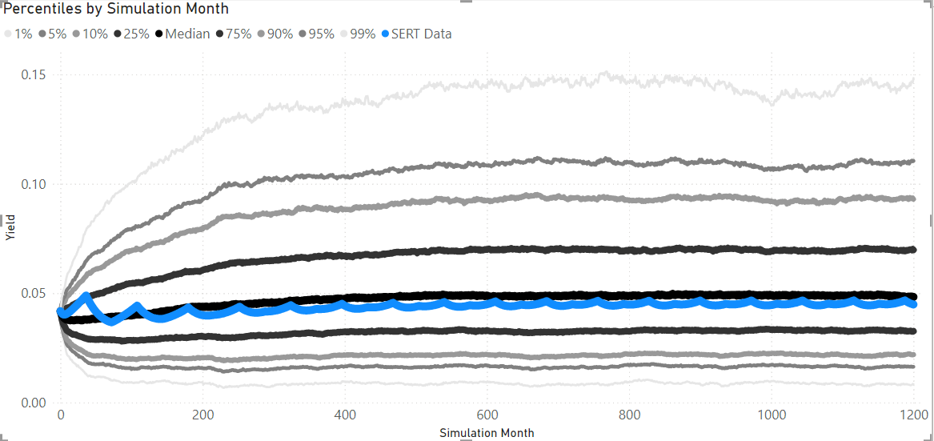
Figure 2: Projected SERT #9 for the 20-Year Par Yield
It’ s possible a further increase could smooth the results our further, but this seemed like a reasonable spot for the Field Test.

There were two final adjustments to the values for the State #2 adjustment. First, the AIRG models the spread as the 20-Year minus the 1-Year. So, its adjustments are negative when we are looking to increase the inversion. In GEMS, the impact by state decreases with Tenor. This means that we need to increase the 2nd State variable in order to increase the inversion. Therefore, the factors in GEMS have their sign reversed from the AIRG. Second, in the AIRG, the shock applies directly to the targeted item (i.e. the slope). As a result, a factor of 40% will result in the spread going to, roughly, 2/3 of a standard deviation above expected. With GEMS, the spread movement is a combination of the movements in all 3 state variables. In addition, we are approximating that movement with a fixed combination of just two of them. Therefore, there is likely to be a difference in how extreme the resulting inversions are relative to the full simulation. To adjust for this, Conning compared the implied SERT’s inversion amount to the distribution from the full 10k simulation. Based on where the AIRG’s target is (i.e. 2 standard deviations after 24 months), Conning selected an adjustment factor of roughly 92% to scale back the observed volatility.

