ESG Exposure 1/21/21: VM-20 Stochastic Exclusion Ratio Test (SERT) Scenarios

A methodology to produce the SERT scenarios (ESG Timeline Item #11) is being exposed for a public comment period. Please send comments to Reggie Mazyck (RMazyck@naic.org) by close of business March 7th, 2021.

Background
A tool must be developed to produce the prescribed set of 16 scenarios to be used for the VM-20 Stochastic Exclusion Ratio Test (SERT).

Methodology
The methodology used to produce the SERT scenarios is intended to follow the current AAA methodology (add link) except where the AAA methodology appears to differ from the scenario descriptions provided in VM-20 Appendix 1.E. For scenarios 13 through 16, the equity scenarios are described as “maintain the cumulative equity return at the 90% (or 10%) level”. The new SERT methodology follows this description. However, the equity returns for scenarios 13-16 produced in the AAA ESG have a delayed pop-up or pop-down.

The recommendation is to convert the Academy’s methodology into target percentiles for the three key variables: 1-Year and 20-Year Treasury Yields and Large Cap Total Return. Note that for scenario 10, the target percentiles are applied to the spread between the short and long rates. See the “Percentile Selection.xlsx” document below to find graphs and formulae describing how the Academy’s SERT methodology will be converted.

Going forward, Conning will take these percentiles and apply them to each projection’s 10,000 scenarios in order to produce 16 paths for these variables. For the additional Treasury Yields, Conning will apply the existing interpolation methodology. For the additional native GEMS equity models (i.e. Mid Cap, Small Cap and Aggressive US Equity), Conning will apply the percentiles from the Large Cap selection. These values will be entered into GEMS using the native User Path technology. This will allow GEMS to calculate all of the other items in both the Basic and Robust datasets conditional on these values. For example, the returns on the Long Inv Corp Bonds will include the following:
- Changes in Treasury Yields
- Expected changes in Corporate Spreads due to Treasury and Large Cap movements
- Expected transitions, defaults and recoveries due to current spread levels
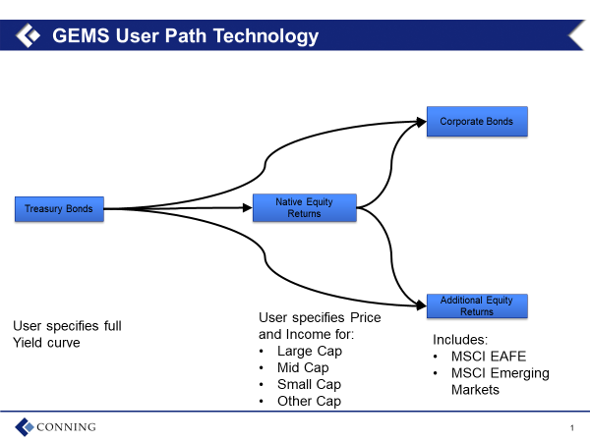

12/31/2019 SERT Scenarios
SERT Scenarios produced as of 12/31/2019 will be provided shortly via a link from the PBR section on the NAIC’s website to the ESG landing page on Conning’s website. These SERT scenarios will be produced to align with the calibration used in the December 18th, 2020 exposure of 10,000 scenarios.

Request for Comments
Please send your comments to Reggie Mazyck (RMazyck@naic.org) by close of business March 7th, 2021. Comments that provide feedback on the methodology used, the output produced, the process to access the output, the format of the output files, or any other aspect of the exposure are welcome.

