October 28, 2020

Mr. Mike Boerner
Chair, NAIC Life Actuarial Task Force (LATF)

Re: APF 2020-09

Dear Mr. Boerner:

Talcott Resolution would like to thank you for considering modification of the VM-20 exemption requirements.

In 2013 Talcott stopped writing new individual life business and ceded virtually all its individual life business to a third party. A small block of business was retained, and the company expects to see some conversions from this block as it runs off. Talcott does not meet the current VM-20 exemption requirements due to the gross premium limits (vs net premiums).

From 2013 through 2019 there were no conversions from the retained block. As for 2020 to date, Talcott has one conversion. An exemption for conversion policies would allow the company to avoid the time needed complying with VM-20, VM-31, and VM-G and spend more time on other (material) business segments.

Talcott supports APF 2020-09 and recommends that it be adopted.

Sincerely,

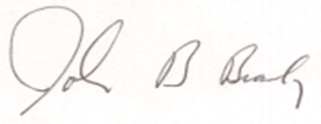

John Brady, FSA, MAAA
Chief Actuary
john.brady@talcottresolution.com
806.791.0522

Cc: Reggie Mazyck

