Recommended Revisions to VM-22 Exposure Draft

Section 3: Reserve Methodology
...
D. The Stochastic Reserve
...
[Insert new paragraph 4 as follows, and renumber existing paragraphs 4 and 5]
4. Do not aggregate Payout Annuities with Account Value Based Annuities.

Section 12: Allocation of Aggregate Reserves to the Contract Level
Section 3.F states that the aggregate reserve shall be allocated to the contracts falling within the scope of these requirements. That allocation should be done for both the pre- and post-reinsurance ceded reserves. Contracts that have passed the stochastic exclusion test as defined in Section 7.B will not be included in the allocation of the aggregate reserve; however, contracts for which the Deterministic Certification Option is elected in Section 7.E are subject to the allocation methodology described in this Section 12. For the purpose of this section, if a contract does not have a cash surrender value, then the cash surrender value is assumed to be zero.
Contracts for which the Deterministic Certification Option is elected in Section 7.E are intended to use the methodology described in this section to allocate aggregate reserves in excess of the cash surrender value to individual contracts.
Under the allocation methodology described in this section, the reserve held for any contract will be no less than the cash surrender value provided under that contract, after consideration of any reinsurance. Additionally, the reserve held for a Payout Annuity contract (whether life-contingent or not) will be no less than the present value of the liability cash flows provided under the contract, after consideration of any reinsurance, discounted using the NAER described in Section 12.B.1 or 12.B.2, as applicable. The allocation methodology is a formulaic approach that is designed, generally, to allocate the excess aggregate reserves based on a measure of the risk and, therefore, to generally allocate a greater portion of the excess aggregate reserves to contracts that have greater risk. For example, an indexed annuity contract with a high benefit GLWB will typically have a larger allocated excess reserve than an otherwise identical indexed annuity contract with a low benefit GLWB or no GLWB.

A. The contract-level reserve for each contract shall be the sum of the following:
A.1. The contract’s cash surrender value minimum allocation value (MAV), as defined in Section 12.C.
2. The contract’s allocated excess reserve (AER), as defined in Section 12.D.

[Delete the original Drafting Note describing the two potential options in the exposure draft, and delete the entire section with the heading “Option 1: VM-21 Approach,” including Table 12.1. Also delete the heading “Option 2: Actuarial Present Value Approach.” The following text is a marked-up version of the “Option 2: Actuarial Present Value Approach” section of the exposure draft.]

B. Scenario actuarial present value (APV)The excess of the aggregate reserve over the aggregate cash surrender value is allocated to policies based on a calculation of the actuarial present value of projected liability cash flows in excess of the cash surrender value:
1. For a group of contracts for which a company does not elect the Deterministic Certification Option in Section 7.E, the Scenario APV for each contract is equal to the discounted Discount the liability cash flows at the NAER, pursuant to requirements in Section 4, for the scenario that produces the aggregate scenario reserve for the group that is closest to, but not less greater than, the stochastic reserve defined in Section 3.D.
a.2. For a group of contracts for which a company elects Groups of contracts that elect the Deterministic Certification Option defined in Section 7.E, the Scenario APV for each contract is equal to the discounted liability cash flows at shall use the NAER in the single scenario used to calculate the reserve to discount liability cash flows.
3. [reordered] For projecting future liability cash flows under either Section 12.B.1 or 12.B.2, as applicable, assume the same liability assumptions that were used to calculate the stochastic reserve defined in Section 3.D.
C. Minimum allocation value (MAV)
1. For Payout Annuity contracts, the MAV is equal to the greater of:
a. The Scenario APV for the contract, or
b. The cash surrender value provided under the contract, if any.
2. For Account Value Based Annuity contracts, the MAV is equal to the cash surrender value provided under the contract, if any, otherwise zero.
D. Allocated excess reserve (AER)
1. For each contract in a group of contracts, the AER is determined by allocating the excess, if any, of the group’s aggregate reserve over the group’s aggregate MAV to the contract in proportion to the excess of the Scenario APV over the MAV for such contract.
2. [reordered] If the Scenario APV for any contract actuarial present value is less than the cash surrender value MAV, then the excess Scenario APV actuarial present value to be used for allocating the excess aggregate reserve to that contract over the cash value shall be floored at zero.
a.3. If all contracts in the group have an excess Scenario APV actuarial present value that is floored at zero, then use the MAV cash surrender value to allocate any excess aggregate reserve over the aggregate MAV cash surrender value.
4. If a group’s aggregate reserve is less than the group’s aggregate MAV, that difference should be allocated to life contingent contracts in proportion to each life contingent contract’s MAV to the sum of the life contingent contracts MAV.

E. As a hypothetical example, consider a company with the results of the following five eight contracts in two groups:

Table 12.1.A: Hypothetical Sample Allocation of Aggregate Reserve: Group A, Account Value Based Annuity Contracts
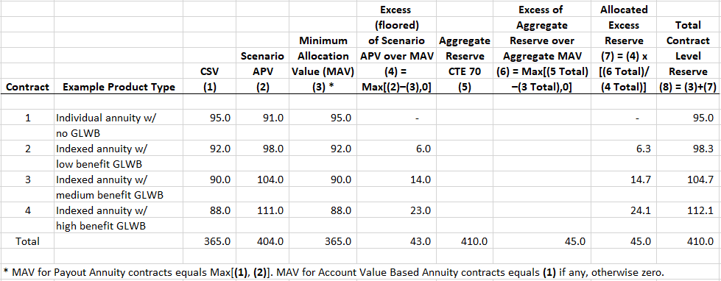

Table 12.1.B: Hypothetical Sample Allocation of Aggregate Reserve: Group B, Payout Annuity Contracts that do not have Cash Surrender Values
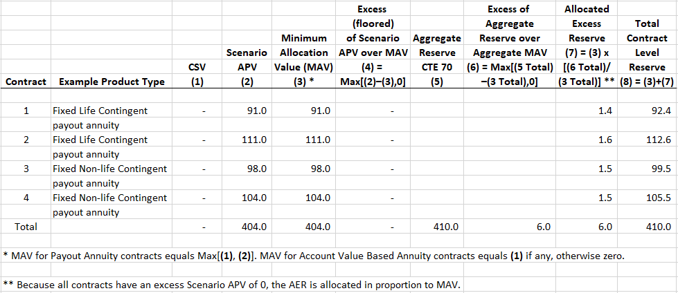

Guidance Note: The Scenario actuarial present value (APV) in the section above is separate from the Guarantee Actuarial Present Value (GAPV) referred to in the additional standard projection amount calculation in VM-21. The GAPV is only applicable to guaranteed minimum benefits and uses prescribed liability assumptions. In contrast, the Scenario APV in this section applies to the entire contract, irrespective of whether guaranteed benefits are attached, and uses company prudent estimate liability assumptions.

