Ronald J. Blitenthal
Senior Vice President,
Chief Regulatory Counsel

Direct line: 612-371-3812
Facsimile: 612-371-3892
Toll free: 800-328-4441, ext. 3812
rblitenthal@oldrepublictitle.com

BY EMAIL
June 23, 2026

Mr. Greg Welker
Ms. Rachel Chester
NAIC Adjuster Licensing Working Group

Re: Draft Independent Adjuster Licensing Guidelines (GL 1224)

Dear Mr. Welker and Ms. Chester:

Thank you for the opportunity to comment on the Independent Adjuster Licensing Guideline changes being considered by the Adjuster Licensing (D) Working Group. I apologize that this comment is late and hope you can still consider it. With regard to the definition of “Staff (Company) Adjuster,” I assume that the Working Group intended to use that phrase somewhere within the Guideline. It would seem appropriate to include that phrase within Section 4 (Exception to License Requirement). The amendment could be as simple as adding a Subsection N in Section 4 that reads: “A ‘Staff (Company) Adjuster.’”

We appreciate your consideration. Please let me know if you have any questions.

Very truly yours,
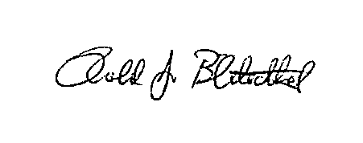
Ronald J. Blitenthal

