Using Your Health Plan

Important Information

You have a health plan. Great news – now you’re insured! But what’s next? You’ll use your plan to access health care.
How much your plan will pay or what services it will cover depends on the plan’s details. This tool will help you know what the details of your health plan mean. It will help you to better understand your plan. With this information, you can make better decisions about your health care.
The examples in this tool are general. They aren’t specific to your health plan.
There are different types of health plans. This tool doesn’t include details about how to use Medicaid [States can customize to identify state Medicaid plan by name], Medicare, or other types of health plans like supplemental policies. See the Health Plan Resources Section to get information and help with Medicaid, Medicare, and other types of health plans.
See the Glossary for definitions for some of the terms used in this tool.

A special thanks to the Maine Health Access Foundation (www.mehaf.org)
for information and graphics derived from its original brochure, I Have Health Insurance! Now What?

Using Your Health Plan

Here are a few important things you need to remember:
- Always carry your insurance card with you. It has basic information about your health plan. It tells your doctor and other health care providers who the plan covers. Show it when you check in at your doctor’s office or go to the pharmacy.

→Your Insurance Card Page 6

Understand how your health plan works. The best way to avoid surprise health care bills is to understand your plan and what your costs will be ahead of time.

→Get to Know Your Health Plan Page 5

→Summary of Benefits and Coverage (SBC) Page 7

→Schedule of Benefits/Outline of Coverage Page 8

→Get the Most Out of Your Health Plan Page 16
- Manage your care and out-of-pocket costs. Pick a Primary Care Provider in your plan’s network. This can be a doctor, nurse, or physician assistant.

→Cost-Sharing: How You and Your Health Plan Share Costs Page 9
- Manage your prescription drugs.

→Your Prescription Medicines Page 15

Know what to do in an urgent or emergency medical situation.

→What to Do in an Emergency Page 17

Plan ahead. Know what you need to do if you have a planned health procedure or a surgery. Check to make sure the facility (for example, a hospital or lab) and all health care providers are in your plan’s network. If they aren’t, you’ll have to pay more of the costs yourself. If you’re going to have a major health care service, like a surgery or procedure, you should call your insurer to ask if you need their approval before you use the health care service.

→Choose a Primary Care Provider in Your Network Page 11

→Avoid Balance Billing Page 12

→Referrals and Prior Authorizations Page 18
- Understand the key points of your health plan, your health, and your health care.

→Different Kinds of Health Plans Page 13

→Job-Based Health Plans Page 14

→If You Have More Than One Health Plan:

Coordination of Benefits Page 19

→How to File a Claim Page 22

→Health Plan Resources Page 23

→Glossary of Terms Page 24
- Update your plan if something in your life changes. Life is unpredictable. If you get married, divorced, or have a baby or adopt a child, your health plan needs to change. If you’re turning 65, find out when you need to sign up for Medicare and when you need to cancel your health plan. Call your insurer and let them know if something in your life changes.

→Life Changes – Your Health Plan Should Too Page 20

Get to Know Your Health Plan
Not every health plan is the same. Maybe you can’t remember the details about your plan – what it covers, what it doesn’t, or what your out-of-pocket costs may be.
Don’t worry. You can get that information when you need it. Here is where you can find information about your plan and get help to understand your benefits.
Check your insurance card. Your insurance card has some of the most important information you need about your health plan. It tells providers basic information about your plan and who’s covered. Most insurance cards list toll-free phone numbers and website information where you can access the most current information for your plan. Be sure you check the back of the card for important information.
You also may find other important telephone numbers on your insurance card. For example, there may be a number you can call if your plan offers advice from a nurse or telehealth services.
Check your health plan’s website. Most health insurers have websites you can use to access the most up-to-date information about your plan. You can learn what your plan covers, what doctors and facilities (for example, hospitals and labs) are in your plan’s network, what prescription drugs the plan covers, what claims the plan has paid, and how much of your deductible you still need to meet. You usually need to register or create an account to log in to get information specific to your health plan.
Check the SBC. Ask your insurance company or employer for a Summary of Benefits and Coverage (called an “SBC”). This is a short list of your benefits and deductibles, co-pays, and coinsurance amounts (called cost-sharing).
Check the policy or certificate. Be sure you have a copy of your policy and review it for more information about your benefits. If you get your health insurance through work, look for your plan certificate.
Your plan information should include a document called a “Schedule of Benefits” or an “Outline of Coverage.” Both have more information about your costs and benefits. They’ll also tell you what services the plan doesn’t cover (called “exclusions”).
Call the insurer. If after looking at your plan documents you still have questions about your plan, call your health insurer.
Other Resources. If you bought your plan outside of work, ask your health insurance agent for help. If your health plan is through work, ask your HR Department to explain things.
The next few pages will help you find more information about your health plan.

Your Insurance Card
Some of the most important information you need to use your health plan is on your insurance card. You’ll need the information on your card if you talk on the phone about your plan or look for information on your insurer’s website.
Your insurance card tells health providers basic information about your plan and who it covers. You’ll need to show your insurance card any time you receive a health care service or talk to a health care provider (a doctor, for example) in person. If you’re covered under more than one health plan (you have coverage through work, but you’re also covered under your spouse’s health plan), you need to bring both insurance cards with you.
When you get your insurance card, check the information on the front of the card. Does the information match what you bought? Is the plan type correct? Is the network name what you expected? Are the cost-sharing amounts correct? If there is a Primary Care Provider (PCP) listed on your insurance card, is it correct?
If any of this information is wrong, call your health insurer right away.
Make sure you also check the information on the back of the card. This is where you will find other helpful information – like phone numbers to call your insurer if you have questions.
Health plans usually give you one or two insurance cards. If you don’t get a card, call your insurer. You also may be able to print a paper copy of your card from your health insurer’s website.
Keep the card with you at all times. Protect your insurance card like you would other sensitive personal and financial information.

Sample Insurance Card
Insurance Company Name
Plan Type: Titanium PPO Plan Effective Date: 01/01/2020
Member Name: Jane Doe Member Number: XXX-XX-XXX
Group Number: XXXXX-XX
Prescription Group # XXXX
Prescription Co-Pay
$15.00 Generic
$20.00 Name Brand
PCP Co-Pay $15.00
Specialist Co-Pay $25.00 Emergency Room Co-Pay $75.00
Member Service: 800-XXX-XXXX
BACK
FRONT
www.myplan.com

Member Service: 800-XXX-XXXX
Nurse Advice Line 24/7: 866-XXX-XXXX
Telehealth Services: 888-XXX-XXXX

Send claims to:

My Plan, Inc
P.O. Box XXXX
City, State XXXXX

Summary of Benefits and Coverage (SBC)
Information on your insurance card about your plan and your cost-sharing can help you figure out what your out-of-pocket costs will be. You also can find more information to help you on the Summary of Benefits & Coverage or SBC. For example, you’ll find information about deductibles on the SBC. The SBC also tells you the types of services your health plan covers and what co-pays or coinsurance you’ll pay. Below is what the front page of an SBC looks like.
A Summary of Benefits & Coverage is usually available when you shop for a health plan on your own or through work, or when you renew or change your plan. If you can’t find an SBC for your plan, ask the insurer, your agent, or your employer for one. Just remember, short-term health plans aren’t required to give you an SBC. (A short-term plan is one that only covers you for 12 months or less and doesn’t have to follow the rules in the Affordable Care Act.)
You can find a sample of an SBC at https://www.healthcare.gov/health-care-law-protections/summary-of-benefits-and-coverage/.
Below is a picture of the first page of an SBC to give you an idea of what an SBC looks like and the kind of information it gives. If you have questions about what the underlined words mean, remember to check the Glossary at the end of this tool.
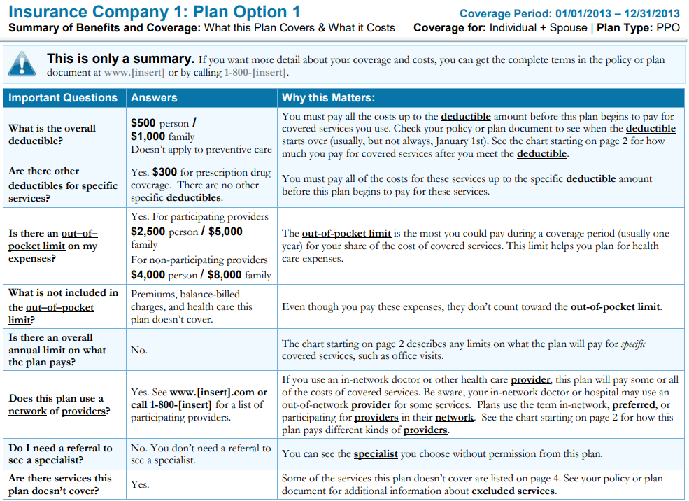

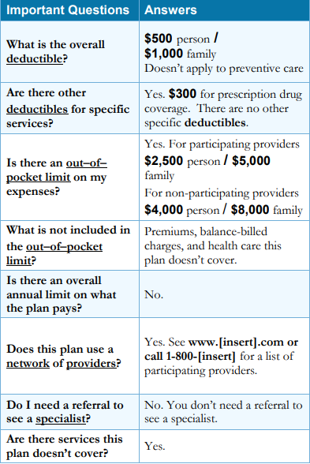

Schedule of Benefits/Outline of Coverage
You can get a list of the services your health plan covers, along with which costs you’ll have to pay. You’ll find this list in the Schedule of Benefits (if your plan is through work) or in the Outline of Coverage (if you bought your plan outside of work). Both list the various services a health plan covers, along with what costs you’ll have to pay. This document also shows which services the plan covers and doesn’t cover.
Many health insurers send a printed copy of your Schedule of Benefits (Schedule) or Outline of Coverage (Outline) when you first enroll in a plan. It’s usually with your insurance policy or certificate. You also may have access to an electronic copy in your member portal on the plan’s website. This list will help you get an idea of how much you’ll pay for services. Keep this document with your insurance papers.
“Benefits” is the term health plans use for health care services the plan covers. The Schedule (or Outline) lists the various categories of benefits your plan covers, such as preventive, hospital, medical, surgical, diagnostic, therapeutic, urgent care, and prescription drug services. For example, under preventive services, the schedule may list "Adult physical examination (1 exam per calendar year)."
A Schedule or Outline is usually broken into several sections:
The heading gives the basic information about your health plan. It explains what type of health plan you have (HMO, POS, EPO, PPO, or FFS/Indemnity), who the plan is through, the benefit year, and your plan’s start date. If you get your health plan through work, this start date will be for the company, not just you. You can learn more about the different plan types on page 12.
The responsibilities section tells you the deductible, co-payments, and coinsurance and what the annual out-of-pocket maximums are. You can learn more about the different types of cost-sharing on page 9.
The health benefits section lists the specific covered benefits. This section also often has information about your cost-sharing.
The pharmacy benefits section identifies the prescription drug benefits in your health plan and the co-payment. You can learn more about how to use your pharmacy benefits on page 13.
The network(s) section tells you the provider network(s) your health plan has contracts with. When you use providers in the network (sometimes called preferred providers), your costs will be lower than if you use providers outside the network.
The dependent benefits section lists which dependents your plan covers and for how long.

Cost-Sharing: How You and Your Health Plan Share Costs
Jot down information about your health plan and cost-sharing below. Use your insurance policy or certificate, your insurance card, your Schedule of Benefits/Outline of Coverage, and/or your SBC to find the information.
Then read the next few pages to understand what the different terms mean and how your costs are calculated.
Deductible: The amount of money you must spend each year on your health care before your plan starts to pay. If family members are covered under your health plan, there will be two deductibles. Once you’ve met the family deductible, you’ve also met the individual deductible. Your plan may pay for some preventive services, like an annual physical, even if you haven’t met your deductible. You may have a separate deductible for prescription drugs.

Your Deductible (Individual): Your Deductible (Family) ______

Prescription Drug (Rx) Deductible:

[ ] included in the deductible above

[ ] Not included in the deductible above

Your Rx Deductible (Individual): ______ Rx Deductible (Family): __________
Co-Pay: A fixed fee you pay directly to the provider when you get health care (for example, $40 for every primary care visit).

Your Co-Pays:
In-network Primary Care:_________________ Out-of-network Primary Care:_____________
In-network Specialist: __ Out-of-network Specialist:________________
In-network Emergency Department:________ Out-of-network Emergency Department:____
In-network Urgent Care:__________________ Out-of-network Urgent Care______________
Prescription: __
Coinsurance: A percentage you pay for most health care even after you meet your deductible. For example, if your coinsurance is 20%, then the insurance company pays 80% of the covered amount and you pay 20% until you reach your out-of-pocket maximum.

Your Coinsurance:

In-network:______________________ Out-of-network:________________________
Out-of-Pocket Maximum: The most you pay during a plan period before your health plan pays all of the costs for covered services. This maximum doesn’t include your monthly premium.

My Out-of-Pocket Maximum: _________ Family Out-of-Pocket Maximum:_______

Monthly Premium: A fixed amount that you pay each month or with each paycheck for your health plan. If you miss payments or pay late, the insurer could cancel your plan.

Your Monthly Premium:

How You and Your Health Plan Share Costs—Example
Jane’s Plan Deductible: $1,500 | Co-Pay: $0 | Coinsurance: 20% | Out-of-Pocket Maximum: $5,000
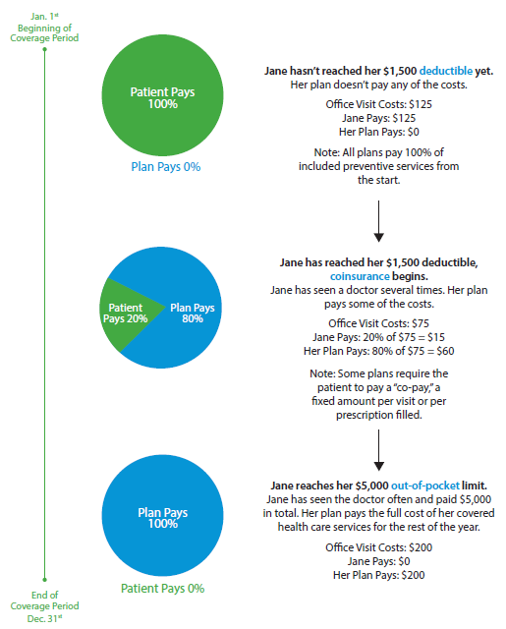

Choose a Primary Care Provider in Your Network
Your insurance company may assign you to a Primary Care Provider. Usually you can change providers if you don’t like the one the plan assigns you. Contact your insurance company to find out how.
For most people, it makes sense to pick a Primary Care Provider from your health plan’s network. You’ll pay the least money out-of-pocket if you use providers in your plan’s network. That’s because the plan has negotiated contracts with the providers.
If you use a provider outside of your health plan’s network when it’s not an emergency, you’ll pay more. And, some plans don’t pay anything for care from non-network providers unless you see them in an emergency.
Your Primary Care Provider is your first stop for health care. It’s where you call or visit each time you need care. They help you get services from any specialists or other health professionals that you need.

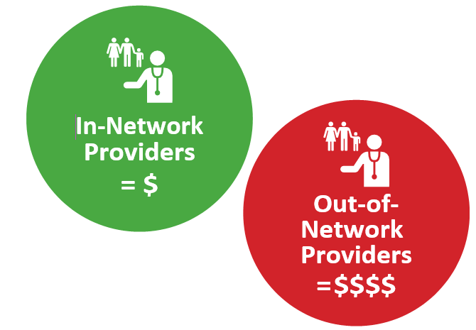

How to Choose a Provider in Your Network
To find the names of providers near you who are in your health plan’s network, first you need to know the name of the network. You’ll find the name in your insurance policy or certificate or on your insurance card. Then, go on your insurer’s website and look for the directory of network providers. Or, you can call your insurer. The phone number is on your insurance card. If your health plan is through work, your employer may have a provider directory.
After you find a provider you want to use, call their office and ask:
1. Are you in my plan’s network?
2. Are you accepting new patients?
If you need help, call your insurance company. The number is on your insurance card.
If you need specialized health care, check whether your local hospitals or specialists are part of your plan’s network.

Avoid Balance Billing
Balance bills happen when a provider who isn’t in your health plan’s network charges more than your plan pays, and the provider bills you for the difference. In-network providers have agreed to accept the plan’s payment as full payment and will not send you a balance bill. So, you can avoid the extra cost of balance bills if you choose providers in your health plan’s network.
Sometimes you may not be able to choose a provider who is in your plan’s network. You may need emergency treatment, or you may see an out-of-network provider at an in-network hospital. Or, you may need care from a specialist and there aren’t any in your network. In these cases, your state may have laws to protect you from balance billing. Contact your state insurance department to find out more.

Different Kinds of Health Plans
My plan is: a PPO an HMO an EPO a FFS a POS I don’t know
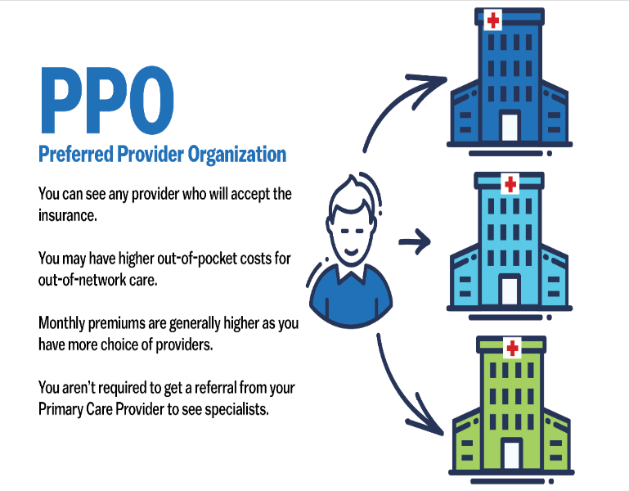
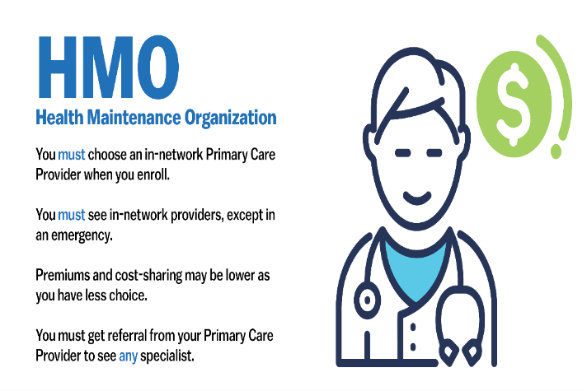

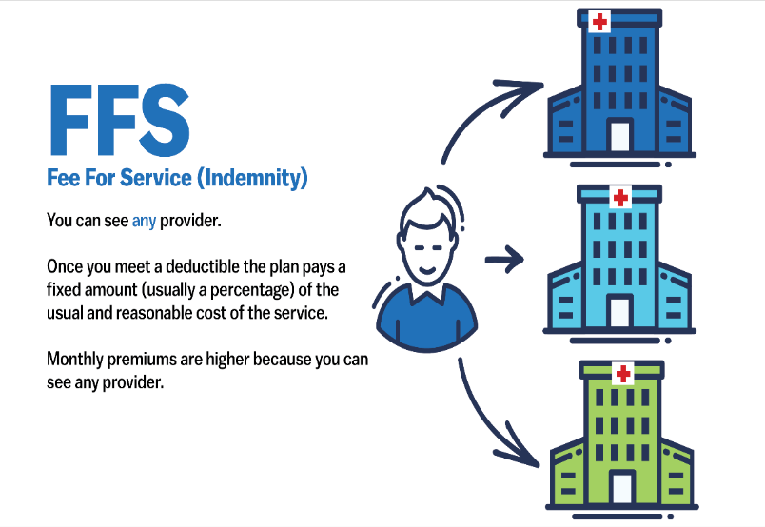
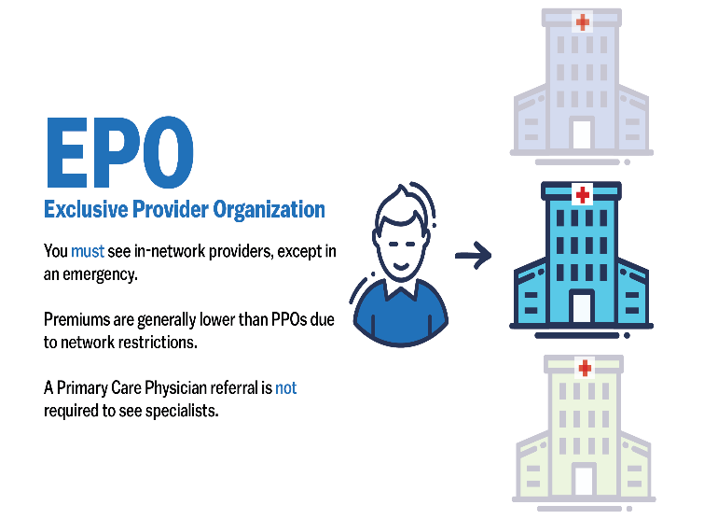
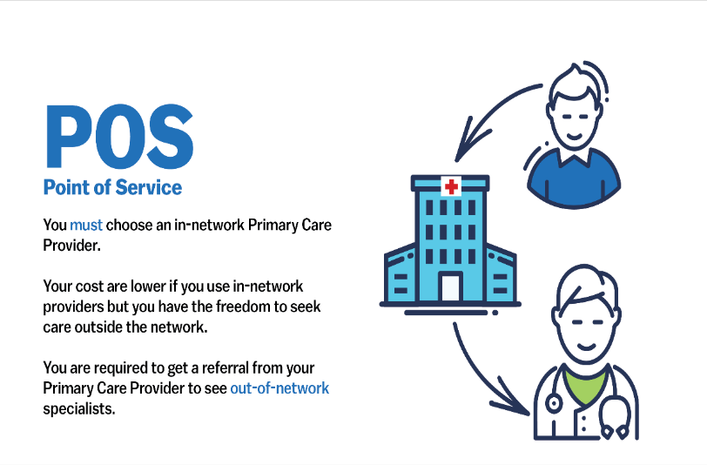

See page 11 to learn more about in-network and out-of-network providers.

Job-Based Health Plans

Your health plan may be through your job or a family member’s job. If the employer pays the costs of the health care services these plans cover, the plan is called self-funded health plans. Many large employers, unions, government agencies, and school districts have self-funded health plans.

Self-funded health plans usually use a third-party administrator (TPA) to review and pay claims for the plan. Sometimes, that TPA shares a brand name with a health insurance company. But the employer still is responsible to provide the money to pay claims – not the insurance company. If a unit of government is the employer, then the government is responsible to provide the money to pay claims.

The U.S. Department of Labor’s Employee Benefits Security Administration (DOL-EBSA) regulates self-funded health plans. State insurance laws generally don’t apply to self-funded plans.

Some employer-based plans are fully insured. Unlike self-funded plans, in a fully-insured plan, an insurance company is responsible for covered health care costs. The insurer charges your employer a premium to take on that financial responsibility.

State insurance departments regulate fully-insured health plans. These plans must follow state insurance laws. State insurance departments can help consumers who have fully-insured plans.

Your Prescription Medicines
Health plans help pay the cost of covered prescription medicines. Insurers use a “formulary” that determines how much of the cost you’ll pay. You can find a link to your plan’s formulary in the Summary of Benefits Coverage in the “Common Medical Events” section in the row labeled “if you need drugs to treat your illness or condition.” A formulary usually has different tiers. Prescription medicines listed in one tier may cost you more than those in another tier.
Always show your pharmacy your health insurance card. Prescriptions that you pay for will count toward your annual out-of-pocket maximum.
To find out which prescriptions your plan covers:
- Visit your insurance company website to find your online health plan formulary.
- Check your insurance policy or certificate to learn more about your formulary.
- If you need help, call your insurance company directly to find out what’s covered.

Example: Categories of prescription drugs in a tiered formulary:
$ Tier 1—Generic drugs. These are lower-cost drugs.
$$ Tier 2—Preferred, brand-name drugs. These drugs cost more because they’re unique, and just one drug company makes them.
$$$ Tier 3—Non-preferred, brand-name drugs. These are also brand-name drugs. But they may cost you more than other brand name drugs that treat the same condition.
$$$$ Tier 4—Some plans use this tier for specialty drugs. Other plans have a separate “specialty” tier. These are high-cost drugs that treat rare or complex diseases.
It’s a good idea to talk with your providers about the best affordable medications for you, based on your plan.
If the pharmacy says that your plan doesn’t cover a prescription drug you’ve been taking, some insurance companies may let you refill the prescription once. That will give you time to talk with your provider about other options.
You also can ask your provider to ask your health plan for an exception. With an exception, you can get a prescription medicine that your plan doesn’t normally cover. Your health insurer might agree because:
- All other drugs the plan covers haven’t worked or won’t work as well as the drug the provider prescribed, or
- All other drugs the plan covers have caused or could cause harmful side effects.

Get the Most Out of Your Health Plan
You can use your health plan to get preventive care to stay healthy. Schedule needed appointments for you and your family. Avoid emergency department visits when you can – it’ll save you money. And, your plan may cover other services that can help you stay healthy. Some services that can help you get the most from your health plan include:
- Care for new mothers and babies
- Annual physicals
- Well-baby visits
- Scheduled preventive screenings such as mammograms, colonoscopies, and others
- Other preventive and wellness services
- Counseling and services for substance use disorders
- Prescription medicines
- Laboratory services
- Help to manage diseases like diabetes or high blood pressure
- Services for kids (for example, vision checks)
- Vaccinations
Your plan may pay all of the costs for some of these services even before you meet your deductible. You don’t have to pay anything for some preventive services. Check with your provider and your plan to make sure your service is considered preventive.
Your plan likely covers the Essential Health Benefits. All Qualified Health Plans that you buy through the Health Insurance Marketplace [State Marketplace Brand] cover these benefits. Some grandfathered plans or employer-based plans that you buy outside the Marketplace may not.

What to Do in an Emergency
Use an emergency department (or ER) only if you have a real emergency, such as any severe pain, like chest or stomach pain, bleeding you can’t stop, or sudden weakness.
You can use urgent care facilities, sometimes called Quick Care, Express Care, or First Care, when you need to see a provider more quickly than you can see your primary provider. They almost always cost less than if you go to the emergency department. If your plan has co-pays, your co-pay for urgent care may not be much more than your co-pay for a doctor visit. Some urgent care facilities take appointments so you may not have to wait long to see a provider.
Contact your insurance company to ask which urgent care facilities near you are in-network.
If you have an emergency or life-threatening situation, call 9-1-1 or go to the nearest emergency department. In an emergency, you should go to the closest hospital. Your health plan can’t require prior authorization before you go to the emergency department or charge you more because the hospital isn’t in your plan’s network. You may still have to pay some of the costs of emergency services, depending on your plan. For instance, you may have to pay a co-pay or part of the costs if you haven’t met your deductible. And, your share of the costs may be more if the hospital wasn’t in your health plan’s network.
If you’re not sure where to go, don’t be afraid to call your Primary Care Provider.

Referrals and Prior Authorizations
Some health plans, mainly Health Maintenance Organizations (HMOs), require a referral before you get care from some providers. A referral is an order from your Primary Care Provider for you to see a specialist or get certain medical services. If you don’t get a referral first, the plan may not pay any of the costs of the services.
Other types of health plans, not just HMOs, may require prior authorization for some services. If you need a special treatment, service, or medical equipment, you may need to get approval first from your health plan. This is called prior authorization. A health plan gives prior authorization when a service is medically necessary. Without it, your health plan may not pay any of the costs. You can ask your provider if you need prior authorization. Some providers will ask the health plan for prior authorization.

If You Have More Than One Health Plan: Coordination of Benefits
If you have more than one health plan, all of your plans work together to pay their shares of your health care costs.
You need to tell your providers if you have more than one health plan. Coordination of benefits rules determine which plan is primary (pays first) and which is secondary (pays second). Talk to both health insurers. Learn what’s expected of you and how the plans will coordinate.
The primary health plan processes your insurance claim first. If there’s still a balance, then the secondary plan processes the claim for the balance. The plans won’t pay more than the total claim amount. You won’t get double the benefits if you have two health plans. And, you have to meet the deductibles and pay your share of the costs in each plan.
Even if you have more than one plan, that doesn’t mean that the plan covers every health care service. A plan only pays for covered benefits. So, for example, if you have cosmetic surgery to improve your looks, neither health plan will pay any of the costs if neither covers cosmetic surgery.
Here's an example of how coordination of benefits works: Let's say you visit your doctor, and the bill comes to $100. The primary plan pays the amount it covers. Let's say that's $50. If the secondary plan covers the doctor’s visit, it might pay up to $50 – if you’ve met your deductible and don’t have any other cost-sharing responsibilities.
A few examples of ways people may have more than one health plan are:
- You’re enrolled in your employer’s health plan, and your spouse has added you to his or her plan.
- A child is covered by both parents’ separate health plans.
- A child has her own health plan (from school or work) and stays on her parent's plan until age 26.
- A child is married and on his spouse's plan and stays on his parent's plan until age 26.
- A person is enrolled in Medicare and also has a private health plan.
- A person is enrolled in Medicaid and also has a private health plan.
- A service member or veteran has TRICARE or coverage through the Veterans Administration (VA) as well as another health plan.
When you use health care services, check that they are in-network for both health plans if you’ll use both health plans.

Life Changes – Your Health Plan Should Too
When life changes — for example, a move, a marriage, a job change — you may need to make changes in your health plan. But often there are special rules about changing your health plan.
Usually you can enroll in health plans only once a year during a set period of time called the annual open enrollment period. Many life changes qualify you to enroll in or change your plan when the change happens. You don’t have to wait for the next open enrollment period. These life changes are called qualifying events. Qualifying events apply to both employer plans and ones you buy on your own.

Changes in Your Family
A family health plan covers more than one family member. When your family changes, due to marriage, divorce, or a child’s birth or adoption, it’s time to review your health plan. You may need to add or remove family members. You also might need to change your plan when an adult child reaches age 26 and isn’t eligible to stay on your plan. You might need to change from an individual to a family plan – or from a family to an individual plan. You can call your health insurer or visit its website to learn how to add or remove family members. If your health plan is through work, check with Human Resources.
As soon as possible, tell your Insurance company when any of these happen:
- Change of address
- Marriage
- Divorce or separation
- Birth or adoption of a child
- Death of covered family member
- A child on your health plan reaches age 26
- An adult on your health plan reaches age 65

Leaving a Group Plan
If you change your job, you might need to change your health plan. If your plan was through work at your old job, you probably have to sign up for a new health plan.
If you lose your job, you may be able to keep the health plan you had through the job. But you’ll have to pay the full premium – your share and the employer’s share. Ask your employer about COBRA continuation coverage. And, if you’re 65 or older when you lose your job and haven’t yet signed up for Medicare, you should do that now to avoid premium penalties or delays in coverage. Contact your State Senior Health Insurance Assistance Program [State SHIP brand] if you have questions.
If you leave a group plan because you can no longer work due to a disability, you can apply for Social Security disability benefits. Once you’ve received these benefits for two years, you’ll be eligible for Medicare.

Check for Affordable Health Plan Options
If your individual or family income changes, it might change your eligibility for help with health plan costs. You can apply at the Marketplace [State Marketplace Brand] to find out if you’re eligible for financial help to buy a Marketplace plan. You also might be eligible for a low- or no-cost health plan through Medicaid or the Children’s Health Insurance Program (CHIP) [State Program Names].
There’s an annual open enrollment period for Marketplace plans. In this period, anyone can enroll in or change their plan. But you might be eligible to enroll or change plans through the Marketplace at other times if one of these happens:
- You lose your health plan, but you paid the premiums
- You lose coverage through Medicare, Medicaid, or Children’s Health Insurance Program
- You can’t stay on the health plan you have now because you’re no longer a dependent
- You move
- You get married
- You divorce or separate from your spouse
- You give birth to or adopt a child
- A covered family member dies
These events qualify you for a special enrollment period – a chance to enroll in or change your health plan without waiting for the next open enrollment period. But you must contact the Marketplace within 60 days of the event. If you missed the special enrollment period, you’d have to wait for the next open enrollment period. You can find out more about special enrollment periods (SEPs) at https://bit.ly/2Df4Wv7.

Medicare
If you’re turning 65 years old soon, find out when you should sign up for Medicare. You should sign up for Medicare Parts A and B if your employer has fewer than 20 employees because Medicare will be primary (pay claims first). If your employer has 20 or more employees and you do not have a Health Savings Account (HSA), then you should sign up for Medicare Part A if you qualify for free coverage. Contact your State Senior Health Insurance Assistance Program [State SHIP brand] if you have questions.
Once you stop working or lose your health plan at work, after you turn 65, you have eight months to sign up for Medicare Part B. If you miss that window, your Medicare premiums will be higher.

How to File a Claim
Most providers file insurance claims for you. That’s why they need your insurance card when you see them. The providers send a bill to your health plan with information about your condition and how they treated you. Your health plan compares your benefits with the services billed and pays your provider. This payment won’t include any amounts that are your responsibility – for example, the deductible, co-payments, or coinsurance. If the plan doesn’t cover any part of your claim or doesn’t cover the health care service, your health care provider can ask you to pay the balance. If you’ll owe coinsurance, many providers estimate the amount and ask you to pay that when you see them.
Some health care providers won’t submit claims for you. You can ask your providers if they will. If you have to submit your own claim, ask your provider to help you so you have the right dates, procedures, and codes on the claim form. Keep in mind that when you submit your own claim, most providers require you to pay the full amount upfront. Then, your health plan will reimburse you after it processes the claim.

When Your Health Plan Pays Your Claims
If your provider submits your claim, don’t pay a bill for a covered service until your health plan has reviewed the claim.
How do you know if the plan has reviewed the claim? Your health plan will send you an “Explanation of Benefits” (EOB) after you receive services. The EOB tells what services the plan paid or didn’t pay, and why.
Your health plan must explain in writing within a set amount of time why it didn’t pay for a service. If you think the plan should have paid for the service, you can appeal the decision.
Your health plan must tell you how you can appeal their decisions. If taking the time to appeal would put your life or ability to fully function at risk, you can file an “expedited” appeal to get a quicker decision.
If you need help to file an appeal, you can contact [State Insurance Agency] Consumer Assistance Program:
[(800) xxx-xxxx ]
[TTY: (xxx) xxx-xxxx | State Website]
You also can contact the [State Insurance Agency] to file a complaint and start an investigation against an insurance company. The [State Insurance Agency] encourages you to call about any problems you have when a health plan denies a claim or service that you believe should have been covered.

Health Plan Resources

The Health Insurance Marketplace [State Marketplace brand] is a resource where individuals, families, and small businesses can learn about their health plan options. You also can compare health plans based on costs, benefits, and other important features; choose a plan; and enroll in a plan.

1 (800) 318-2596 | TTY: 1 (855) 889-4325 | HealthCare.gov

Your state department of insurance regulates the insurance industry. It examines and licenses insurance companies and those who sell insurance, reviews rates and coverage forms, conducts audits, and sponsors programs that increase awareness of State laws.

Consumer Assistance Hotline:
1 (800) | website | other phone number

For seniors and others enrolled in Medicare, each state operates a State Health Insurance Assistance Program (SHIP) [State Brand]. This is a free health benefits counseling service for Medicare beneficiaries and their families or caregivers. Find your state’s SHIP at the number below or at https://www.shiptacenter.org/

State SHIP Program
Medicare beneficiaries also can contact Medicare directly at the following number:
Medicare 800-MEDICARE

Glossary of Terms

Balance Billing: When a provider, who isn’t in your plan’s network, charges more than your plan pays and bills you for the difference in addition to cost-sharing.

Benefits: The health care services a health plan covers. The plan’s documents define the benefits that it does and doesn’t cover.
Claim: A request for your health plan to pay for health care services. You or your health care provider submits to the claim.
Coinsurance: The percentage of the cost of a covered health care service you pay (20%, for example) after you've met your deductible.
Let's say your plan's allowed amount for an office visit is $100, and your coinsurance is 20%.
- If you've met your deductible: You pay 20% of $100 or $20. The insurance company pays the rest.
- If you haven't met your deductible: You pay the full allowed amount, $100.
Coordination of Benefits: A way to figure out which plan pays first when two or more health plans are responsible to pay the same claim.
Co-payments: A fixed amount ($20, for example) you pay for a covered health care service after you've met your deductible.
Let's say your health plan's allowed amount for a doctor's office visit is $100. Your co-payment for a doctor’s visit is $20.
- If you've met your deductible: You pay $20, usually at the time of the visit.
- If you haven't met your deductible: You pay $100, the full allowed amount for the visit.
Co-payments (sometimes called "co-pays") can vary within the same plan for different services, like drugs, lab tests, and visits to specialists.
Cost-Sharing: The share of costs for covered services that you pay yourself. This term generally includes deductibles, coinsurance, and co-payments. It doesn't include premiums, balance billing amounts for providers not in the network, or the cost of health care services the plan doesn’t cover.
Deductible: The amount you pay for covered health care services before your health plan starts to pay. If you have a $2,000 deductible, for example, you pay the first $2,000 of covered services in a plan year. After you’ve paid $2,000 of your own money for covered services, you usually pay only a co-payment or coinsurance for covered services for the rest of the plan year. Your plan pays the rest.
Exclusions: Health care services your health plan doesn’t cover. If you receive these services, you pay all of the costs.
Network: The facilities, providers, and suppliers your health plan has a contract with to provide health care services.
Open Enrollment Period: A time (once a year) when anyone can enroll in or change their health plan.
Out-of-Pocket Costs: Expenses for health care your health plan doesn’t pay. Out-of-pocket costs include deductibles, coinsurance, and co-payments for covered services plus all costs for services your health plan doesn’t cover.
Out-of-Pocket Maximum/Limit: The most you have to pay for covered services in a plan year. After you spend this amount on deductibles, co-payments, and coinsurance, your health plan pays all of the costs of covered services.
The out-of-pocket limit doesn't include your monthly premium. It also doesn't include anything you pay for services your plan doesn't cover.

Primary Care: Health services that include a range of prevention and wellness as well as treatments for common illnesses.
Primary Care Providers (PCP): Health care professionals (including doctors, nurses, nurse practitioners, and physician assistants) who manage your care. A PCP often maintains long-term relationships with you. She advises and treats you for a range of health-related issues. A PCP also may coordinate your care with specialists.
Prior Authorization: Approval from a health plan to get a service or fill a prescription. If your plan requires prior authorization and you don’t get it, the plan may not pay any of the costs.
Qualifying Event: A life change (for example, a marriage or a job change) that lets you enroll in or change your health plan before the next open enrollment period.
Referral: An order from your Primary Care Provider to see a specialist or get certain medical services. Many Health Maintenance Organizations (HMOs) require you to have a referral before they pay for health care from anyone other than your Primary Care Provider.
Self-Funded Health Plan: A type of plan where the employer itself collects premiums from enrollees and pays medical claims. Used by many large employers, the employers can contract with a third-party administrator to manage enrollment, process claims, and manage provider networks. Or, the employer can manage the plan itself.
Special Enrollment Period: A time when you can enroll in or change your health plan because of a qualifying event.
Third-Party Administrator: A company that reviews and pays claims for an employer’s self-funded health plan. May share a brand name with a health insurance company.
Urgent Care: Care for an illness, injury, or condition so serious that a reasonable person would seek care right away, but not so serious as to require emergency department care.

Essential Health Benefits include these categories: - Ambulatory patient services (outpatient services) - Emergency services - Hospitalization - Maternity and newborn care - Mental health and substance use disorder services, including behavioral health treatment - Prescription drugs - Rehabilitative and habilitative services (those that help patients acquire, maintain, or improve skills necessary for daily functioning) and devices - Laboratory services - Preventive and wellness services and chronic disease management - Pediatric services, including oral and vision care

