Health Care Bills: Explanation of Benefits

After you receive health care services and your health plan receives a claim for payment, your health plan will send you a document called an Explanation of Benefits or EOB.

What is an EOB?

The EOB is not a bill. It’s the health plan’s explanation of how much it paid for the cost of services you received.

What does an EOB tell me?

An EOB tells you:
- The services you received
- How much each health care professional or facility charged for services
- How much the health plan paid
- How much you may owe your health care professional or facility (provider), which may be labeled patient or member responsibility.

What should I look for on an EOB?

Review the amount the EOB says you owe as your share of the bill. Compare that amount to:
- The bills from your health care providers, and
- What you’ve already paid.

If you have questions about the amounts shown, call your health care provider’s billing office.

What does an EOB look like?

Not all EOBs look alike, but here are a few things to look for on your EOB.

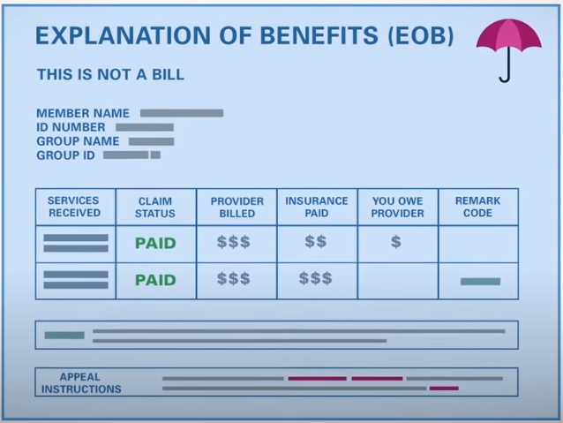

- Information about the person who received the services. This includes the health plan ID number and the member name, sometimes identified as “patient.” If it’s your health plan, the EOB often refers to the patient as “self.” If the plan is through your spouse or parent, then their name may be on the EOB.
- A list of services received, including the dates you received them. There also may be billing codes to identify the services. If you need more information about billing codes, contact your health plan or health care professional’s billing office.
- Information about the professional or facility. This will name the person (doctor, nurse practitioner, psychologist, physical therapist, or others) or facility (laboratory, hospital) that provided the service.
- The amount the professional or facility billed the health plan.
- The “allowed” amount. This is the total amount that the health care professional (the provider) is allowed to collect from the health plan and patient. The health plan has negotiated the allowed amount with providers in-network in your health plan.
- The amount the health plan paid for each service.
- The amount you owe the provider. This may include money you paid during your visit. Remember the EOB is not a bill. Compare the amount the EOB says you owe to any bills from your health care professional or facility.
- Information about denials and other details or notes. The health plan may use codes to explain denial reasons and notes. You should see an explanation of the codes on the EOB.

How else is an EOB helpful?
An EOB is an important tool to explain how much you owe and help you track how much you’ve spent out-of-pocket for covered health care costs. That helps you know how far along you are in meeting your deductible and out-of-pocket limit for the year. If you’ve reached your out-of-pocket limit and are asked to pay for services, you should contact your health plan right away.
You’ll also find instructions on your EOB to file a grievance or appeal if the health plan denies coverage for services or pays less than you believe your plan should pay.

Who receives an EOB?
Usually, the health plan sends the EOB to the primary person on the health plan. An employer who provides the insurance usually sends EOBs to the employee, including EOBs for a spouse and dependents on the plan.
You may ask the health plan to send your EOBs to a different address for confidential services or if the information on an EOB would put you in danger.

