ESG Exposure 1/21/21: Scenario Statistics and Reports

A set of scenario statistics and reports (ESG Timeline Item #13) are being exposed for a public comment period. Please send comments to Reggie Mazyck (RMazyck@naic.org) by close of business March 7th, 2021.

Background and Monthly Process:
To help companies understand the range of results, Conning will produce statistics and reports based on the scenario output. These will be delivered with the scenario output by 4:00 PM Central Time on the first business day of the following month.
Simulation Summary
For the base model, there will be one Simulation Summary report for each column of the Basic dataset. The Simulation Summary will include:
- a “fan chart” illustrating percentiles of the return distribution over time,
- a table of statistics at different periods in the projection, and
- a graph of the cross-sectional volatility throughout the projection.

The Simulation Summary reports for the 10,000 scenarios as of 12/31/19 exposed on December 18th, 2020 can be accessed via a link from the PBR section on the NAIC’s website to the ESG landing page on Conning’s website, or by clicking the following link directly below.
Simulation Summary as of 12/31/19
Note: The Simulation Summary currently contains separate reports for income and price and displays monthly returns. It may be preferable to:
- summarize just total returns, and/or
- summarize returns year over year, instead of monthly.
We are seeking feedback on this.
Average Yield Summary
To help envision the progression of yield curves, Conning will also produce a summary of average yields over time. (Note: To avoid over burdening the chart, the report will only include selected future time periods.)
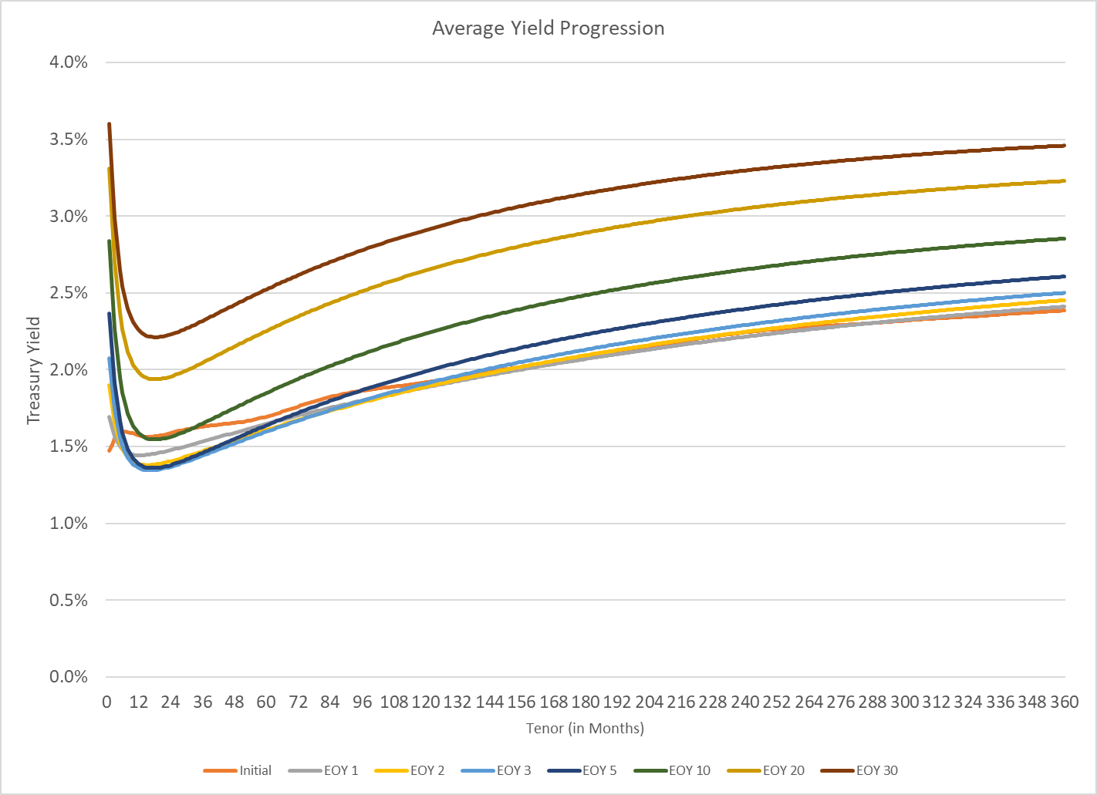

Additional Items
Conning will also provide charts to help analyze other key items. For example, this may include information on yield curve inversion frequency, correlation (e.g. between different points on the yield curve, between equity and treasury returns, etc.), excess returns (e.g. excess returns over cash, equity returns over long treasury returns, long corporates over long treasuries etc.). The list of items can be extended as needed.
Subset Reports
Conning will produce reports which compare the scenario subset results to those from the entire distribution of 10,000 scenarios. For the Yields, the percentile results from the 10,000 scenarios would be compared to the percentiles taken from each subset and would be presented in a similar fashion to the graph below where the full set of GEMS scenarios is compared to AIRG scenarios. The actual subset reports will be available shortly via a link from the PBR section on the NAIC’s website to the ESG landing page on Conning’s website.
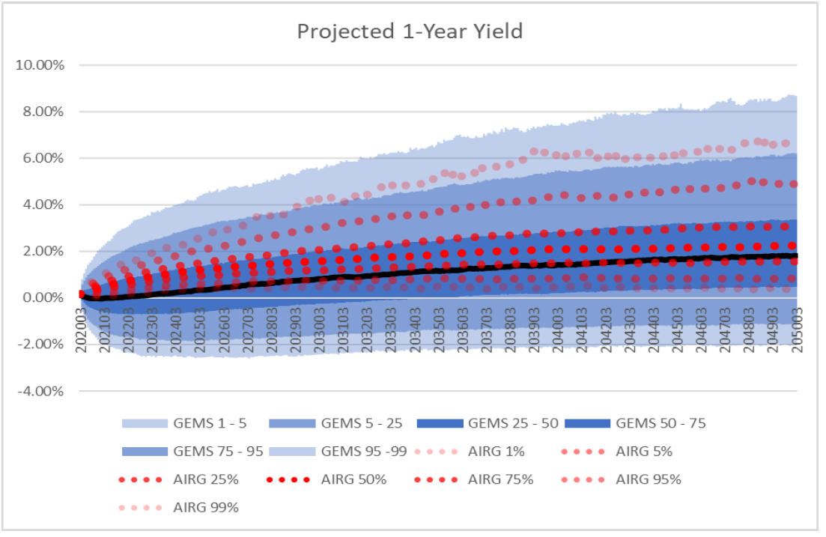

Request for Comments
Please send your comments to Reggie Mazyck (RMazyck@naic.org) by close of business March 7th, 2021. Comments are appreciated on any aspect of the reports, including:
- the format and useability of the reports,
- the desired statistics to be included,
- whether reports for total returns are more desirable than separate reports for income and price, and
- whether returns should be summarized on a monthly or annual basis.

