Subsidiary, Controlled and Affiliated Entities (SCA) Filing Procedures – Filing a Sub-1 Form

- Accessing VISION to file an SCA Page 2

- Filing a Sub-1 form (Initial Filing) Page 3-8

Note to filer: Per the Purposes and Procedures Manual of the NAIC Investment Analysis Office (P&P Manual), Subsidiary, Controlled and Affiliated Entities (SCAs) are required to be filed. A Sub-1 form is required to be filed within 30 days of the acquisition or formation of the investment. A Sub-2 form is required to be filed annually for any existing investment, by June 30th of the next calendar year. Prior to September 5, 2016, these filings were completed in ISIS. After September 5, 2016, they will be completed in VISION. These filing instructions help navigate filings through VISION. For additional questions, please contact the individuals below.
Also see “SCA Filing Procedures-Sub 2” for instructions on how to file a Sub-2 form and an appeal to a Sub-2 form.

Fatima Sediqzad, SCA Valuation & Accounting Policy Advisor fsediqzad@naic.org 816.783.8894
Jill Youtsey, FRS Insurance Reporting Analyst II jyoutsey@naic.org 816.783.8419
Note: Do NOT hit “Cancel” at any time during the filing process; this will discard your filing and you will have to start over!

1. Accessing VISION to File a SCA
- Log on to the filing website https://vision.naic.org

- If you need a User ID and Password contact the NAIC Help Desk at 816-783-8500 or via email at securitiessupport@naic.org. All first-time VISION users will need a User ID.

- Click on the “SCA Filings” tab.

  - The “SCA Filings” tab details all prior SCA filings and/or initiate a Sub-1 filing

2. Filing a Sub-1 form (Initial Filing)
- From the “SCA Filings” screen, click on the “Initiate Sub-1” button.
- Follow the filing wizard:
  - Filer and SCA Tab – Select insurance reporting entity and identify which SCA you are filing.

    - Select Filer – if you have multiple companies you file for, pick the correct Insurance Reporting Entity

    - Find Issue – Enter the SCA’s CUSIP and select “Find”

    - If you do not have a valid CUSIP or PPN, contact CUSIP Global Services at 212-438-6500 or via email at cusip_ppn@cusip.com. This is a requirement to file an SCA.

    - SCA Name – Enter the legal name of the SCA

    - Filing Year – Enter the year of the audited financials. (Often prior year – 12/31/2015)
    - Was SCA Company Acquired or Formed? – Select answer

    - When all of the fields above have been filled in, click “Next”
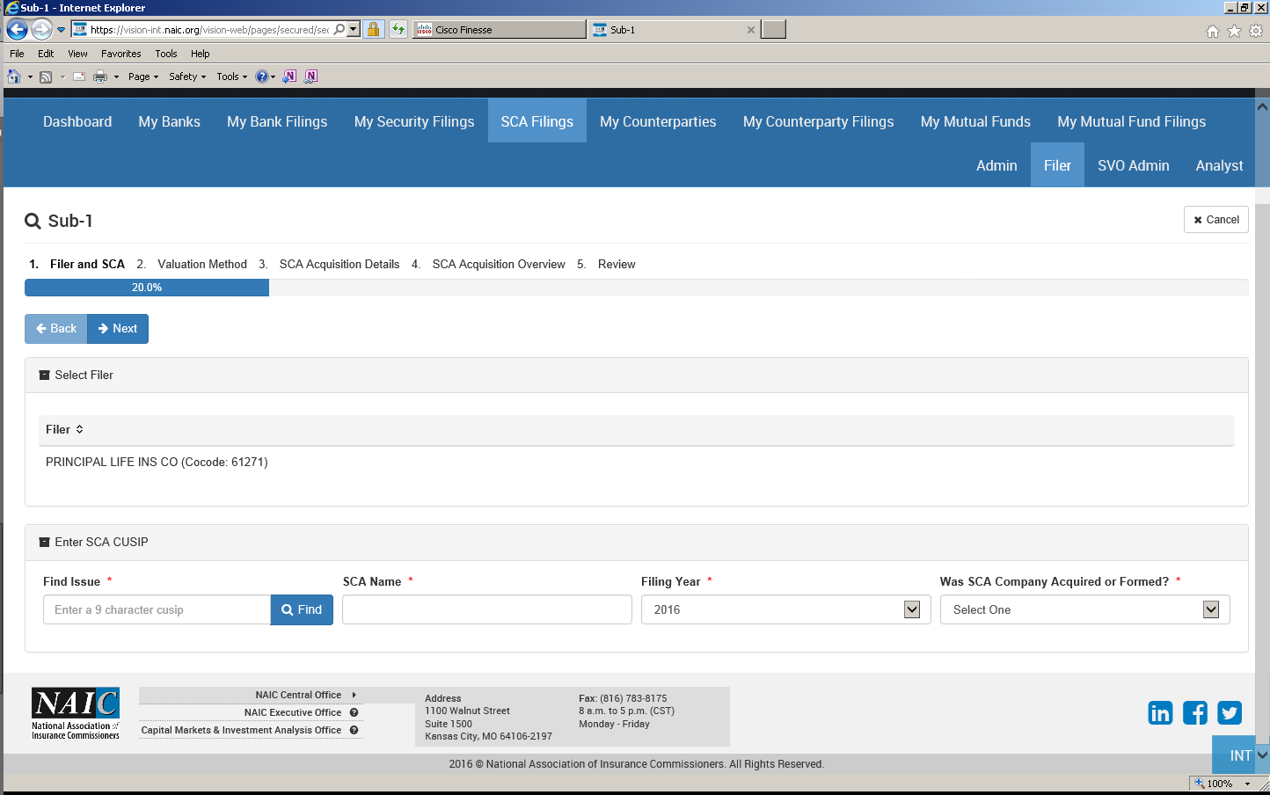
  - Valuation Method Tab – Identify which valuation method the SCA is using

    - Select SCA Type – Refer to SSAP No. 97—Investments in Subsidiary, Controlled and Affiliated Entities to ensure selection of the correct valuation method:
    - Subsequent questions are tailored based on SCA Type:

      - 8(a) – Market Value

(a) Discount percentage: Sliding scale discount based on ownership percentage. (See Appendix C of SSAP No. 97.)

    - 8b(i) – US Insurance SCA Entities – (Must be licensed insurance entity)
          - Stock Type – common or preferred stock ownership

          - CoCode – NAIC company code of the SCA insurance company

    - 8b(ii) – Non Insurance SCA Entities Statutory Basis

          - Accounting Standard – US GAAP or Foreign basis as used in audit support

          - Stock Type – common or preferred stock ownership
iv. 8b(iii) – Non Insurance SCA Entities GAAP Basis
- Accounting Standard – US GAAP or Foreign basis as used in audit support

- Stock Type – common or preferred stock ownership

- 8b(iv) – Foreign Insurance SCA Entities

- Stock Type – Common or preferred stock ownership

    - When all of the questions have been addressed, click “Next”

  - SCA Acquisition Details Tab – Identify what type of business the SCA is, when it was acquired, and report goodwill (if applicable).

    - Principal Business – Identify the principal business of the SCA company

    - Date Shares Acquired – Include Month / Date / Year

    - Is Seller a Related Entity as defined under SSAP 25? – Select Yes / No
Depending on the answer, there may be a few more questions.

    - Goodwill – Based on the acquisition of the SCA, select:

      - No Goodwill

      - Positive Goodwill

      - Negative Goodwill
(If positive or negative goodwill, goodwill worksheet will be a required attachment.)
  - SCA Acquisition Overview Tab – Report claimed value of SCA and include filing comments
    - Total Value Claimed – Value of SCA (Include Goodwill)
    - Shares owned – Number of shares insurance reporting entity owns
    - Value Per Share – Total value claimed divided by the number of shares owned
    - Percent Outstanding Shares Owned – Percentage of shares issued and outstanding that the insurance reporting entity owns
    - Consideration Paid – Amount paid for SCA
    - Does the SCA directly or indirectly own shares of the insurance reporting entity? Relates to reciprocal ownership. SCA Elimination Worksheet will be required: http://www.naic.org/sca_subsidiary_controlled_affiliated.htm

    - Does the SCA directly or indirectly own shares of an upstream intermediate or ultimate parent? Relates to reciprocal ownership. SCA Elimination Worksheet will be required: http://www.naic.org/sca_subsidiary_controlled_affiliated.htm

    - Is the SCA consolidated with other subsidiaries? The Stat. Adjustment Worksheet will be required: http://www.naic.org/sca_subsidiary_controlled_affiliated.htm )
    - Analyst Name / Phone Number / Email – Name and contact information for Individual who prepared the filing in case SCA reviewer has questions.
    - Comments – Available for additional information for reviewing the SCA.
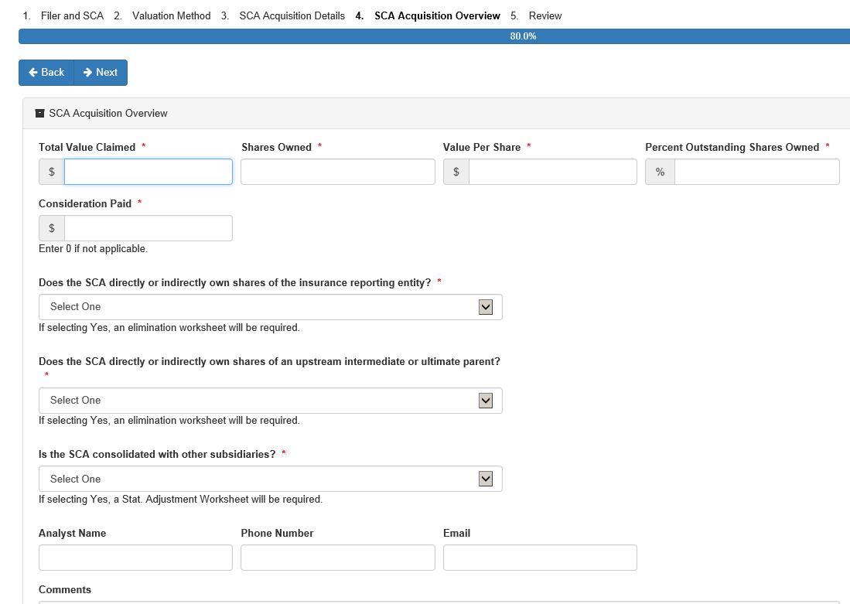
  - Review tab
    - Review all fields of the SCA to ensure they are filed correctly.

IMPORTANT NOTES:

If something is not filled out correctly, click “Back” and update!!

After clicking “Prepare SCA Filing” you WILL NOT be able to make any changes!!
DO NOT hit cancel at any point during the filing process - This will discard your filing!!
When finished reviewing, click the “Prepare SCA Filing” button

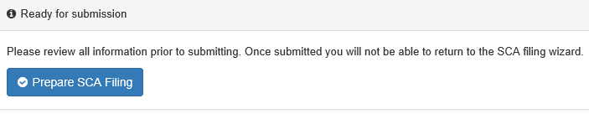

  - SCA Filing Detail Tab – Shows all the filing detail and attach supporting documents
    - To attach a document

      - Click “Edit” under Supporting Documents

      - Click “Attachments” to the file you want to add
If you have a document to add that is not listed click “+ Add”

      - Find your document and upload

      - When finished uploading documents click “Save” under Supporting Documents

    - Required Sub-1 Documents
      - SCA Sub-1 Acquisition Overview - Always required for Sub-1 - “*”

    - Other Required Documents
      - Required depending on answers to questions:
        - SCA Goodwill Worksheet – If positive or negative goodwill
        - SCA Elimination Worksheet – If “Yes” to the Reciprocal Ownership
        - SCA Stat. Adjustment Worksheet – If “Yes” to Consolidated

Note: If applicable, these are required, but there will not be a “*”.

    - Worksheets and other SCA documents available: http://www.naic.org/sca_subsidiary_controlled_affiliated.htm

After attaching all required documents - Click “Submit” to finalize Sub-1 filing:
After Submitting – You Have Completed the Sub-1 Filing!!!
Upon submission of the Sub 1 filing in VISION, an NAIC analyst will review it. When the filing has been reviewed, the filer can download the final review results from the filing screen. The filer will click on the filing number under the “SCA Filings” tab of the VISION home screen. Once in the filing screen, the “Export State Information” button will be visible on the screen. When the filer clicks this button, the final review results will open. Filer should save this for their records.

G:\FRS\DATA\Stat Acctg\3. National Meetings\A. National Meeting Materials\2020\Summer\Meeting\A.1 - 20-17 - Updating SCA Review Process - Sub 1 filing.docx

