Part III - Section I – Appendix H
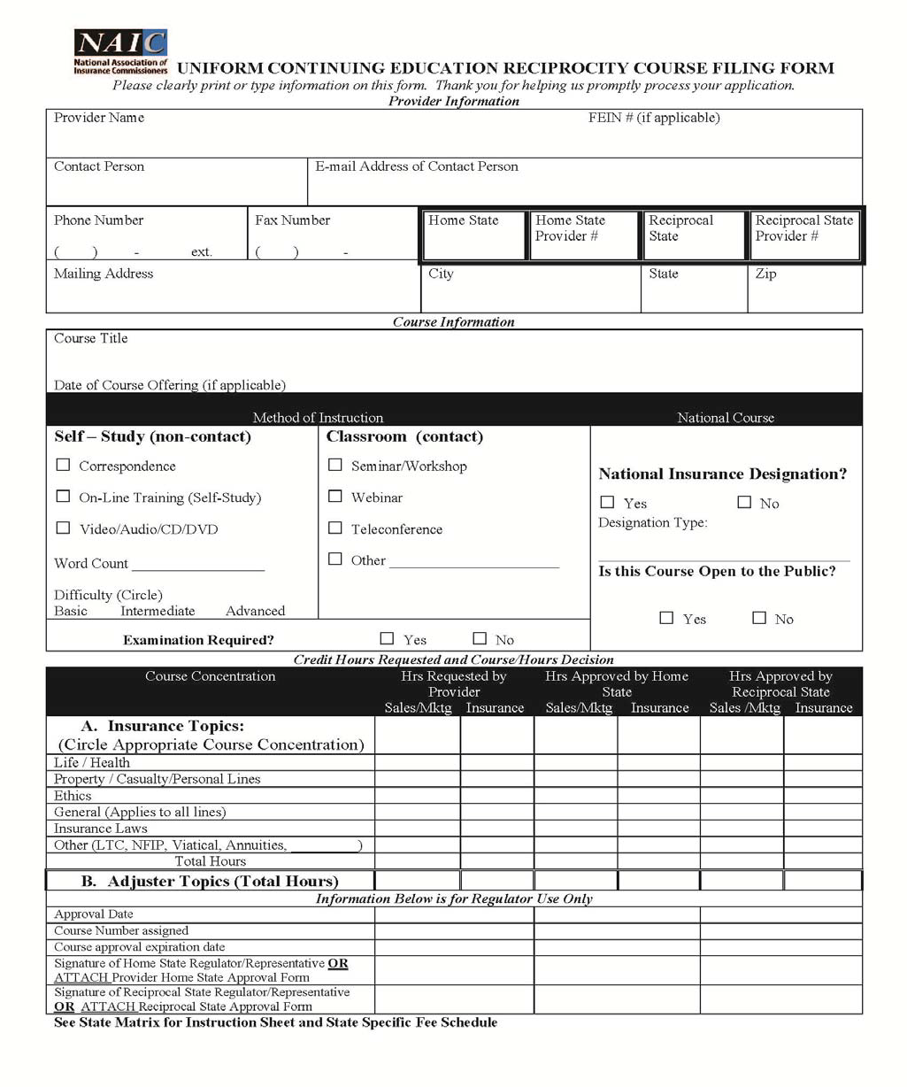

INSTRUCTION SHEET
NOTE: This course may NOT be advertised or offered as approved in the state to which application has been made until approval has been received from the Insurance Department.

1. If you are a PROVIDER filing for approval from the Home State:
1.1 Complete all the fields in the “Provider Information” section except “Reciprocal State” and the adjacent “Provider #” fields.
1.2 Complete the Course Information Section.
1.3 In the “Credit Hours Requested and Course/Hours Decision” section, complete the “Hrs. Requested by Provider” columns, detailing in the respective columns the number of hours for sales – and marketing-related instruction and the number of hours for other insurance-related instruction. Please note the following:

1.3.1 When using this application, which is governed by the NAIC CE Reciprocity Agreement in conjunction with ‘states’ laws, only whole numbers of credit hours will be approved – partial hours will be eliminated.

1.3.2 States that approve sales/marketing topics will consider the hours in the “sales/Mktg” column and the hours in the “Insurance” column when deciding the number of hours to approve. States that do not permit sales/marketing topics as part of continuing education credit hours will only consider the hours shown in the “Insurance” column when making their credit-hour approval decisions.

1.3.3 Contact the individual state to determine whether there are any specific requirements for submitting insurance adjuster courses.

1.4 Submit the application form along with required course materials, a detailed course outline, instructor information, if required, and the required course application fee. Refer to website below for instructor information
(www.naic.org/documents/urtt_cer_CE_Matrix.xls).
2. If you are a PROVIDER filing for approval from a Reciprocal State:
2.1 Make a sufficient number of photocopies of the Home State approval form to enable you to submit a copy of this application to each of the Reciprocal States where you are seeking credit.
2.2 On each application, write the Reciprocal State and the provider number assigned to you by that state in the “Reciprocal State” and adjacent “Provider #” fields.
2.3 Send the CER application, home state approval, if home state issues one, a detailed course outline, and the required fee to the reciprocal state. If this is a National Course *, the Providers will be allowed to submit an agenda which must include date, time, each topic and event location in lieu of a detailed course outline.
2.4 Subsequent national course offerings should only be reported for events that are conducted in the “home” state.
* National Course is defined as an approved program of instruction in insurance related topics, offered by an approved provider, and leads to a national professional designation or is a course offered to individuals who must update their designation once it is earned.

3. If you are a HOME STATE or the designated Representative of the Home State:
3.1 After reviewing the course materials, complete the “Hrs Approved by Home State” column.
3.2 Enter the date of approval, course # assigned, course approval expiration date. Sign the CER Form OR attach the home state approval form.
3.3 If the class is not approved, note it on the bottom of the CER Form.

4. If you are the RECIPROCAL STATE or designated representative of the Reciprocal State:
4.1 After reviewing “Hrs approved by Home State” complete the “Hrs Approved by Reciprocal State”.
4.2 Enter the date of approval, course number assigned, course approval expiration date. Sign the CER Form OR attach the reciprocal state approval form.
4.3 If the class is not approved, note it on the bottom of the CER Form.

