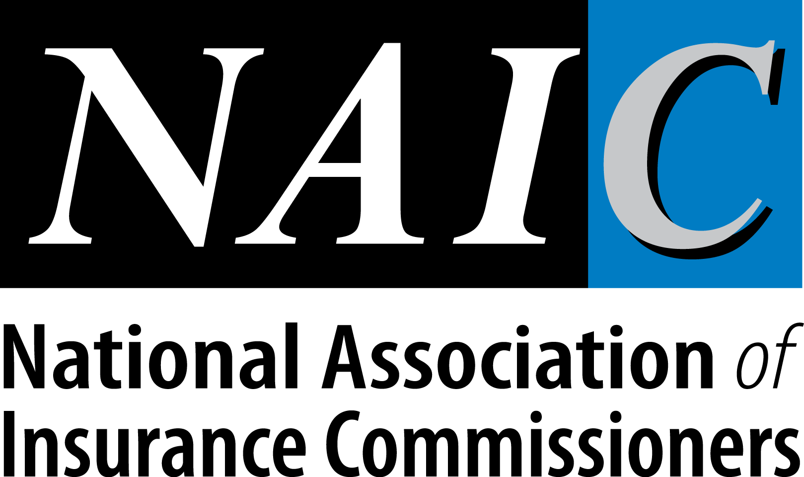 UNIFORM CONTINUING EDUCATION RECIPROCITY COURSE FILING FORM
Please clearly print or type information on this form. Thank you for helping us promptly process your application.

Provider Information
Provider Name FEIN # (if applicable)

Contact Person |  | E-mail Address of Contact Person
Phone Number  ( ) - ext. | Fax Number  ( ) - |  |  | Home State | Home State Provider # | Reciprocal State | Reciprocal State Provider #
Mailing Address |  |  |  | City |  | State | Zip
Submitter Name (if different from provider contact person above)
Submitter Phone Number |  |  | E-mail Address of Submitter

Course Information
Course Title

Date of Course Offering (if applicable) | Existing Course Number (if applicable)
Method of Instruction

Non-Contact / Asynchronous*  Self – Study  □ Correspondence  □ On-Line Training (Self-Study)  □ Recorded Media  □ Other _____________________  Word Count ___________________  Mandatory Run-time ____________________  (Interactive Components of Course) | Contact / Synchronous*  Classroom  □ Seminar/Workshop  □ Other _______________________  Webinar  □ Virtual Class/Webinar/Video Conference  □ Other _______________________
Measurement used for successful completion: □ Attendance □ Final Exam □ Other ____________
Is this course open to the public? □ Yes □ No
National Designation? □ Yes □ No
If yes, Designation Type: ____________________________________________________________

Difficulty (Check): □ Basic □ Intermediate □ Advanced

Credit Hours Requested and Course/Hours Decision
Course Concentration | Hrs Requested by Provider  Sales/Mktg Insurance |  | Hrs Approved by Home State  Sales/Mktg Insurance |  | Hrs Approved by Reciprocal State  Sales /Mktg Insurance
- Producer Topics:
(Circle Appropriate Course Concentration)
Life / Health
Property / Casualty/Personal Lines
Ethics
General (Applies to all lines)
Insurance Laws
Other (LTC, NFIP, Viaticals, Annuities, etc.) ____________________________________

Total Hours
- Adjuster Topics
(Circle Appropriate Course Concentration)
General
Workers Comp
Ethics
Other _____________________________

Total Hours
- Public Adjuster
(Circle Appropriate Course Concentration)
General
Ethics
Other _____________________________
Total Hours
Information Below is for Regulator Use Only
Approval Date
Course Number assigned
Course approval expiration date
Signature of Home State Regulator/Representative OR ATTACH Provider Home State Approval Form
Signature of Reciprocal State Regulator/Representative OR ATTACH Reciprocal State Approval Form

INSTRUCTION SHEET
NOTE: This course may NOT be advertised or offered as approved in the state to which application has been made until approval has been received from the insurance department.

1. If you are a PROVIDER filing for approval from the Home State:
1.1 Complete all the fields in the “Provider Information” section except “Reciprocal State” and the adjacent “Provider #” fields.
1.2 Complete the Course Information Section.
1.3 In the “Credit Hours Requested and Course/Hours Decision” section, complete the “Hrs. Requested by Provider” columns, detailing in the respective columns the number of hours for sales – and marketing-related instruction and the number of hours for other insurance-related instruction. Please note the following:
1.3.1 When using this application, which is governed by the NAIC CE Reciprocity Agreement in conjunction with ‘states’ laws, only whole numbers of credit hours will be approved – partial hours will be eliminated.
1.3.2 States that approve sales/marketing topics will consider the hours in the “sales/Mktg” column and the hours in the “Insurance” column when deciding the number of hours to approve. States that do not permit sales/marketing topics as part of continuing education credit hours will only consider the hours shown in the “Insurance” column when making their credit-hour approval decisions.
1.3.3 Contact the individual state to determine whether there are any state specific requirements for submitting courses.
1.4 Submit the application form along with required course materials, a detailed course outline, instructor information, if required, and the required course application fee.

2. If you are a PROVIDER filing for approval from a Reciprocal State:
2.1 Make a sufficient number of photocopies of the Home State approval form to enable you to submit a copy of this application to each of the Reciprocal States where you are seeking credit.
2.2 On each application, write the Reciprocal State and the provider number assigned to you by that state in the “Reciprocal State” and adjacent “Provider #” fields.
2.3 Send the CER application, home state approval, if home state issues one, a detailed course outline, and the required fee to the reciprocal state. If this is a National Course *, the Providers will be allowed to submit an agenda that must include date, time, each topic and event location in lieu of a detailed course outline.
2.4 Subsequent national course offerings should only be reported for events that are conducted in the “home” state.

* National Course is defined as an approved program of instruction in insurance related topics, offered by an approved provider, and leads to a national professional designation or is a course offered to individuals who must update their designation once it is earned.

3. If you are the HOME STATE or designated representative of the Home State:
3.1 After reviewing the course materials, complete the “Hrs Approved by Home State” column.
3.1.1 Multiple types of credit and delivery methods can be approved using one CER Form.
3.2 Enter the date of approval, course # assigned, course approval expiration date. Sign the CER Form OR attach the home state approval form.
3.3 If the course is not approved, note it on the bottom of the CER Form.

4. If you are the RECIPROCAL STATE or designated representative of the Reciprocal State:
4.1 After reviewing “Hrs approved by Home State” complete the “Hrs Approved by Reciprocal State”.
4.1.1 It is unnecessary for each State to perform a substantive review of continuing education courses that have previously been approved by the Home State.
4.1.2 Reciprocal states cannot award different credits than the home state unless certain aspects are not allowed by state law.
4.2 Enter the date of approval, course number assigned, course approval expiration date. Sign the CER Form OR attach the reciprocal state approval form.
4.3 If the course is not approved, note it on the bottom of the CER Form.
4.4 The reciprocal state agrees to approve the CER submission within 30 days of receipt.

Substantive Review – A thorough review of the course to confirm compliance with the home state’s applicable laws and regulations for the approval of insurance continuing education. The review includes a determination whether the:

1. Subject matter meets the criteria for insurance education, to include approvable and non-approvable topic guidelines;
2. Provider has procedures for reviewing course material in order to keep it up to date and timely;
3. Course design and instructional strategies are appropriate for the method of delivery;
4. Credit hours are properly calculated based on instruction method;
5. Criteria for completing the course meets the standards applicable to the instruction method.

*Drafting Note: The instructor information matrix was eliminated in 2018 as this information should be readily available on individual state/jurisdiction websites.

