**MEMORANDUM**

TO: Property and Casualty Insurance (C) Committee

FROM: NAIC Staff

DATE: Oct. 20, 2021

RE: Report on the Cybersecurity Insurance Market

The purpose of this report is to provide an understanding of the U.S. cybersecurity insurance market, which encompasses insurers domiciled in the U.S., as well as alien surplus lines insurers that write cybersecurity coverage.

**Overview**

Cybersecurity protection continues to be crucial to the effective and efficient operation of U.S. businesses. Insurers face cybersecurity risks in their daily operations, as do all firms in the financial sector. The reasons the financial services sector is susceptible to cyberthreats are multifaceted. Financial firms receive, maintain, and store substantial amounts of personally identifiable information (PII); however, insurers, in many cases, receive personal health information in addition to personal financial information from both policyholders and claimants. In both cases, recent legislation is potentially expanding the definition of PII, adding to the risk associated with a cybersecurity event.

Health care breaches continue to grow each year.[1] Health care breaches grew by approximately 55% during 2020,[2] and the number of health care breaches continues to rise in 2021.[3] The increased value of personal health information is due to health information containing more PII than financial records.

The NAIC collects data from insurers writing cybersecurity insurance each year through the Property/Casualty Annual Statement Cybersecurity and Identity Theft Supplement (Cyber Supplement). This report focuses on the cyber insurance market by presenting data found within the Cyber Supplement, as well as alien surplus lines data collected through the NAIC’s International Insurance Department. This year, 141 insurer groups submitted the data on the Cyber Supplement for the 2020 calendar year.

The 2020 data show a cybersecurity insurance market, including both U.S. domiciled insurers and alien surplus lines insurers writing business in the U.S., of roughly $4.1 billion in direct written premiums, reflecting an increase of 29.1% from the prior year.[4] Insurers writing standalone cybersecurity insurance products reported approximately $2.58 billion in direct written premiums, and those writing cybersecurity insurance as part of a package policy reported roughly $1.49 billion in direct written premium.[5]

**Cybersecurity Insurance Coverage**

The Cyber Supplement requires U.S. domiciled insurers to report the following information on standalone cybersecurity insurance policies and coverage sold as part of a package policy:

* Number of claims reported (first-party and third-party).
* Direct premiums written and earned.
* Direct losses paid and incurred.
* Adjusting and other expenses paid and incurred.
* Defense and cost containment expenses paid and incurred.
* Number of policies in force (claims made and occurrence).

**Total Market – U.S. Domiciled Insurers**

U.S. domiciled insurers writing cyber coverage reported $2.75 billion in direct written premium in 2020. Direct earned premiums reported were $2.43 billion. Direct written premiums for the 2020 data year increased by 21.7% from the 2019 data year.

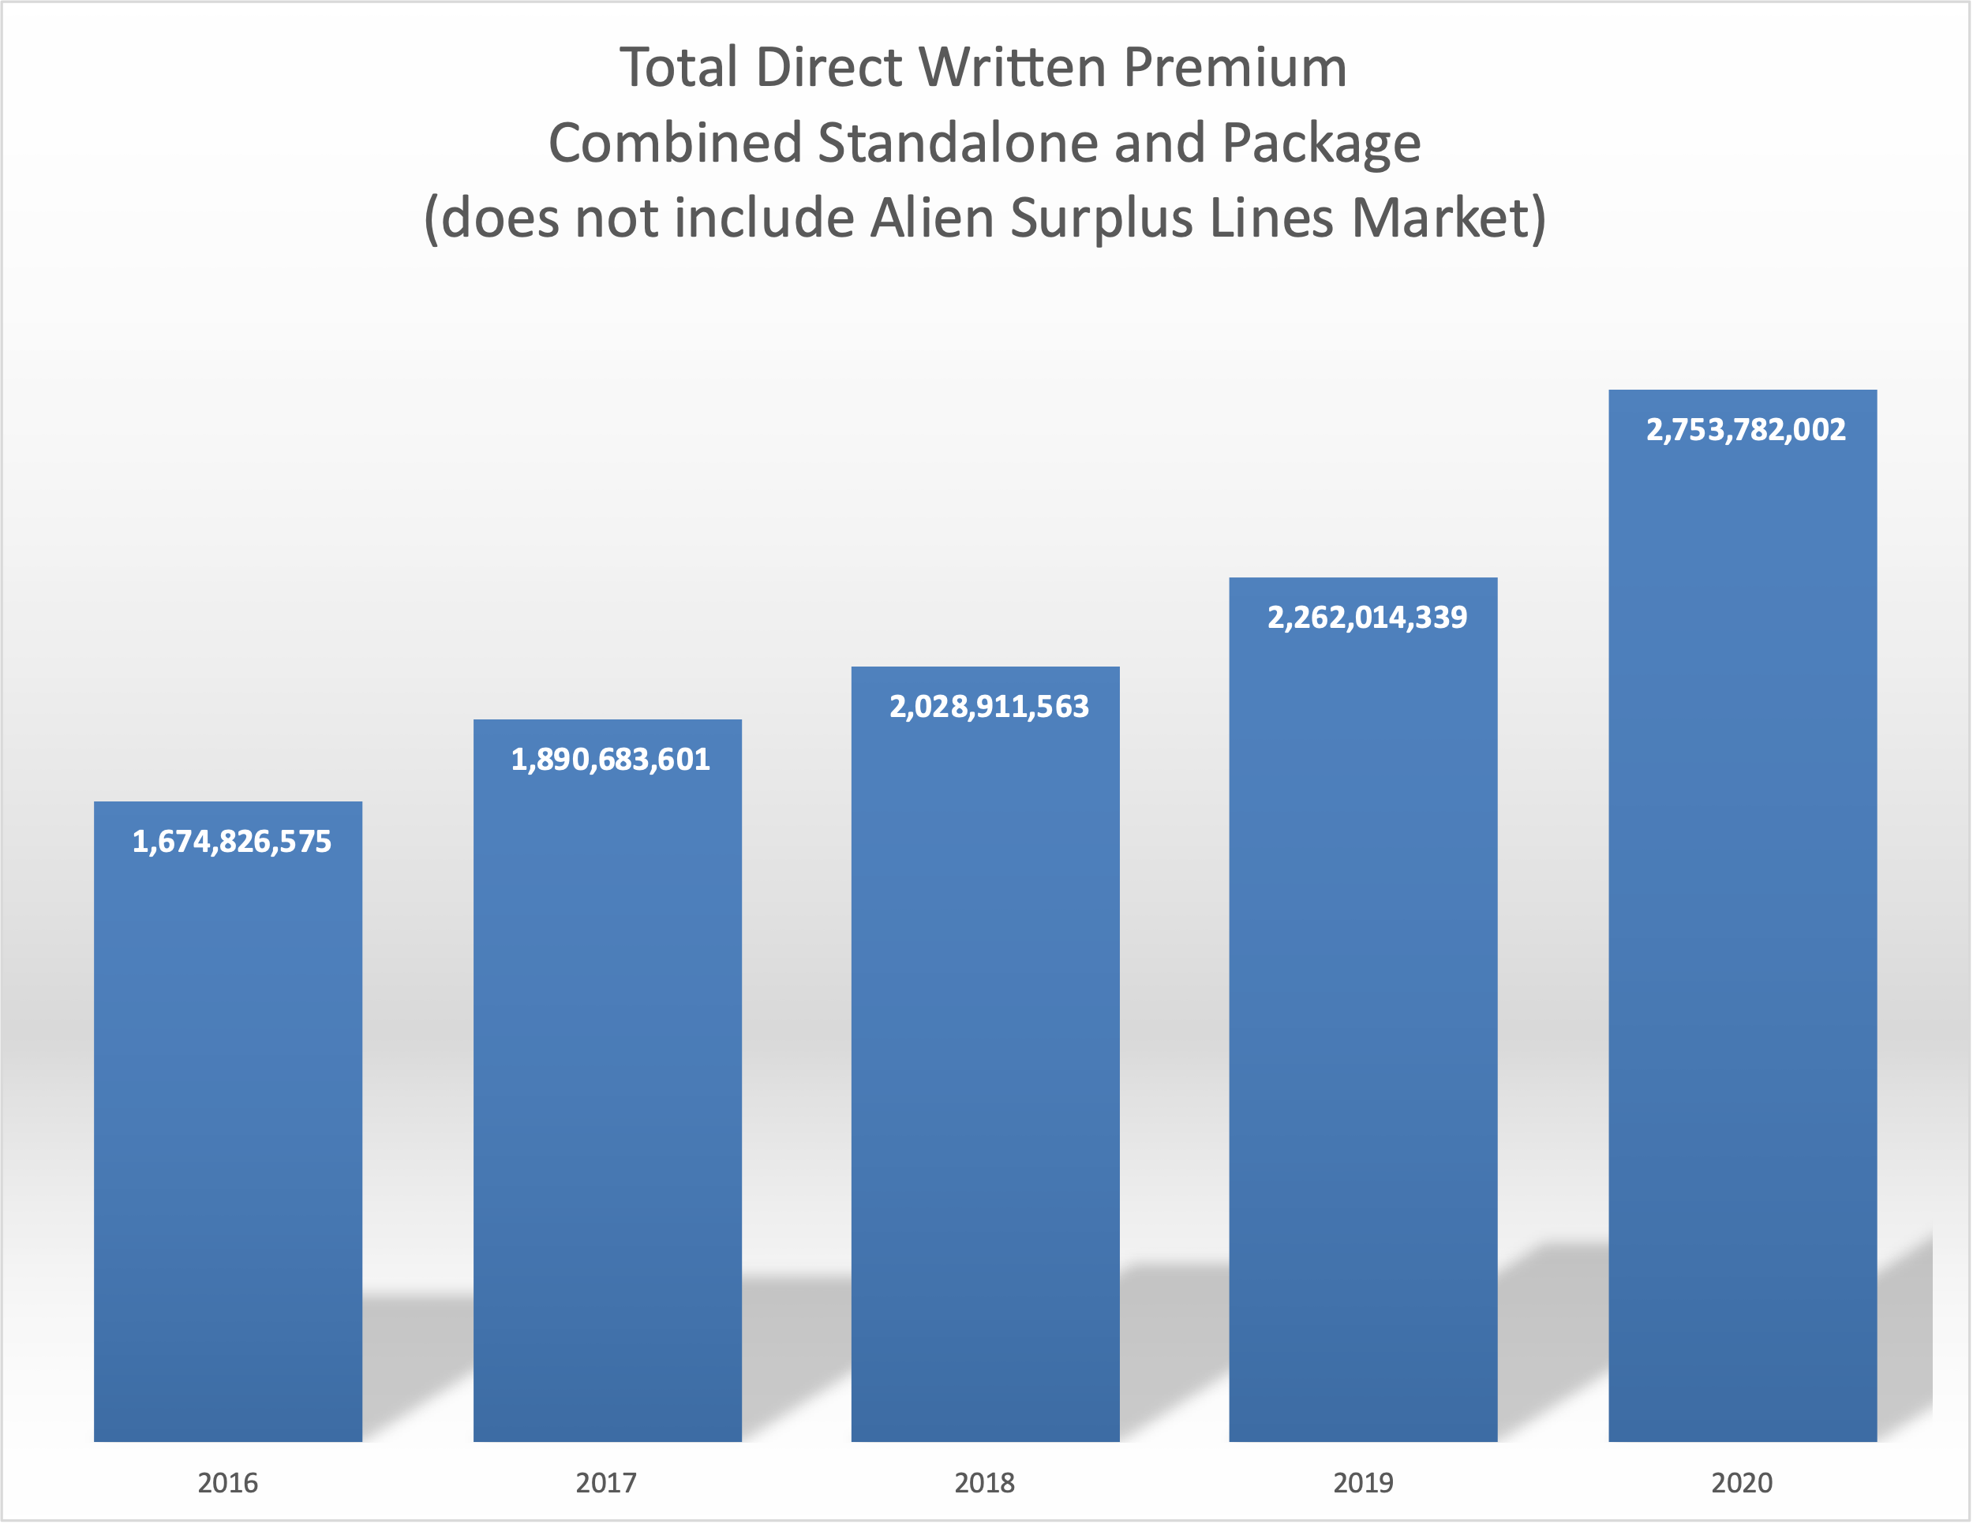

To provide perspective, total U.S. domiciled insurers cyber direct written premiums of $2.75 billion account for only 0.38% of $727 billion[6] property/casualty (P/C) direct written premium in the U.S.

During the 2020 calendar year, U.S. domiciled insurers reported a total of a little over four million policies in force. Policies in force increased by 21.3% from 2019 to 2020, approximately the same percentage increase insurers saw in premium growth. Average policy cost rose by 0.38%. Policy prices have risen in 2021, and this will likely be reflected in the 2021 data to be reported next year.

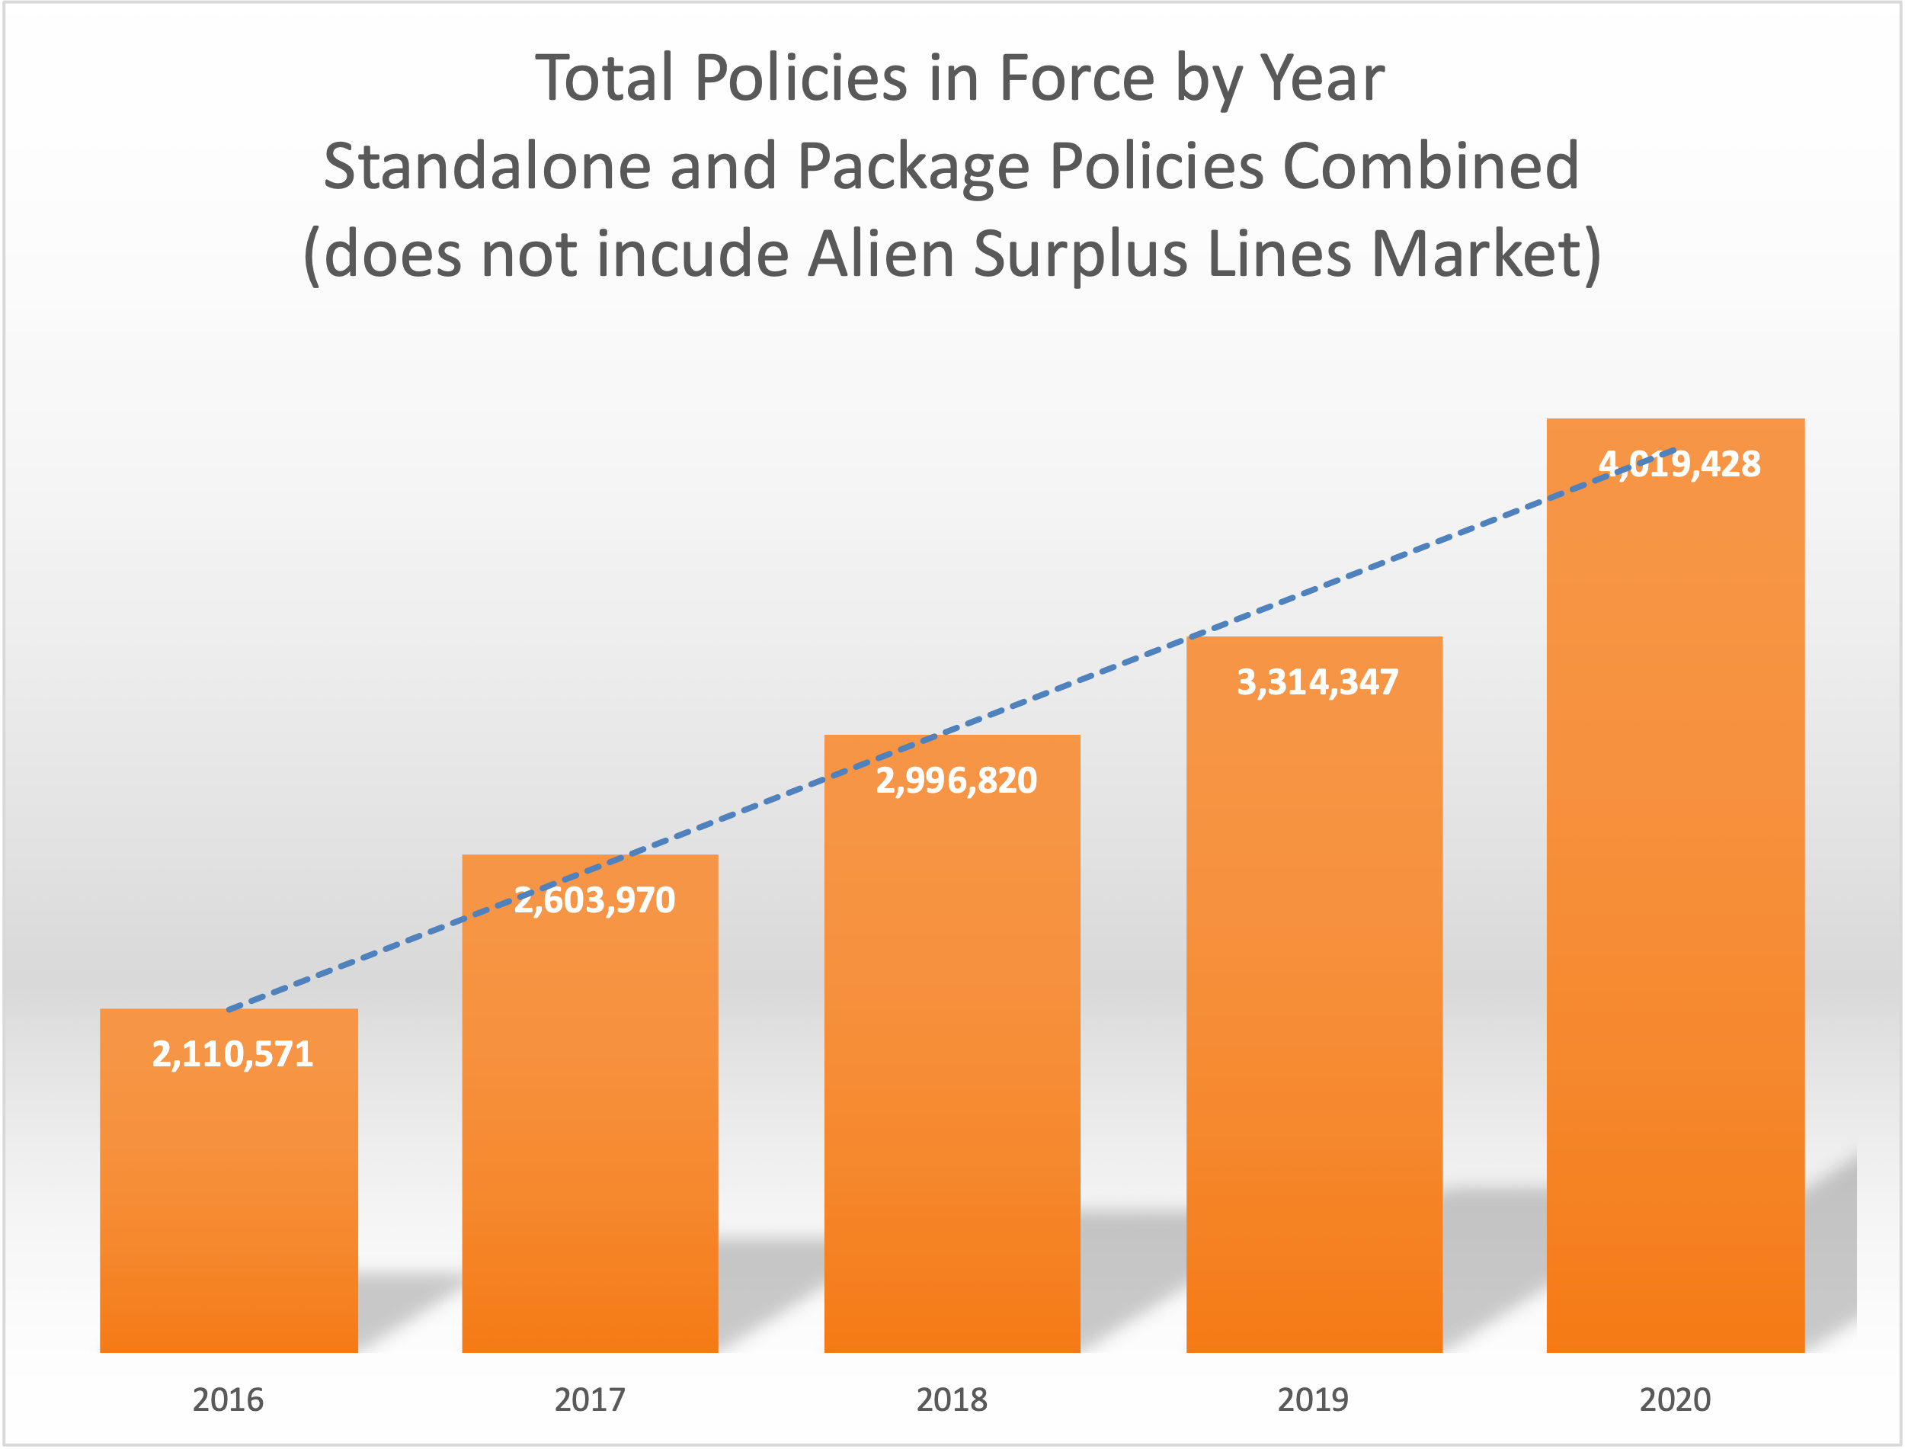

**Loss Ratios**

The top 20 groups in the cyber insurance market reported direct loss ratios in the range of 24.6% to 114.1%. The figure below depicts the average loss ratios over the past four years. The loss ratio for 2020 for the top 20 groups averaged 66.9%, up from 44.6% in 2019.

Exhibit 1 presents the loss ratios for these insurer groups. It is important to note that the cybersecurity insurance market is still developing. Therefore, an element of catastrophe exposure continues to exist. The cyber market continues to be a developing market; as a result, the wide range of loss ratios is not unanticipated.

The top 20 U.S. groups writing standalone and package cyber insurance combined are listed in the table below.

|  |  |  |  |  |  |
| --- | --- | --- | --- | --- | --- |
| **2020 RANK** | **2019 RANK** | **GROUP NAME** | **DIRECT WRITTEN PREMIUM** | **LOSS RATIO W/DCC** | **MARKET SHARE** |
| 1 | 1 | CHUBB LTD GRP | $404,144,104 | 61% | 14.7% |
| 2 | 2 | AXA INS GRP | 293,025,192 | 98.2% | 10.6% |
| 3 | 3 | AMERICAN INTRNL GRP | 228,424,711 | 100.6% | 8.3% |
| 4 | 4 | ST PAUL TRAVELERS GRP | 206,817,208 | 85.5% | 7.5% |
| 5 | 5 | BEAZLEY GRP | 177,746,192 | 47.9% | 6.5% |
| 6 | 6 | AXIS CAPITAL GRP | 133,549,784 | 46.2% | 4.8% |
| 7 | 7 | CNA INS GRP | 119,612,168 | 105.7% | 4.3% |
| 8 | 10 | FAIRFAX FINANCIAL | 108,687,558 | 55.7% | 3.9% |
| 9 | 11 | HARTFORD FIRE 7 CAS GRP | 102,864,503 | 25.4% | 3.7% |
| 10 | 8 | BCS INS GRP | 86,582,699 | 59.1% | 3.1% |
| 11 | 14 | TOKIO MARINE HOLDINGS INC GRP | 78,160,355 | 51.1% | 2.8% |
| 12 | 12 | SOMPO GRP | 72,588,641 | 114.1% | 2.6% |
| 13 | 13 | ZURICH INS GRP | 64,430,818 | 40.4% | 2.3% |
| 14 | 9 | LIBERTY MUT GRP | 41,856,727 | 30% | 1.5% |
| 15 | 18 | APOLLO GLOBAL MGMT GRP | 39,338,993 | 29.6% | 1.4% |
| 16 | 15 | BERKSHIRE HATHAWAY | 37,366,878 | 25.8% | 1.4% |
| 17 | 19 | MARKEL CORP GRP | 29,736,405 | 38% | 1.1% |
| 18 | 28 | EVEREST REIN HOL INC | 28,173,404 | 48% | 1% |
| 19 | 17 | CINCINATTI FNCL GRP | 24,888,476 | 24.6% | 0.9% |
| 20 | 25 | SWISS RE GRP | 23,654,519 | 42.6% | 0.9% |

During 2020, the top 10 U.S. groups wrote almost 68% of the cyber insurance market, with written premiums totaling approximately $1.86 billion. This market share percentage varied little from 2019.

**Standalone Policies Versus Package Policies – U.S. Domiciled Insurers**

During 2020, insurers writing standalone cyber coverage reported $1.62 billion in direct written premiums and $1.42 billion in direct earned premium. The standalone cybersecurity insurance direct written premiums for 2020 increased by 28.1% from the prior year, and the total number of standalone policies reported in 2020 increased by 22% from the number written in 2019.

The reported direct written premiums for cybersecurity package policies totaled $1.14 billion, which is an increase of 13.6% from the prior year. The NAIC did not estimate missing premium this year, as the insurers not reporting direct written premium had very few claims and are not significant enough to include.

**Alien Surplus Lines Insurers Writing Business in the U.S.**

The NAIC receives cybersecurity data filed by alien surplus lines insurers via the NAIC’s International Insurance Department. Alien insurers wrote $961.2 million in cybersecurity standalone package policies in 2020, a 7.9% increase from the prior year.[7]

Alien surplus lines insurers wrote $350.1 million in direct premiums for cybersecurity package policies, a 71.4% increase from last year. The total written premium for both policy types was $1.3 billion, indicating a total premium increase of 19.8%.

**Identity Theft Coverage – U.S. Domiciled Insurers Only**

From a market perspective, the 2020 data continues to indicate that U.S. insurers’ most common product related to cybersecurity is in the form of identity theft coverage. Insurers wrote approximately 20.3 million policies, both standalone and package policies, up roughly 4% from the prior year. Currently, some homeowners policies include this coverage for no extra charge.

Standalone identity theft policies represented a little over $7 million in direct written premium, and the number of policies decreased by 3.1% from the number of policies in force in the previous year. Package policies represented $233.1 million in direct written premium, and the policies in force increased by almost 4% from the prior year.

**Ransomware**

Ransomware poses a significant threat as it escalates in frequency and severity. Ransomware attacks have grown by 62% since 2019.[8]

Initially, ransomware merely encrypted files. The affected party would then need an encryption key to unencrypt the files. The victim of the attack pays a ransom to obtain the encryption key. The problem is ransomware now also often involves extortion. Extortion comes into play when cybercriminals threaten to release or sell sensitive data after collecting the ransomware payment.[9]

Ransomware is likely one of the biggest reasons cyber insurance costs are on the rise. In 2020, there was a 400% increase in ransomware incidents. Additionally, extortion demands climbed sharply.[10]

**Cyber Insurance Underwriting and Rating Changes**

Currently, cyber insurers are seeing their expenditures, as a proportion of premiums paid, surpass 70%. It should be no surprise that cyber insurance premiums are on the rise.[11] A recent survey of brokers shows an increase of 10–30% in cyber insurance prices during the last quarter of 2020. Additionally, the survey indicates the increased pricing trend continuing in the first quarter of 2021, as renewal pricing on cyber insurance rose by an average of 18%.[12] Predictions indicate rates for cyber insurance buyers to increase by 15–50% overall in 2021.[13] However, even as prices rise, demand has grown for cyber insurance in the second quarter of 2021.[14] These price increases are likely to be seen in the 2022 version of this report.

Insurers are adding exclusions to standard coverage lines to avoid duplication of cyber coverage. Additionally, insurers are incorporating sub-limits. Elimination of overlapping coverage and sub-limits will likely improve underwriting performance.[15]

Additionally, cyber insurance limits have dropped from $10 million to $5 million for some industry sectors.[16] At the same time limits are dropping, cyber underwriters are raising self-insured retention levels. Excess markets are also charging almost as much as the primary insurer.[17]

Changes regarding risk factors are occurring in the underwriting process. Underwriters are starting to use tools to evaluate prospective insureds’ computer networks to decide whether they will write the cyber business.[18]

**Data Table**

The chart below depicts the information collected from all years of data collection.

* *Alien surplus lines data was not reported for the 2015 data year.*

*\*\* As a result of further analysis, the data for the 2019 data year has been amended.*

Marsh and McClennan indicated that the cyber insurance take-up rates for their clients in 2020 was 47%, indicating a 5% increase from 2019 take-up rates.[19] While businesses are aware that cyber risk is a looming issue, it is not uncommon for policyholders to believe their current business insurance policy cover a cyber loss.[20]

This report shows premiums grew substantially in 2020 as cyberthreats, particularly those having to do with ransomware, continue to rise. As state insurance regulators monitor this evolving market they may wish to consider whether any enhancements are needed to the Cyber Supplement to better understand the market.

W:\National Meetings\2021\Fall\Cmte\C\Cyber_Supplement_2020_Report.docx

1. *https://www.securelink.com/blog/healthcare-data-new-prize-hackers/*.
2. *https://www.forbes.com/sites/davidbalaban/2021/05/30/attacks-on-healthcare-sector-are-on-the-rise/?sh=4658c7dc264c*.
3. *https://www.hipaajournal.com/july-2021-healthcare-data-breach-report/*.
4. Based on this year’s restated alien surplus lines premium for 2019.
5. Alien surplus lines premium has been restated in this year’s report to $1.1 billion, which is a 23.3% increase from the numbers reported in last year’s report.
6. *https://content.naic.org/sites/default/files/inline-files/YE2019%20Industry%20Report.pdf*.
7. Note: Alien surplus lines premium was restated for 2019.
8. *https://www.blackfog.com/the-state-of-ransomware-in-2020/*.
9. *https://www.pbs.org/newshour/nation/why-ransomware-attacks-are-on-the-rise-and-what-can-be-done-to-stop-them*.
10. *https://www.insurancejournal.com/news/national/2021/07/07/621416.htm*.
11. Ibid.
12. *https://www.gao.gov/assets/gao-21-477.pdf*.
13. Gallagher Market Conditions 2021.
14. *https://www.ciab.com/resources/q2-p-c-market-survey-2021/*.
15. *https://www.gao.gov/assets/gao-21-477.pdf*
16. Ibid.
17. *https://www.ciab.com/download/31507/*.
18. Gallagher Market Conditions 2021.
19. # Cyber Insurance: Insurers and Policyholders Face Challenges in an Evolving Market, GAO, May 2021.

   
20. *Riskandinsurance-digital.com/riskandinsurance/august_2021.*