Health Care Bills: Explanation of Benefits

After your visit to your doctor or another health care provider, you'll receive information about your claim in the form of an Explanation of Benefits, or EOB. The EOB is not a bill. It is an explanation generated as part of the claims process and shows you the payment breakdown for the services received.

What does the EOB tell me?

Essentially, the EOB will tell you how much your provider charged, how much the health plan paid, and how much you are responsible for or owe your provider. Your EOB comes from your health plan and is separate from the bill your provider may send. Make sure to compare “owed” amounts listed on the EOB with the bill from your provider’s office or the co-pay you already paid.

What does the EOB look like?

This document may be mailed to you or be made available electronically in your member portal.

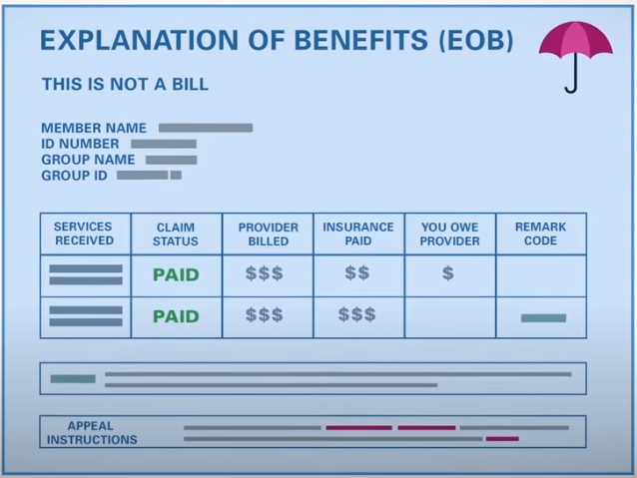

Not all EOBs look alike, but here are a few things to look for on your EOB:
- Information about the person receiving the services, including the ID number and the member name sometimes identified as “patient” – if it’s your insurance, the EOB will usually include the notation “self” when referring to the patient, if the insurance is through your spouse or your parent, then their name will be included on the EOB;
- A list of the services received, which should include the dates of service and may include billing codes – if the billing codes are not provided on the EOB, there should be notes about how to get the codes if you would like to review them;
- Information about the provider or facility – this may be the name of a specific doctor, nurse practitioner, psychologist, physical therapist, etc., or it may be the name of a laboratory, hospital, or other office;
- The amount billed by the provider or facility;
- The “allowed” amount is the amount the health plan designates for each service – when you go to an in-network provider, the health plan will pay that provider all or a portion of a negotiated rate for the services provided. Do not be surprised if the allowed amount is lower than the provider/facility billed amount;
- The amount the health plan paid for each service.
- Any amount you owe to the provider – this amount may include the copay you paid in the office at the time of your visit;
- Information about denials, additional details, or other notes – you may see codes in line with each service, and the codes should be defined below the table listing the services.

How else is an EOB helpful?

The EOB is also an important tool for tracking how much you have spent on out-of-pocket health care costs. It will tell you how far along you are in meeting your deductible and your out-of-pocket limit for the year. If you’ve reached your out-of-pocket limit and you are asked to pay for services, you should contact your health plan right away.

Finally, your EOB has instructions for filing a grievance or appeal if coverage for your services is denied or only partially covered.

Who receives the EOB?

Usually, the EOB goes to the primary person listed on the health plan documents. If an employer provides the health plan, the employee is usually the person who receives EOBs, including the EOBs for a spouse and dependents. If disclosure of the information on an EOB would place you in danger, you may ask the health plan to send your EOBs to an alternate address.

