SPIR Admissions Eligibility
Prospective Senior Professional in Insurance Regulation (SPIR) Candidates must:
- Be currently employed by a state DOI.

- Hold a current and active PIR Designation.
or
- Submit a detailed curriculum vita (“vita”) describing how prior coursework or professional experience demonstrates mastery of:
- broad fundamental concepts in the areas of market conduct, rate and form, and financial regulation as addressed within APIR-level course requirements; and
- the more specialized skills and competencies addressed at the PIR level of the Designation Program.

Candidates complete their SPIR enrollment application along with their vita to enter the program at the SPIR level. The Designation Advisory Board reviews the vita and approves/denies the request.
The applicant is automatically enrolled at either the APIR or PIR level, depending upon his/her qualifications, if the vita request is denied. Enrollment fees are non-refundable.

SPIR Requirements
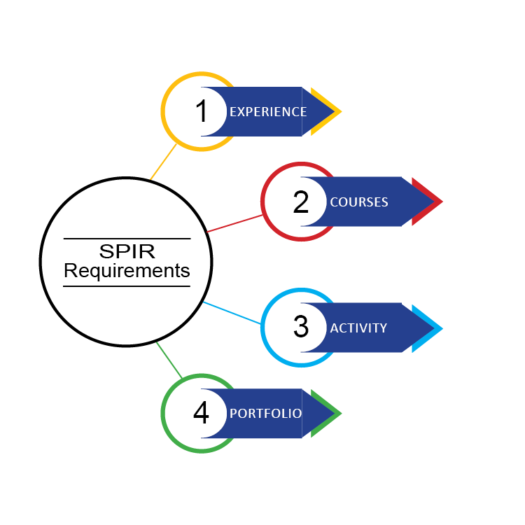
SPIR designation candidates must fulfill the following four requirements:
EXPERIENCE
- Be elected or appointed as the chief insurance regulator in a state, U.S. territory or the District of Columbia or have at least five years of full-time work experience with a state DOI.
And

COURSES
- Satisfactorily complete the NAIC courses below and achieve a passing score on each corresponding exam.
  - Regulatory Leadership Forum
  - Practical Manager Program (the annual group program; note that the state-customized version does not count toward this requirement)
And

ACTIVITY
- Satisfactorily complete ONE of the following action learning activities:
- Achieve the highest designation from:
    - American Institute for Chartered Property Casualty Underwriters (AICPCU) - CPCU,
    - Chartered Life Underwriters (CLU) - CLU,
    - Society of Financial Examiners (SOFE) - CFE,
    - Insurance Regulatory Examiners Society (IRES) - CIE, or
    - Life Office Management Association (LOMA) – FFSI/FLMI.

- Complete two SPIR-level qualified electives from the Catalog of Elective Courses. The course must have been completed no more than three years prior to applying for the SPIR to earn program credit.

- Teach an NAIC course managed by the NAIC Education & Training Department.* The teaching assignment must involve the following:
    - Actively participating on a course development team.
    - Preparing course materials, text, handouts, and/or slides in support of pre-defined learning outcomes.
    - Developing instructional techniques (e.g., exercises, cases, lectures, etc.) that assist the students in achieving learning outcomes.
    - Writing and/or reviewing test questions as needed.
    - Teaching or facilitating at least part of the course online or in a classroom setting.

- Research and author an article that is published in the Journal of Insurance Regulation.

- Be the lead in a structured, formalized mentoring relationship within any DOI for at least six months.* The mentoring project must involve the following:
    - Developing and submitting a pre-mentoring plan that includes the name/title of the mentee and the goals of the mentoring relationship. A description of the mentoring program you have designed should also be submitted, including specific activities (e.g., training, one-on-one meetings, observations, etc.) that will take place along with a six-month timeline of those activities.
    - Implementing the pre-mentoring plan.
    - Asking the mentee to evaluate his/her experience based on three factors: 1) degree of mutual participation;
2) achievement of stated goals; and
3) level of personal enrichment (e.g., growth in confidence, autonomy and self-direction).
    - Submitting the mentee’s signed evaluation.
And

PORTFOLIO
- Complete and submit the Best Practices in Regulatory Leadership Portfolio.

*The teaching assignment and the mentoring project must be completed after being formally admitted to the Designation Program at the SPIR level to earn program credit. Teaching assignments are subject to course project availability.

