Economic Scenario Generator (ESG) Reserves and Capital Field Test Specifications

Primary Contact:
Scott O’Neal, FSA, MAAA (soneal@naic.org)

Section I: Overview

- Objectives

The ESG Field Test should be able to address the following questions:

- Reserve and Capital Impact | - How does the new ESG impact industry reserves and capital in different economic environments?  - How do reserve and capital impacts vary by product type?  - What is the impact of the changes to each ESG model (i.e. interest rate model, equity model, corporate model)?  The impact will be determined by comparing reserves and capital calculated using the field test ESG scenario sets against results that were determined using currently prescribed or allowed ESGs used in Annual Statement and/or RBC reporting.
- Range of Results | - What is the range of reserve and capital impacts across companies (e.g. percentage increase/decrease)?  - Which particular companies and product types have the highest and lowest impacts, and why?
- Metrics | - Which particular interest rate and equity scenarios cause the greatest stress?  - How do results compare for CTE70 vs. CTE98? Calculate different CTE levels (e.g., CTE70, CTE98, CTE90) to compare to existing requirements.  - How do the metrics perform with different scenario set sizes?
- Stability Over Time | - How do the reserve and capital results change across scenarios produced for different economic environments?
- Exclusion Testing and Reserve Components | - Does the new ESG change the likelihood of the SR being the dominant reserve?  - Do the exclusion tests still perform as intended?  - Does the VM-20 DR scenario still capture risk appropriately?  Note: Companies that currently pass the stochastic exclusion test will not have a stochastic reserve model.
- Hedging Impact | - Does the new ESG impact hedge effectiveness? If so, what feature is driving this (e.g. the new ESG produces additional yield curve shapes, such as humps)?
- Sensitivity Tests and Attribution | - Do baseline results and/or sensitivity tests indicate that the field-tested ESG calibration needs to be modified?  - What are the drivers of reserve and capital changes as determined from attribution analysis?

- Tentative Timeline

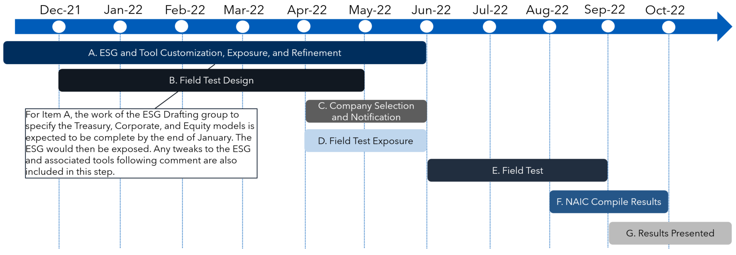
Note: Dotted lines represent the beginning of the month.

- Structure

- NAIC to collaborate with the American Academy of Actuaries’ ESG Field Testing Subgroup and American Council of Life Insurer’s ESG Field testing group to design the NAIC ESG Field test. Field test recommendations will be brought to a joint meeting of the Life Actuarial (A) Task Force and the Life RBC (E) Working Group.
- Field Test Participants
  - The NAIC has solicited volunteer companies to participate in the ESG field testing.
  - Further analysis needs to be completed to assess product coverage.
  - Additional participants may be requested if desired by regulators.
- The NAIC will work with state regulators to coordinate the following:
  - Communicating with field test participants and providing ESG Field Test instructions and result templates.
  - Collecting, aggregating, and summarizing company results

- Reserve and Capital Frameworks Covered

VM-20 | - All individual life insurance policies issued on or after the operative date of VM-20, or issued during the transition period, if elected by the company. Smaller insurance companies may obtain an exemption from VM-20 calculations.  - Stochastic reserves, Deterministic reserves, and stochastic exclusion ratio test (SERT) values will need to be field tested
VM-21/C3 Phase II | - Variable deferred or immediate annuity contracts whether or not they have GMDBs or VAGLBs, group annuity contracts containing GMDBs or VAGLBs, and policies or contracts with guarantees similar in nature to GMDBs or VAGLBs where there is no other explicit reserve requirement  - Stochastic Reserves and the Additional Standard Projection Amount will need to be field tested. Different CTE levels will need to be tested for reserves and capital
C3 Phase I | - Include certain annuities (with the exception of indexed annuities) and single premium life insurance for C3 Phase I testing.  - Reported C3 Phase I capital will be compared against results produced using the field test scenario sets. Participants that are testing products according to the C3 Phase I methodology will be asked to use a choose a scenario set with at least 200 scenarios for the ESG field test candidates rather than scenario sets with 50 or 12 scenarios as used in reported C3 Phase I results.
VM-22 (Out of Scope) | - VM-22 methodology changes will be deferred to the VM-22 field test, and therefore VM-22 calculations are out of scope for this field test.

- Survey Questions

In addition to providing quantitative results, field test participants will also be asked to respond to a series of survey questions. These questions will be designed to help further understand the companies field test results or help provide additional insight beyond what the quantitative results will show. Survey questions are contained in the Field Test Instructions document.

Section II: Assumption and Model Specifications

- Population

- Use the actual inforce assets and liabilities corresponding to the 12/31/21valuation date. For model runs that adjust the starting conditions from the 12/31/21 environment, make adjustments to the inforce assets and liabilities as appropriate. The types of adjustments will be detailed in the Field Test Instructions document. .
- To the extent that it is not possible for a company to run all relevant statutory reserve and capital models for the field test, a company may elect to run a representative set of their models or inforce. Companies should then either adjust the final results to align with their reported reserve and/or capital amounts, or alternatively, they should adjust their reported amounts to align with the representative business that is being field tested.

- Reserve/Capital Model Type

- Models should be capable of projecting asset and liability cashflows across numerous stochastic scenarios according to the requirements of the respective reserve or capital framework.

- Asset/Liability Assumptions

- Utilize company and/or prescribed assumptions relevant to each respective reserve or capital framework.

- ESG Models and Scenarios

Model | Field Test Recommendation
Treasury | - Field test two Treasury model candidates
 | - Conning Calibration and Generalized Fractional Floor (“Non-shadow”)
 | - Alternative Calibration and Shadow Floor (“Shadow”)
Equity | - Equity Utilize the existing GEMS® equity model with equity-Treasury linkage based on the short Treasury rate for field testing. Additionally, apply the following calibration updates:
 | - Update the equity model calibration to account for changes made to the Treasury model
 | - Apply a Sharpe-ratio approach with a 5% corridor to set the expected returns for the international equity indices
Corporate | - Include GEMS® corporate model in initial field testing with the calibration updated for consistency with other generated returns on a risk/reward basis

- Field test participants will be provided scenario sets from the new ESG for field testing via the https://naic.conning.com/scenariofiles website.
- Parameters for the ESG and statistical summaries will be released alongside the scenarios
- 10,000 scenarios will be provided along with 1,000, 500, 200, and 40 scenario subsets. The subsets will be produced using the existing AAA Scenario Picking Tool methodology (see “Resources” section below for more information)
- As part of the field test, participants will be asked to compare results using the scenario sets from the new ESG to results that were determined using currently prescribed or allowed ESGs used in Annual Statement and/or RBC reporting. Field test participants will be responsible for obtaining scenario sets used for their reported results.
- Participants should run the same number of scenarios corresponding to their reported numbers for each respective reserve or capital model, with the exception of C3 Phase I which has alternative instructions. Any discrepancies between the number of scenarios used in the reported as compared to the field test should be addressed in a qualitative survey question. .
- Participants will also be asked to run the 16 SERT scenarios. This step will be optional for VM-21 and C3 Phase I, but required where companies already have the SERT implemented in their VM-20 models. This will be used to facilitate the results analysis. Since the SERT scenarios cover a range of interest rate and equity combinations, the results could be used to help explain and validate the stochastic results.
  - Reasoning: When evaluating results from stochastic scenarios, one challenge is how to identify the drivers of reserve/capital change. Individual stochastic scenarios can be hard to describe, but the SERT scenarios were designed to capture changing economic environments that are easy to explain.

- Summary of Field Test Runs

The field test runs are described in the Field Test Instructions document.

- Metrics/Output

- Reserve/Capital Framework specific results
  - VM-20
    - Stochastic reserve
    - Deterministic reserve
    - Stochastic Exclusion Ratio Test results
  - VM-21
    - Stochastic reserve
    - VM-21 CTE70 Best Efforts and CTE 70 Adjusted
    - Additional Standard Projection Amount
      - TBD: Company-Specific Market Path (CSMP) scenarios
  - C3 Phase II
    - Total Asset Requirement
    - C3 Charge
  - C3 Phase I
    - Reserves that were cash flow tested for asset adequacy
    - The C3 Phase I results should be summarized by applying the weights in the table below to the respective percentiles.
------------------------ Percentile Weighting -------------------------¬
92 92.5 93 93.5 94 94.5 95 95.5 96 96.5 97 97.5 98

.02 .04 .06 .08 .10 .12 .16 .12 .10 .08 .06 .04 .02
- Reinsurance
  - Companies should provide results on a post-reinsurance basis. Optionally, companies may provide results on a pre-reinsurance basis in addition to providing on a post-reinsurance basis.
- Participants will also be asked to provide scenario level results by projection timestep according to the respective reserve or capital framework. For example, companies will be asked to provide the present value of accumulated deficiencies at time zero and future timesteps for the VM-20 stochastic reserve calculation.

- Aggregation

- Field test participants are allowed to aggregate business according to the requirements of each respective reserve or capital framework. For example, participants electing to include whole life insurance and term insurance in their testing may aggregate within the established VM-20 Reserving Categories, but not across the categories.

- Fund Mapping

- The GEMS ESG contains additional equity and bond fund returns that would allow for a more refined mapping of funds. Companies shall use their existing fund mapping rather than create a more refined fund mapping. A survey question will ask participants to qualitatively or quantitatively address how their results would be impacted by including a more refined fund mapping.

Section III: Attribution Analysis

Note: We are seeking comment on how attribution analyses could be incorporated into the ESG Field Test along with recommendations for particular areas of focus.

Section IV: Resources

- AIRG used for C-3 Phase I

- Life Risk-Based Capital (E) Working Group

- AIRG used for C-3 Phase II, VM-20, and VM-21

- Society of Actuaries Resource Page for Economic Scenario Generators

- Proposed SERT Scenario Methodology

- Proposed Scenario Subset Selection Methodology

- ESG Landing Page (source for NAIC scenarios, documentation, etc.)

