Linking Equity and Interest Rate Considerations
In GEMS, there are two direct links between the Treasury and Equity models. First, the Dividend Yield is linked to a specific tenor. In the standard GEMS US calibration, this link is to the 10-Year Treasury Yield (z(t) in Equation 1). However, the impact of this link is relatively muted on the Total Return distribution since there is a corresponding drop in the expected Price return (see Equation 1). The second link is the more material one: the drift in the Price is linked to the Overnight Treasury Yield (r(t) in Equation 1). This link means that expected equity Total Returns will rise and fall with changes in this variable.
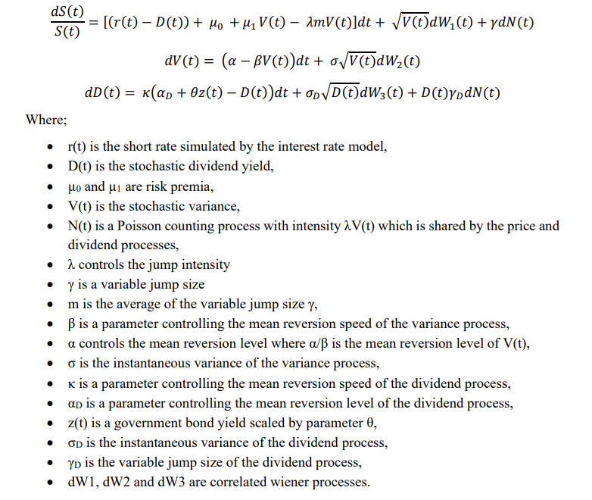
Equation 1: Key GEMS Equity Equations

There are several key reasons that Conning has built this relationship into our equity model. There are also some key items that should be considered about proposed changes to this relationship.

Relative Returns
One of the key reasons to have this link is to reflect that investors make tradeoffs between different investments. For example, if Treasury Yields returned to their double digit 1980’s level, what would expected equity returns be? The AIRG has no link between interest rates and equities. Comparing Figure 1 and Figure 2, we see that the AIRG produces large shifts in the Bond returns when the Yield curve shifts, but no changes in Equity returns. This means that there can be very different tradeoffs between these different Assets. For example, in the Figure 2 elevated Yield scenario, Money Market investments are expected to have higher returns than US Large Cap Equities despite much lower expected volatility.
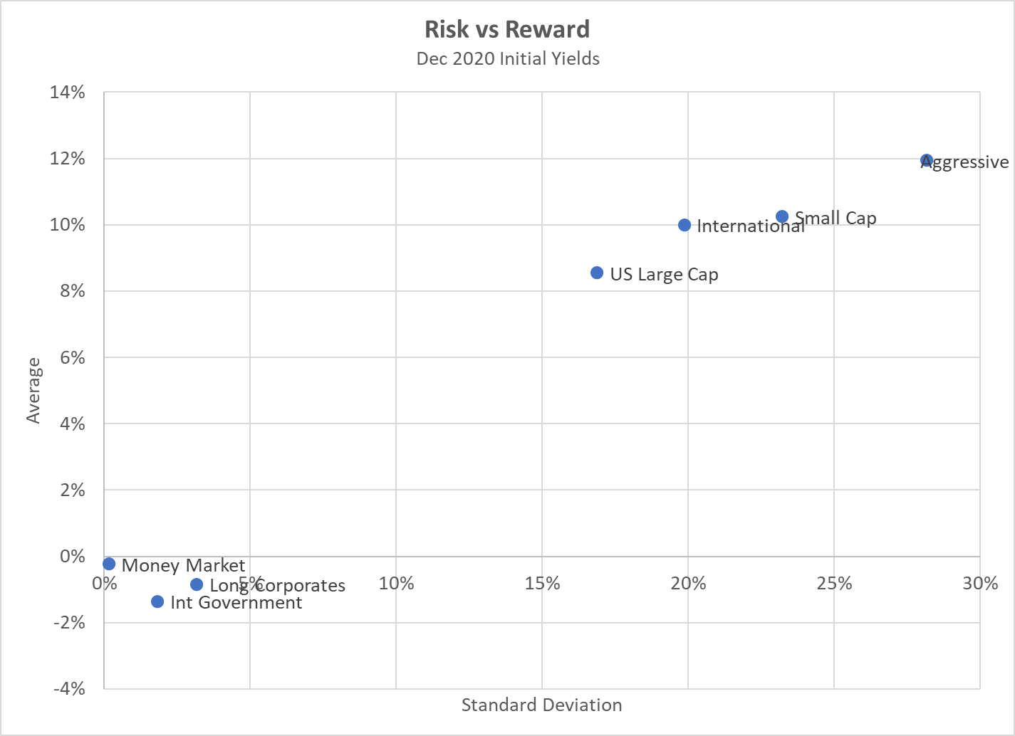
Figure 1: First Year Risk and Reward for several Asset Classes from the AIRG model based on December 2020 Initial Yields
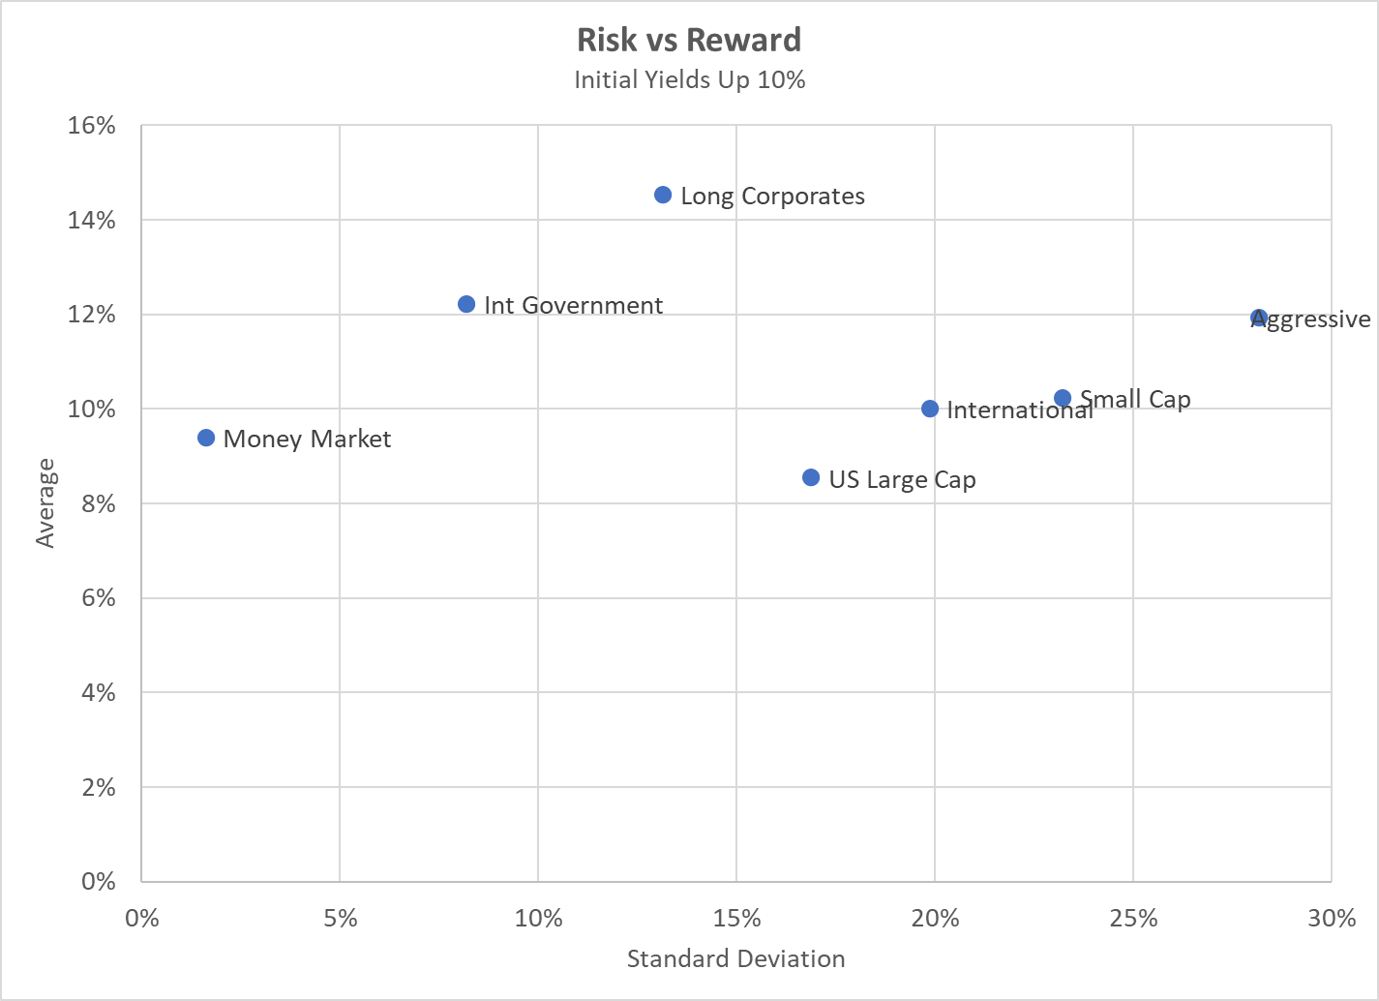
Figure 2: First Year Risk and Reward for several Asset Classes from the AIRG model based on shifting December 2020 Yields up 10%
To avoid this situation, there really aren’t many options other than a structural linkage between the Equity and Treasury models. Changing the correlation between the Asset Classes won’t affect these relativities. Changing the parameters between runs won’t affect these relativities within a specific run. The only other plausible choice would be to switch to a different point than the Overnight Yield on the Treasury curve since the levels of different tenors tend to move together in the simulation.

Hedging
Since one of the most common risk management tools that Life insurers use for the products covered by these scenarios is hedging, it can be useful to ensure that there is a reasonable relationship between these scenarios and how the derivative market prices securities. In particular, since derivatives are priced based on Risk Neutral models, this would lead us to have the kind of direct link to short Treasuries that is embedded in GEMS. For example, if you look at the Black-Scholes equation (see Figure 3), you see that there is a direct link to the Treasuries. Consider a delta-hedging strategy on a company’s VA GMDB exposure where the separate account investments are all in the S&P 500 index. The delta hedging strategy would consist of shorting the S&P 500 index and purchasing a risk-free asset (i.e. US Treasury). If expected equity returns aren’t linked to Treasuries, then hedging will actually create a link between an insurer’s net equity exposure (i.e. long position +/- hedge exposure) and Treasury Yields. If they are linked, then hedging would be expected to offset the underlying Treasury exposure in the long investment.
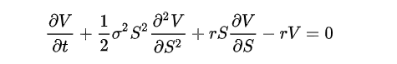
Figure 3: Black-Scholes equation: V is the price of the option, S is the price of the stock, σ is the volatility of the stock and r is the risk-free rate

Common Practice
The AIRG does not link expected equity returns to short Treasury yields. However, directly linking expected equity returns to short Treasury Yields is a fairly common practice. For example, the Capital Asset Pricing Model assumes that expected returns on risky assets are a combination of Treasury Yields and a Risk Premium based on their systemic equity risk. In fact, the entire concept of an “Equity Risk Premium” is based on comparing expected equity returns to Treasury Yields, typically short tenor ones. You can see an example of this linkage in the American Academy of Actuaries’ VA RBC Report when justifying having lower expected future than historical returns.

This relationship is not just theoretical: we also see signs of it in practice. For example, most pension funds rely heavily on a Discount Rate to set their liabilities. This Discount Rate is meant to track with the pension’s expected returns on their assets. Over the past decade, most pension funds have seen a gradual decrease in their Discount Rate such as the example shown in Figure 4 for the Ontario Teacher’s Pension Plan. This is despite the fact that equity returns have generally been quite robust over this same period: the average annual return on the S&P 500 has been over 16% during the last decade.
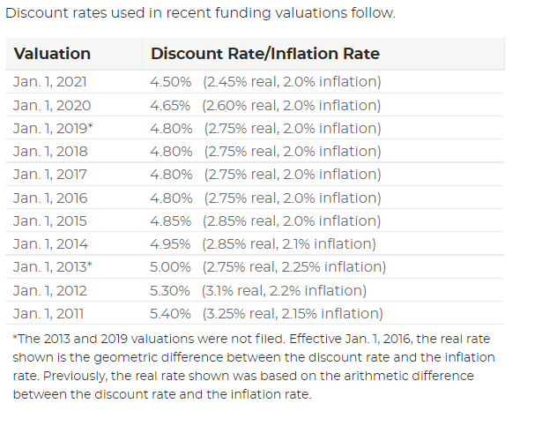
Figure 4: Historical Discount Rate for the Ontario Teacher’s Pension Plan (Discount Rate - Ontario Teachers' Pension Plan (otpp.com))

Correlation
There has been some concern expressed that this direct relationship will create a larger correlation between Treasury Bonds and Equities than that observed in the historical data. However, that is not a likely outcome from GEMS given the marked difference in expected volatility for Treasury Bonds vs. Equities. For example, in the Revised Baseline scenarios for December 2020, the 1-Month Spot has a standard deviation of about 2.5% at the end of 30 simulation years. At that same point, the US Large Cap has a standard deviation of about 17%. Figure 5 shows that this wide disparity in volatility produces correlations that stay below 10% between US Large Cap and all three Government Bond classes (i.e. Short, Intermediate and Long Government Bonds).
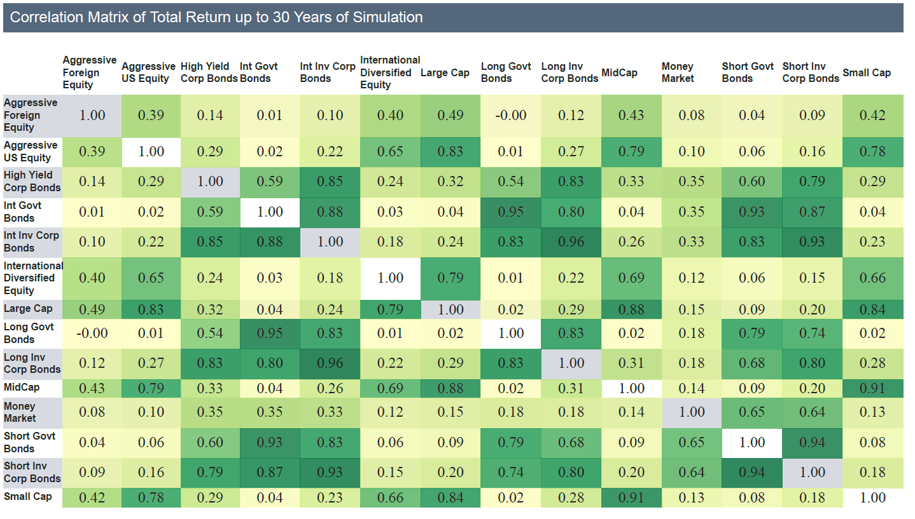
Figure 5: Correlations between Asset Class Returns for the Revised Baseline scenarios for December 2020

Selected Tenor for Linkage
There was some concern about linking equity returns to the short rate. Specifically, since the short end of the curve has tended to be more volatile, linking to it might create more variability in the expected equity returns. For example, Figure 6 shows that the 1-Month Yield dropped about 1.5% over 2020. The proposal was to possibly switch to a longer, less volatile portion of the Treasury curve, say the 10-Year. In 2020, that would have meant a drop of only about 1.0% in the initial value.
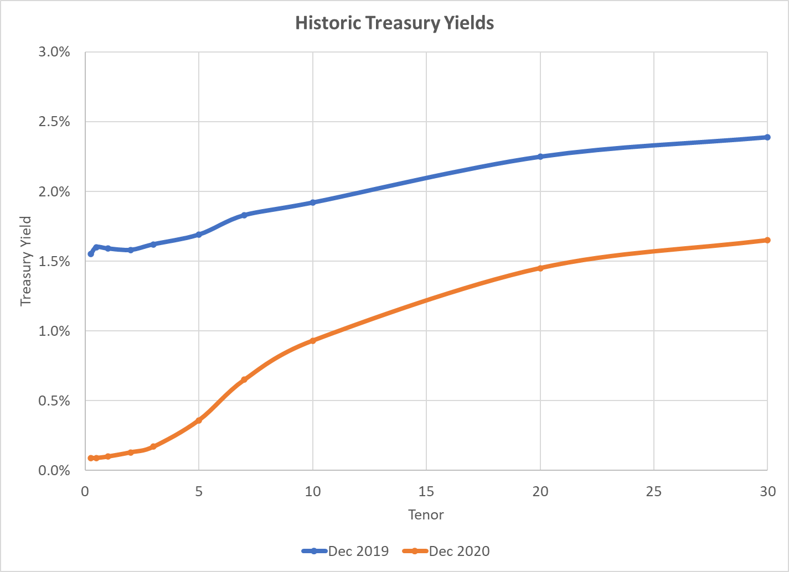
Figure 6: Comparison of Treasury Yield curves from December 2019 and 2020

In Figure 7, we can see that this magnitude of change in initial Treasury Yields equates to a little over 12% difference in projected Equity returns over a typical 30-year projection period for the Revised Baseline calibration. What may be less clear is that switching the link from the Overnight Treasury to the 10-Year Treasury would have had only a minimal impact on this delta: Conning estimates the difference in cumulative equity returns would have still been almost 11% lower despite the much smaller change in the initial 10-Year Yield. While the magnitude of this difference is tied to the Treasury calibration, it is tied to a feature that will almost certainly be included in the final selection: long Yields revert slower than short Rates do. This feature means that changes in the 10-Year Yield will take longer to revert away than those for the Overnight Rate. So, the cumulative effect on equity returns of using the Overnight Treasury vs. the 10-Year Treasury is likely to be much closer than the differences in their Yields would suggest.

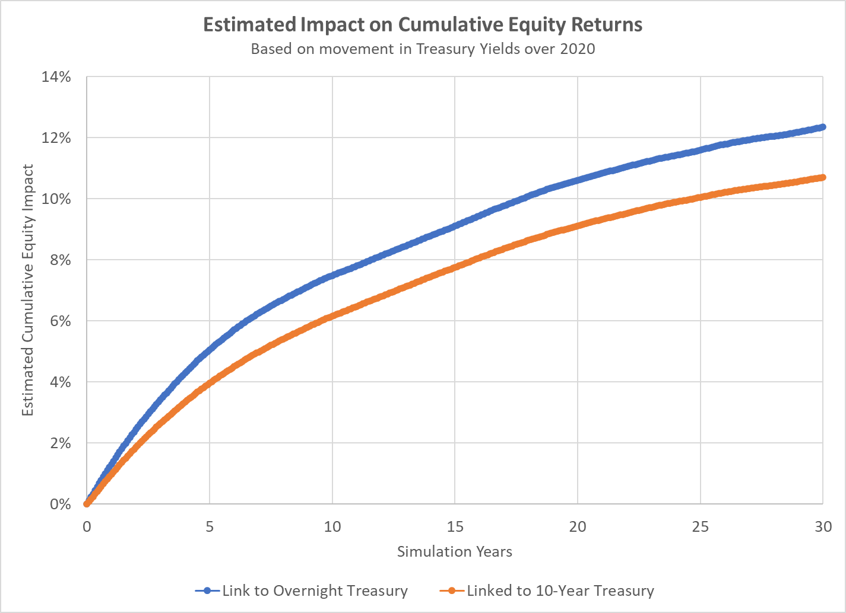
Figure 7: Estimated impact of change in 2020 Treasury Yields on Cumulative Equity returns based on two alternative linkages

Page 27 of “AAA C3 Phase 2 Final Report 2005 – 06 with TOC.pdf”, June 2005
S&P 500 Total Returns by Year Since 1926 (slickcharts.com)
The correlations in earlier projection periods will be different, but the same considerations will apply to them. For example, the corresponding number at the end of year 1 is around -5% for all three of these categories.
That difference is a function of both the initial Yield differential and the selected mean reversion speeds for the state variables. As a result, the actual impact would depend on the Treasury calibration.
This is also a feature of the current AIRG model.

