AG 51 GUIDANCE DOCUMENT – YEAR-END 2026

Below is a request for information related to companies’ long-term care insurance (LTCI) asset adequacy testing that is being sent to each company filing an Actuarial Guideline 51 (AG 51) Memorandum. The request is related to a Valuation Analysis Working Group of the National Association of Insurance Commissioners project to review AG 51 reserve analysis. For each of the items below, please provide an answer or point to the section and page in the AG 51 filing where the item is addressed. The same confidentiality standards will apply to this information as applied to the AG 51 memorandum. The response should be sent as separate section of the AG 51 filing on the AG 51 filing due date.

I. Inforce

a. Provide charts containing the distribution of business (number of lives) by issue age and attained age band, issue year, coverage type, inflation protection, benefit period, and premium payment period. For premium payment period, distinguish between inforce policyholders with lifetime premium periods, inforce policyholders with limited-pay premium periods but still paying premiums, and inforce policyholders no longer paying premiums. In these charts, please exclude policyholders on claim. A consolidated spreadsheet template is being provided to help standardize this reporting of the policy inforce. Please use the template “AG 51 Guidance Document YE 2026 Requests - Consolidated.xlsx” [Inforce Data] tab and return a copy with the response.



II. Morbidity

In this context, morbidity refers to claim incidence rates, length of claim, and claim utilization.

a. Provide the year of the most recent morbidity study applied to support the company’s morbidity assumptions and provide the data period covered in the study. Explain which aspects of morbidity assumptions are reviewed on an annual basis and which are reviewed on a less frequent basis.

b. Discuss the general trend in morbidity experience and expectations over the past year and past several years at the company. If the trend has been in the direction of higher morbidity overall or in certain attained-age ranges, explain the extent to which this finding is reflected in updated assumptions. Also, if the company uses a claims-cost model (as opposed to a first-principles model), explain how company and/or industry trends in incidence and length-of-claim are tracked and reflected in updated assumptions.

c. Discuss the relevance of outside morbidity data applied to support the company’s morbidity assumptions, along with how that data was adjusted to fit the company’s circumstance and how the fit was determined to be appropriate. Explain how validation to historical company experience was performed.

d. Discuss whether and how the morbidity assumptions were compared with industry-average morbidity rates. Is there a reason for company assumptions to be higher or lower than industry average experience, such as benefits provided, policy provisions, underwriting standards, or claims practices? Note that the most recent Society of Actuaries’ (SOA) morbidity study is based on 2000-2016 data and may understate future morbidity in many instances. If the SOA table is relied upon, provide information on how morbidity assumptions used by the company are based on updated experience.

e. Discuss how morbidity assumptions for attained ages 85 and over were set in light of potential gaps in availability, credibility, and relevance of supporting data.

f. Discuss whether the company expects changes in morbidity assumptions in upcoming years as older-age experience develops. Describe how the company added margin to the morbidity assumption to address a potential increase in morbidity expectations. Also, please express a confidence interval of claim-cost-related assumptions for attained ages 90 and 95, including how the interval was determined. Does any sensitivity testing of the impact of adverse developments in morbidity appropriately address the level of potential older-age morbidity assumption increase?

g. Discuss assumed morbidity improvement (if applicable) and the basis for that assumption. Is the assumption supported by company experience? Does justification go beyond studies performed on the population as opposed to studies performed on insureds? Also, explain if the morbidity improvement and mortality improvement assumptions were determined separately. If not, please state the rationale.

h. Where applicable, provide an overview of changes in morbidity assumptions from those used in the previous AG 51 filing, including the basis for any changes.

i. Discuss assumed benefit utilization (current and projected future), including the cost-of-care inflation assumption. Explain the extent to which cost of care inflation is assumed to correlate with the company’s projected interest rate scenarios and provide justification for this assumption. Provide the current average daily maximum benefit for policies with 5% compound inflation protection, policies with other inflation protection, and policies with no inflation protection.

j. Discuss the assumed underwriting wear-off pattern, duration in years of the wear-off, and the impact on beyond-select period morbidity assumptions. For policy durations 5, 10, and 20, provide the range of incidence rates for the best and worst underwriting classes for unmarried policyholders. If applicable, provide support for assumed differences in ultimate incidence rates between underwriting classes.

k. Explain whether incidence rates are determined using a denominator that is based on total lives or active lives. If the projections use a different denominator than the studies used to determine the incidence rate assumptions, please explain how adjustments are made to reconcile the difference and provide an example of this reconciliation, if possible. (If the company uses a total claim cost model, please address this question assuming that “incidence rates” were replaced with “claim costs”).

l. To help in understanding the morbidity assumption, calculate the present value of future benefits as of policy duration 10 of the following set of policies, each with $150 initial daily benefits, 2 ADL or severe cognitive impairment trigger, and 85- to 105-day elimination period:
i. Female, issue age 55, lifetime benefits, 5% compound inflation
ii. Female, issue age 55, 3-year benefits, no inflation

For each calculation, use the following prescribed assumptions for the following factors:
- Ultimate, annual voluntary lapse of 0.5%
- 2012 IAR mortality, assuming a 1/1/2017 policy issue date, applied to active lives
- 4% discount rate
- Assume the most preferred underwriting classification that contains at least 30% of the lives
- Assume a single female with no partner discount.

Use the company’s assumptions for AG 51 calculations on claims’ incidence, length of claim, benefit utilization, and any other morbidity-related aspect. Please indicate if this morbidity assumption includes moderately adverse margins or not.
Provide a spreadsheet demonstrating the calculation (e.g. including all applicable inputs and calculations/formulas) in support of the present value figures, and provide commentary to explain any changes to the results from last year.

m. This request is intended to help in the understanding of differences in companies’ morbidity assumptions underlying the present value amounts calculated in association with item II.l immediately above.

For the present value calculation associated with two cells:
i) female, issue age 55, lifetime benefits, 5% compound inflation and
ii) female, issue age 55, 3-year benefits, no inflation,

Please provide the following durational information used in the present value calculation for each cell:

For attained ages 65, 70, 75, 80, 85, 90, 95, and 100:
- 1-year incidence rate assumption
- Maximum Annual Benefit, equal to 365 times Maximum Daily Benefit, inflated at 5% per year for the 5% compound inflation cell
- Utilized Annual Benefit
- Length of stay assumption over an entire claim for a claim starting at the specified attained age
- Total Claim Cost for a claim started at the specified attained age

A preferred format for this information is shown below (Submissions in Excel are preferred):

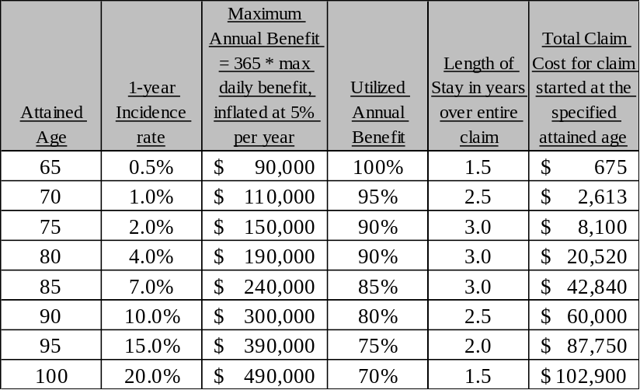

The assumptions above should only be provided for one year associated with the specified attained ages, not as the sum or average over a quinquennial range.
It is anticipated that the final column will be the product of the four preceding columns. If this is not the case, then please provide a narrative description of any adjustments.
A spreadsheet template AG 51 Guidance Document YE 2026 - Assumptions for Sample PVFB.xlsx is being provided to help standardize this reporting of the policies inforce. Please use this tool and return a copy with the response.



It is preferred that any adjustments to incidence rates, including morbidity improvement, underwriting, spousal discount, etc., be embedded in the incidence rates in the table.

If the company uses a total claim cost model, please provide the total claim cost data column as well as any other data columns that are available.

Also, if there are any other factors not included in the table above that you believe could potentially lead the company’s present value amounts to be lower or higher than industry averages, then please include a narrative description. Identify if, for any of the cases in the two cells above, you believe the results are impacted by more conservative morbidity assumptions having been selected due to lower-than-average company credibility for that specific issue age and/or benefit type. Please identify whether the company morbidity assumptions used for this exercise were best estimate assumptions or included margins. Also identify if the morbidity assumptions used by the company and reflected in the calculations are unisex or gender-specific. Please explain if the attained age values shown in the table are for total lives or active lives.

In addition, please identify the type of product used as the basis for the calculation, in particular whether it was an expense reimbursement product, an indemnity (also known as cash) product, or another type. If there are other significant product aspects that are unique, please include a description. Identify whether the product is individual or group.

III. General assumptions.

a. Discuss the relevance of outside data and/or analysis applied to support the company’s non-morbidity-related assumptions, along with how that data and/or analysis was adjusted to fit the company’s circumstance and how the fit was determined to be appropriate. Explain how validation to historical company experience was performed.

IV. Reinsurance treaty information

a. Provide information on any new LTCI-related reinsurance transactions or significant changes to existing LTCI-related treaties that occurred in 2026.

b. Provide information on reinsurance ceded treaties that warrant careful review related to collectability. Discuss aspects of that review that have been conducted.

V. Sensitivity Tests

If the company performed cash-flow testing, provide the present value of ending surplus in a level interest-rate scenario using baseline assumptions. If the company performed a gross premium valuation, provide the resulting value using baseline assumptions. Also, provide the same values using all baseline assumptions except:

a. No morbidity improvement and no mortality improvement.

b. No morbidity improvement but with mortality improvement.

c. No future, non-approved premium rate increases.

d. Net yield pickup on existing and reinvestment assets at 150 basis points above Treasury yields at the time the asset was purchased or will be purchased. This spread applies as an average over the entire portfolio supporting the LTCI block. Please describe any simplifying methodologies performed to accomplish this test.

e. 80% benefit utilization of the projected total daily benefit amounts for products with higher-than 3% annual inflation protection. If a first-principles morbidity approach is not used, therefore making the utilization assumption difficult to isolate, please complete the analysis and provide the result using a modeling approach that in the judgment of the company best approximates the request. Then describe how the chosen method approximates the future utilization assumptions in the model for purposes of this sensitivity test.
Please use the template (attached in Section I) “AG 51 Guidance Document YE 2026 Requests - Consolidated.xlsx” [CFT Results] tab and return a copy with the response.

VI. COVID-19 impact

Related to COVID-19 and related economic market disruptions:

a. Please provide your observations, if any, on the impact of COVID-19 on your company’s LTCI block.

b. Please discuss and describe if you have made any changes to short-term or long-term projection assumptions (e.g. mortality, morbidity, investment yields, etc.) as a result of COVID-19 and/or your most recent experience.

VII. Asset / Liability Risk Management
The requests in this section are intended to help in the understanding of the company’s risk management approach for asset strategies aiming to ultimately support the contractual claim payments of the liabilities.
- Please provide your observations in the table below, if any, at each year-end reporting where they are or can be made available. Please use the template (attached in Section I) “AG 51 Guidance Document YE 2026 Requests - Consolidated.xlsx” [ALM Metric] tab and return a copy with the response.

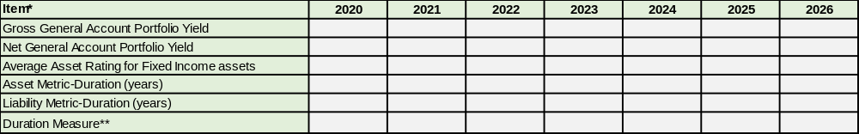

The risk and/or sensitivity metric is most appropriately expressed by a duration measure, for example, a Macaulay Duration and/or an Effective Duration. Please provide any or all of these that the company has available. Weighted Average Life is less informative.
- Please provide your projections of the elements in the table above, at each scenario’s year-end for the Cash Flow Testing sensitivity tests performed. Please use the template (attached in Section I) “AG 51 Guidance Document YE 2026 Requests - Consolidated.xlsx” [Section VII (b)] tab and return a copy with the response.

- Please provide commentary regarding alternative assets if this asset class has a substantial impact on the asset risk / sensitivity metric provided above.

AG 51 provides uniform guidance for the asset adequacy testing applied to a company’s LTCI block of contracts, and is effective for reserves reported with respect to the Dec. 31, 2017, and subsequent annual statutory financial statements. A statement of actuarial opinion on the adequacy of the reserves and assets supporting reserves after the operative date of the Valuation Manual is required under Section 3B of the NAIC Standard Valuation Law (#820) and VM-30 of the Valuation Manual. Section 14A of Model #820 provides that actuarial opinions and related documents, including an asset adequacy analysis, are confidential information, while Section 14B provides that such confidential information may be shared with other state regulatory agencies and the NAIC. The asset adequacy analyses required under AG 51 reviewed in the preparation of this report were shared with the Valuation Analysis (E) Working Group and the NAIC in accordance with these requirements, and continue to remain confidential in nature.

