Request from Chair:
The Adjuster Licensing (D) Working Group is currently reviewing the Independent Adjuster Licensing Guideline (GL 1224) with particular attention to definitions for “Staff (Company) Adjuster” and “Designated Home State”. Initial revisions have been prepared by the Working Group Chair and Vice Chair and are now available for review.
Please review the draft revisions for GL 1224 and provide your suggestions/comments by Friday, June 19, 2026, to Gwelker@naic.org and Rachel.Chester@dbr.ri.gov.
Initial revisions prepared for review and comment are the following:
Adding two Drafting Notes under Section 1
Drafting Note: A state may adapt these guidelines to include staff (company) adjuster licensing where required.
Drafting Note: A state that issues independent adjuster licenses but does not require licensure of staff adjusters may consider permitting a staff adjuster who is a resident of that state to obtain a resident independent adjuster license to facilitate reciprocal licensure in other states.
Adding the definition of “Designated Home State” and a related drafting note
- “Designated Home State” means a qualifying state or territory of the United States that issues independent adjuster licenses that will permit a nonresident who resides in a state that does not license independent adjusters to designate that state as their home state by meeting the same application requirements that apply to residents of that state. A state or territory qualifies as a Designated Home State if that jurisdiction requires its resident independent adjusters to pass a license examination to meet the knowledge qualification, require a national criminal background check to meet the fitness and character qualification, and complete continuing education as required in this Guideline to ensure continued compliance.

Drafting Note: A state may choose to expand the definition of designated home state to include granting designated home state status to business entities where applicable.
Amending the definition of “Home State”
E.F. “Home state” means the District of Columbia and any state or territory of the United States in which an independent adjuster maintains his, her or its principal place of residence or principal place of business where the adjuster physically works or is physically located and is licensed to act as a resident independent adjuster. If the resident state does not license independent adjusters for the line of authority sought, the independent adjuster shall designate as his, her or its home state any state in which the independent adjuster is licensed and in good standing.

Adding the definition of “Staff (Company) Adjuster (as copied from Appendix K)
K. “Staff (Company) Adjuster” means a person who is a salaried employee of an insurer or an affiliate of the insurer, and who is engaged in adjusting insured losses solely for that company or other companies under common control or ownership.

COMMENTS RECEIVED

South Carolina Comments
First suggestion:
The lettering should reflect that the definition of “Uniform Business Entity Application” should be M instead of K. 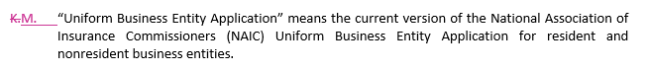
Chair/Vice Chair comment: agreed! Will also update K to M in the Drafting Note directly below the “Uniform Business Entity Application” definition.
Second suggestion:
Section 5, C “Do we need to add verbiage or a Drafting note that states ‘or as otherwise declared by statute or regulation’?”
Chair/Vice Chair comment: This section is not currently under review.
Final suggestion:
Section 9, A “There appears to be double spacing between was and licensed. The double spacing appears a few more times throughout the document.”
Chair/Vice Chair comment: agreed! We will make updates to the true drafting errors that are insignificant to the substance of the document.

Minnesota Comments
We offer the following for your consideration as a restructured presentation of the definition of “Designated Home State”:
“Designated Home State” means a qualifying state or territory of the United States that:
(1) issues independent adjuster licenses;
(2) requires its resident independent adjusters to (a) pass a license examination to meet the knowledge qualification, (b) undergo a national criminal background check to meet the fitness and character qualification, and (c) complete continuing education as required in this Guideline to ensure continued compliance; and
(3) will permit its designation as the home state of a nonresident who resides in a state that does not license independent adjusters, if that nonresident meets the same application requirements that its residents must meet.
Chair/Vice Chair Comments: agreed!
Michigan’s Comments
First suggestion: MI’s suggested edits are in blue
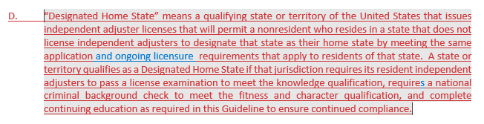
Chair/Vice Chair Comments: agreed!
Second suggestion: MI’s suggested edits are in blue
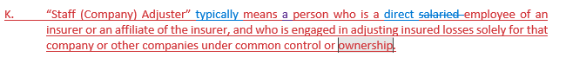
Chair/Vice Chair Comments: agree with “direct”.
Note: Michigan has several other comments on sections that are not currently under review, perhaps for future consideration.
California Comments
First suggestion:
CA’s edits are in blue
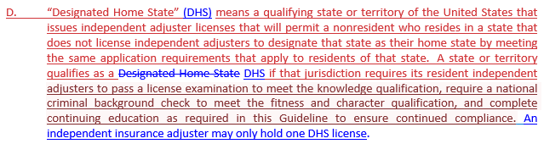
Chair/Vice Chair Comments: we agree on the abbreviation of DHS and subsequent usage. Regarding the addition of the last sentence, it is recognized that licensees claiming multiple DHS states is an issue to be addressed; however, there are legitimate circumstances where a licensee may need to hold more than one DHS or possibly even a resident license and a DHS license because a line of authority may or may not be issued in a jurisdiction.
Second suggestion:
Section 7 B - CA’s edit is blue
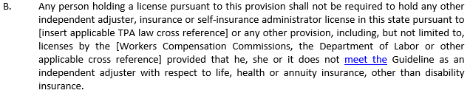
Chair/Vice Chair Comment: agreed! While not captured in South Carolina’s suggestions above, SC also suggested words were missing and CA’s edit works well.
Third Suggestion:
Section 11, B (2) CA’s edit is blue
Chair/Vice Chair Comments: the same as the comments noted for CA’s first suggestion.
(CA COMMENTS CONTINUE ON THE NEXT PAGE)
Fourth suggestion:
Section 11, C (5), CA’s edit is blue
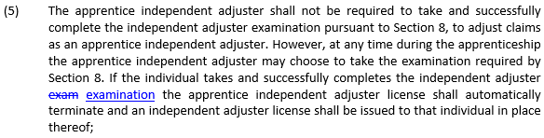
Chair/Vice Chair Comment: agreed. This is a technical correction for consistency. We will review the entire document for any other occurrences.
Final Suggestion:
CA’s suggested additions are in blue
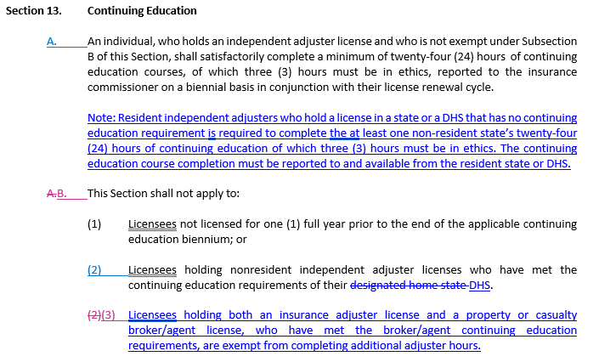
Chair/Vice Chair Comments: This section is not currently under review.

(INTENTIONALLY BLANK, GO TO NEXT PAGE)
SILA COMMENTS
First Suggestion:
“Our recommendation is to remove the “or physically located” from the definition, to read:
“Home state” means the District of Columbia and any state or territory of the United States in which an independent adjuster maintains his, her or its principal place of residence or principal place of business where the adjuster physically works and is licensed to act as a resident independent adjuster.
The inclusion of the phrase “Or physically located” in the definition is duplicative to the “adjuster physically works”. The inclusion also leaves room for interpretation of the physical location of the individual or business. The SALS Steering committee is also requesting clarification as to what issue is trying to be fixed with the modification to the language in the “home state” definition.”
Chair/Vice Chair Comments: Many jurisdictions have presented concerns about rampant abuse of using a business address as a home state when an individual never physically goes to that business address. The intent here is to draw attention to the actual place that the person reports to for work every day, not just to capture where they might have to drive to inspect a particular loss on any given day (which might also mean “adjuster physically works”). A business state in another state is acceptable, it just can’t be a “home state” if the individual doesn’t actually physically work there – this is an important distinction.
Second Suggestion:
“The second recommendation for change is to remove the word “Salaried” from the definition of Staff (Company) Adjuster (Section 2.K).
“Staff (Company) Adjuster” means a person who is a (salaried) employee of an insurer or an affiliate of the insurer, and who is engaged in adjusting insured losses solely for that company or other companies under common control or ownership.
The existing definition that states “salaried employee” excludes individuals that are time-card employees. Removing the addition of “salaried” and stating the definition as “employee” will ensure the definition is more inclusive of the Staff Adjuster population.
Chair/Vice Chair Comments: This is in sidestep with Michigan’s comments.

(SILA COMMENTS CONTINUE ON THE NEXT PAGE)
Final Suggestion:
The SALS Steering Committee is also requesting the NAIC State Licensing Handbook- Chapter 18 be reviewed in consideration with the proposed changes to the Independent Adjuster Licensing Guideline. Both documents reference one another, and to ensure uniformity in the modifications of the definitions.
Chair/Vice Chair Comment: agreed, as applicable.

Industry Comment – Old Republic Title
“With regard to the definition of “Staff (Company) Adjuster,” I assume that the Working Group intended to use that phrase somewhere within the Guideline. It would seem appropriate to include that phrase within Section 4 (Exception to License Requirement). The amendment could be as simple as adding a Subsection N in Section 4 that reads: “A ‘Staff (Company) Adjuster.’”
Chair/Vice Chair Comments: There are jurisdictions that require company/staff adjuster licensing. We believe that the drafting notes in Section 1 address this appropriately. As such, we do not recommend that company/staff adjusters be included in Section 4 as an exception to the licensing requirement.

