Life Actuarial (A) Task Force/ Health Actuarial (B) Task Force
Amendment Proposal Form

- Identify yourself, your affiliation and a very brief description (title) of the issue.
This APF was jointly prepared by the Staff of Office of Principle-Based Reserving, California Department of Insurance and NAIC Support Staff.

This APF addresses recommendation #26 from VAWG’s 10/24/2018 memo regarding PBR Recommendations and Referrals to LATF.

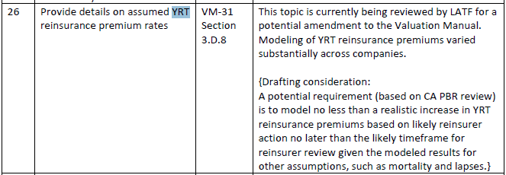

- Identify the document, including the date if the document is “released for comment,” and the location in the document where the amendment is proposed:

Valuation Manual (January 1, 2019 edition), VM-20 Section 8.C.18 (New Section) and VM-31 Section 3.C.8.b
- Show what changes are needed by providing a red-line version of the original verbiage with deletions and identify the verbiage to be deleted, inserted or changed by providing a red-line (turn on “track changes” in Word®) version of the verbiage. (You may do this through an attachment.)

Please see the attached Appendix.

- State the reason for the proposed amendment? (You may do this through an attachment.)

Please see the attached Appendix.

.

NAIC Staff Comments:

Dates: Received | Reviewed by Staff | Distributed | Considered
2/25/19
Notes: APF 2019-17 (CA OPBR/NAIC PBR) rev. 2/27/19

W:\National Meetings\2010\...\TF\LHA\

© 2015 National Association of Insurance Commissioners

Appendix

ISSUE:

During the review of 2017 PBR reports, regulators noted wide variance in the modeled future YRT premium rates. This wide variance did not appear to be driven by differences in the situations of, and increases likely to be experienced by, the different companies. Companies have expressed uncertainty in how to develop this prudent estimate assumption. Many have companies also expressed a desire that additional guidance be added to the Valuation Manual on this aspect of PBR.

While regulators were concerned with the lack of support for the assumptions applied in the 2017 PBR reports, this appeared to be an inevitable result of the difficulty of determining an appropriate prudent estimate assumption for future YRT premium rates. Regulators found that even more concerning was the apparent unfairness across companies that the diverse approaches created.

While CA had originally considered a more general recommendation, as noted in the drafting consideration in VAWG 26, it was subsequently determined based on re-reviewing the variety of margins applied in the 2017 PBR reports that this would do little to eliminate the wide variance across companies and the resulting fairness issue. Instead, CA and the NAIC have based a proposal on the APF submitted by Transamerica, Prudential, and John Hancock, following a similar principles-based approach, with modifications to reflect:
- Reinsurers will also increase YRT rates to reflect the implicit margin in PBR due to the restriction on future mortality improvement.

A Question that we would request commenters respond to is whether the mortality improvement should be specified as applying for 10 years, 15 years, the same length of time that mortality improvement is generally applied in AAT, or some other approach.
- The unmodified Transamerica/Prudential/John Hancock approach would have unfairly penalized companies with very low credibility blocks. While a company’s mortality margin is higher due to very low credibility and a very short sufficient data period (SDP), these are not aspects that would be paralleled in the mortality on the reinsurer’s larger block and so would not trigger the same response.
- Reiterate explicitly that approximations may be used in lieu of a full recalculation of the prudent estimate mortality using increased credibility.
- State explicitly that no margin should apply for years when the reinsurance features are guaranteed.
- Add appropriate disclosure requirements.

SECTIONS:

VM-20 Section 8.C.18 (New Section) and VM-31 Section 3.C.8.b

REDLINE:

VM-20 Section 8.C.18 (New Section)
- When projecting non-guaranteed future reinsurance features, the company shall use prudent estimate reinsurance premiums in projecting the reinsurance cash flows. The ceding company shall project reinsurance cash flows pursuant to all provisions within a reinsurance agreement and shall determine the prudent estimate reinsurance premiums using the following procedure:
  - Use the reinsurance rates and provisions from the relevant reinsurance agreement as the anticipated experience assumption for reinsurance, subject to any modifications in Section 8.C.18.c. No margin is required for years in which the reinsurance features are guaranteed. For years when reinsurance features are not guaranteed, Section 8.C.18.b below sets forth the prescribed reinsurance premium margin.
Guidance Note: While the most commonly considered non-guaranteed reinsurance feature is future YRT premium rates, other non-guaranteed features are also to be considered, such as non-guaranteed expense allowances.

  - Set the reinsurance premium margin equal to λ times the reinsurance premium rate, where λ = [(i) – (ii)] divided by (ii), in which (i) and (ii) are described below:
    - “Baseline credibility” prudent estimate mortality, i.e., prudent estimate mortality following Section 9.C.1 through Section 9.C.6, but recalculated (1) with the margins determined under Section 9.C.5.b modified to reflect a credibility percentage equal to the greater of the one originally determined pursuant to Section 9.C.4 and 80% and (2) with grading modified to reflect a sufficient data period equal to the greater of the one originally determined pursuant to Section 9.C.6.b.ii and 10 years.
    - Company experience mortality as provided in Section 9.C.2, but recalculated including mortality improvement beyond the valuation date. Mortality improvement rates shall equal the greater of (1) the future mortality improvement rates that the company actually expects to occur and (2) the mortality improvement rates of Section 9.C.3.g, whether or not the company chose to apply mortality improvement to the industry basic mortality table.
Guidance Note: Simplifications or approximations to estimate the effect of the “baseline credibility” prudent estimate mortality in Section 8.C.18.b.i are permissible if they comply with VM-20 Section 2.G.
For example, in situations where the sufficient data period originally determined pursuant to Section 9.C.6.b.ii was greater than or equal to 10 years, there is a simple approximation. Separately for the 2008 VBT limited underwriting, the 2015 VBT using Limited Fluctuation, and the 2015 VBT using Bühlmann, for a given credibility percentage, X%, the ratio of the margin with X% credibility to the margin with 80% credibility is fairly stable across all attained ages. Thus, the effect of the baseline credibility can be approximated by calculating (i)′ by following Section 8.C.18.b.i using prudent estimate mortality rather than “baseline credibility” prudent estimate mortality and then obtaining (i) by multiplying (i)′, by Ɵ/100 in durations prior to when grading begins, by (100 + Ɵ)/200 in the grading durations, and by 1.0 in durations after grading is complete, where Ɵ is:
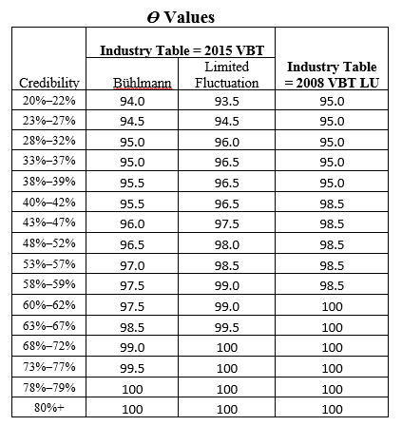

Guidance Note: In the case where applicable industry tables are used in lieu of company experience, Section 8.C.18.b.i would be the industry tables, but using company experience margins corresponding to the baseline 80% credibility and grading corresponding to a sufficient data period of 10, graded into that same industry table with industry margins. Similarly, Section 8.C.18.b.ii would be the industry tables, with future mortality improvement applied using the mortality improvement rates in Section 9.C.3.g.

  - Reinsurance premium prudent estimate assumptions may be modified if, in the company’s judgment, the prescribed reinsurance premium prudent estimate assumptions do not appropriately reflect the expected reinsurance premium experience under a moderately adverse scenario. In cases where the reinsurance premium prudent estimate assumptions are modified, the modifications must not result in reinsurance premium anticipated experience assumptions that are lower than those prescribed in Section 8.C.18.a or reinsurance premium margins that are lower than those prescribed in Section 8.C.18.b without prior approval by the domiciliary commissioner.

Guidance Note: Examples of reasons to modify the reinsurance premium prudent estimate assumptions include, but are not limited to, counterparty default concerns, reinsurance contract language that contains particularly restrictive or permissive provisions regarding reinsurance rate increases, and potential recapture of the reinsured business.

VM-31 Section 3.C.8.b

b. Assumptions – Description of reinsurance assumptions used to determine the cash flows included in the model, including the anticipated experience assumptions and margins for future reinsurance premiums reflecting non-guaranteed reinsurance features. For future reinsurance premiums, describe any adjustments made pursuant to VM-20 Section 8.C.18.c and provide the rationale for such adjustments.

REASONING:

As PBR becomes mandatory in 2020, the 2020 Valuation Manual should include clear guidance on the modeling of future YRT premiums.

