Steps to Clear Cache in Google Chrome

The steps shown here will apply to the latest versions of Google Chrome. However, the steps should be almost similar to whatever version you may be using.

Step 1: Click on the Chrome menu icon seated towards the right end, besides the address bar.

Step 2: Navigate to Tools -> Clear browsing data. If you love keyboard shortcuts you can use the Ctrl + Shift + Delete combination and ignore Step 1 and Step 2.
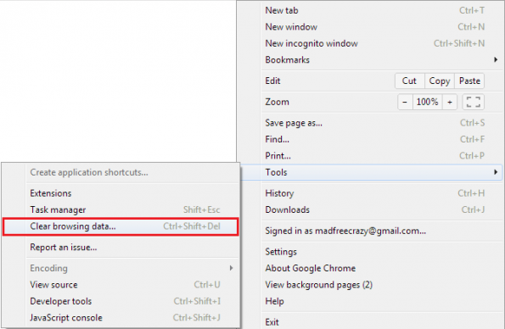

Step 3: A pop up (as shown below) will appear on your screen. Here, you can select, not just cache, but any browsing data that you wish to delete.

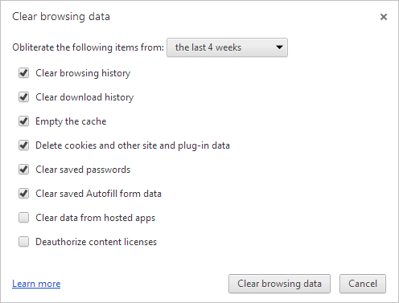

Step 4: Since we are concerned with browse cache, tick mark the option reading Empty the cache and uncheck all others. In order to clear cache completely we suggest that you select beginning of time from the drop down. Click on Clear browsing data when done.
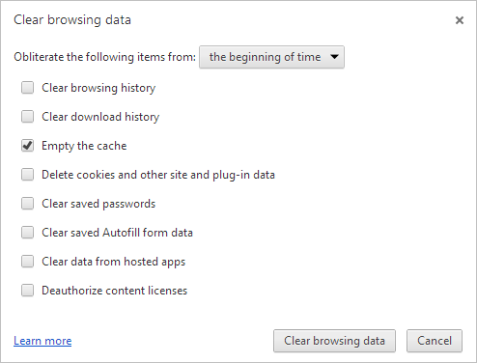
Cool Tip: We have covered Chrome settings URLs. So, you can also navigate to the data clearance page by using the URL chrome://chrome/settings/clearBrowserData. OR just use chrome://chrome/history/ and then click on Clear all browsing data button.
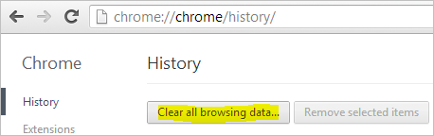

Conclusion
Clearing cache has its own set of advantages and disadvantages. Though, you may not want to lose the cache data (since, it is really useful), it becomes important to do so at times. Meanwhile, there is a small suggestion that I would leave with. Here it is.
Suggestion: If you are facing a problem and think it is due to browser cache issues, you should first try the browser’s incognito/private mode. And, if you still see the problem, it is not your cache, it is something else.
Also perform these steps:
Google Chrome
- Click the Chrome menu icon
- Select Settings.
- Near the bottom of the page, click Show advanced settings.
- In the "Privacy" section, click Content settings.
- Enable or disable cookies:
  - To enable cookies, select Allow local data to be set (recommended).
  - To disable cookies, select Block sites from setting any data.
  - CLICK MANAGE EXCEPTIONS (under cookies)
  - GO TO HOST NAME PATTERN AND ALLOW EXCEPTIONS FOR
    - Nipr.com
    - Naic.org
    - Paypal.com
- Click Done to save.

