


FINANCIAL STABILITY(E) TASK FORCE
Attachment Five

U.S. Insurance Industry

MACROPRUDENTIAL

RISK DASHBOARD
Summary Report
As of December 31, 2025
DRAFT

Published: August, 2026

Table of Contents
Executive Summary 4
Recommendations 6
Macroprudential Assessment 7
Macroeconomic Risk: Summary 8
Interconnectedness Risk: Summary 13
Underwriting & Profitability Risk: Summary 17
Market Risk: Summary 24
Credit Risk: Summary 28
Liquidity Risk: Summary 31
Capital Adequacy Risk: Summary 35
Emerging/Other Risk 38
Appendix A: Risk Assessment Scale 39
Appendix B: Insurance Industry by the Numbers 40

Macroprudential Risk Dashboard Summary
Risk Category | Trend | Summary of Assessment
Macroeconomic |  | The U.S. economy is strong based on traditional indicators. This is tempered by U.S. Sovereign rating agency downgrades and USD/FX volatility.
Interconnectedness |  | FABN issuance and Life Cross-border reinsurance activity continues an upward trend, while most other transmission channels of interconnectedness remain stable.
Capital Adequacy |  | Life and PC sectors remain very well capitalized with stable outlooks. However, the Health sector has experienced some capital deterioration and has a negative outlook by credit rating agencies.
Underwriting & Profitability |  | Life and PC sectors are profitable. However, Health experienced a significant decrease in net income and a profit margin. Nat Cat and LTC risks were also key risk drivers.
Credit |  | Private Credit, structured securities, and offshore life reinsurance exposure are the drivers of the Mod-high assessment.
Market |  | Common equity holdings increased, while private equity and other indicators remain stable. Level 3 assets are significant but remain stable.
Liquidity |  | PC and Life liquidity ratios and cash flows improved. Cash, ST investments and U.S. Gov allocations remain increased. Health cash flow and liquid assets have modestly declined.
Emerging/Other |  | Heightened monitoring of private credit, cross border reinsurance, AI and cyber continues and may overlap with other risk categories.

Risk Assessment Scale/Legend Trend Scale (Trend of the risk)
 | High |  | Significant Increase
 | Moderate-High |  | Increase
 | Moderate-Low |  | Stable
 | Low |  | Decrease
 |  |  | Significant Decrease

Executive Summary
Overall, the U.S. insurance industry continues its well-established pattern of adapting to a dynamic risk landscape and playing a key role in the financial sector by helping policyholders manage risk. Aggregate capital levels continue to increase overall and provide a significant buffer above regulatory capital requirements to absorb risk. Liquidity risk is deemed low as overall industry allocation to cash and short-term investments and U.S. Government securities is at the highest levels in the last five years.
Regulator Use
This report was derived from a detailed regulator only comprehensive risk dashboard. Each of the eight risk categories summarized in this report contains a set of key risk indicators that provide the basis for the assessment. Key risk indicators that have significantly changed or are key drivers of the risk assessment are highlighted in this report. State regulators may wish to review these industry-wide risk drivers to determine if the same or similar risks are impacting their individual regulated entities. The risks identified in this report may assist with the risk assessment components of financial analysis and completion of risk matrices during examinations.

Key Highlights:

Health Sector
Several risk indicators within the underwriting, Capital Adequacy and liquidity risk categories indicate increased level of risk in the Health sector. Specifically, capital has deteriorated, loss and combined ratios are elevated, cash flow decreased and some rating agencies have a negative outlook on the sector.

Private Credit
Private credit funds have experienced substantial growth in recent years, with assets under management (AUM) now comparable in size to the U.S. high yield corporate bond and leveraged loan markets, which has led to some increase in insurance company holdings in this area. Limited available information on borrower fundamentals and a lack of secondary market trading can make timely valuations challenging and result in limited transparency into the sector. These factors also make quantification of the exposure for the insurance industry a challenge.

Level 3 Assets
Level 3 asset exposure continues modest growth, currently at 17% of cash and invested assets, which is significant. Level 3 concentration may contribute to valuation and liquidity risk. Note many private credit investments are also considered level 3 assets. This is a new risk indicator in the market risk category, and the exposure will continue to be monitored. The Invested Assets (E) Task Force will be analyzing, researching, and discussing the exposure in more detail throughout 2026.

Natural Catastrophe Risk
The overall exposure of the U.S. insurance industry to Natural Catastrophe Risk, primarily impacting property insurers, continues to be a concern. Meteorological Factors, insured losses, rate increases and residual market activity drive the elevated level of concern.

Macroeconomic Trends
The more significant macroeconomic trends state insurance regulators closely monitor are inflation and interest rate trends. Recent higher levels of inflation pose risk to various property insurance coverages, where the rising costs of materials and labor has the potential to impact underwriting results.

Significant Shifts in Life Sector
There has been a noted trend of changing strategies and ownership structures to improve the performance and profitability of life insurance operations. Some of these trends have been in response to the previous prolonged low-interest rate environment and other market conditions. In many cases, these trends have been associated with new entrants attempting to utilize their experience in other areas of asset management to enhance returns. Other monitored trends include an increase in complex investment structures, pension risk transfer activity, asset intensive reinsurance, affiliated asset managers, and cross-border reinsurance structures, which are some of the key factors driving the assessment.

Significant increases in the level of Funding Agreement issuance backing Funding Agreement Backed Notes (FABN) and Federal Home Loan Bank (FHLB) advances, along with Securities Lending and Repurchase Agreement activity, have significantly increased the Life industry operating leverage to enhance returns. This risk is tempered by asset liability management practices and the predictability of these types of liabilities.

Recommendations
State regulators and NAIC staff have raised the following recommendations for further consideration either by the Financial Stability (E) Task Force (FSTF, or the “Task Force”) or the Macroprudential (E) Working Group.

Interconnectedness
Several of the key issues and topics highlighted in this document have the potential to increase or obscure the level of financial interconnectedness between U.S. insurers and other financial institutions and other jurisdictions.

This includes increasing complexity in investment practices, increased use of asset-intensive offshore reinsurance, and increased use of off-balance sheet special purpose vehicles, all of which can lead to less transparent types of interconnectivities among insurers and other financial institutions.
Therefore, we recommend the Task Force, in collaboration with other Financial Condition (E) Committee groups, continue to discuss ways to improve the identification and assessment of industry and group interconnectedness.

Life Reinsurance Counterparty Risk
This report highlights an increased level of cross-border life reinsurance, which exposes U.S. insurers to additional credit and potentially recapture risk, if the ceded business does not perform up to expectations. While some regulatory enhancements are already underway (i.e., AG 55, enhanced disclosures, enhanced monitoring), the significance of this trend could warrant additional policy considerations, including capital and reserve considerations.

Private Credit
The quantification of the private credit exposure of insurers is limited due to challenges in identifying and understanding the nature of all private credit investments. While several initiatives around additional disclosures and identifiers in the Annual Statement have been implemented or will be implemented in 2026 to assist in identifying private credit investments, there might still be room for additional enhancement in this area. As such, we recommend that enhanced disclosure requirements aimed at improving regulator identification and understanding of private credit exposures continue to be pursued and implemented.

Operating leverage
FHLB and FABN activity represent significant operating leverage in non-traditional insurance products for industry, which may also have interconnectedness and liquidity risk associated with the activity. Given the continued growth in this activity, state insurance regulators (via the FSTF, MWG, SAPWG and Blanks WK) have implemented enhanced disclosures planned for the 2026 Annual Statement in this area. The new disclosures will enable regulators to more accurately quantify the funding agreements that back FABNs and measure the extent of operating leverage. As such, we recommend that the implementation of the new disclosures, including the accuracy and utility of the information received, continue to be monitored and closely reviewed by regulators.

Macroprudential Assessment

Macroprudential policies and practices are intended to provide regulatory oversight to the overall financial system. The financial crisis of 2008 demonstrated that substantial consequences can arise from insufficient capital, liquidity, and transparency in the financial sector during times of stress. In response to the financial crisis, state insurance regulators have increased their focus on the stability of the insurance industry within the overall financial system. The primary aim of our domestic macroprudential policy is to identify potential financial stability threats to and from (inward and outward risks) the U.S. insurance industry. The U.S. Insurance Industry Macroprudential Risk Assessment shall serve as our primary tool to identify, measure and monitor risks to the insurance industry.

Financial Stability Oversight Council (FSOC)
The state insurance commissioner member of the U.S. Financial Stability Oversight Council (FSOC) has traditionally been the Chair or a member of the NAIC Financial Stability Task Force. The state insurance commissioner member of FSOC provides regular updates to the FSTF on matters of financial stability and macroprudential topics that may impact the U.S. insurance industry. Additionally, several NAIC staff are members of FSOC committees and working groups in support of the state insurance commissioner FSOC member.

This structure provides a formal mechanism for state insurance regulators to incorporate U.S. Financial Stability risks into its state-based system of insurance regulation and its Macroprudential Supervision of the insurance industry. Additionally, the structure provides a mechanism for state-based insurance regulation to communicate potential financial stability risk within the insurance industry to other federal FSOC member regulatory agencies. This process may also be referred to as inward and outward view of risks, to and from the insurance industry.

International Association of Insurance Supervisors (IAIS) and Other International Bodies
The NAIC and a few of its members are members of the IAIS and their macroprudential monitoring process. The NAIC and a few state regulators are members of various IAIS committees and working groups whereby they contribute to and benefit from global financial stability and macroprudential risk monitoring processes. The IAIS Global Monitoring Exercise (GME), is the formal process the IAIS has in place to monitor global insurance risks. A couple of IAIS key risk monitoring deliverables include the Global Insurance Monitoring Report (GIMAR) and a global risk dashboard.

The NAIC and state regulator members of the IAIS are also the support personnel and members of the NAIC FSTF and MWG. This structure is the formal mechanism in place to exchange information on matters of potential financial stability risks between the global insurance industry and the U.S. insurance industry. This U.S. Macroprudential Risk Dashboard Report may include global risks if the risk is also deemed a risk in the U.S.
In addition, the IAIS provides the Financial Stability Board (FSB) outcomes of the annual GME and the insurance sector perspective on the FSB cross-sectoral analysis of financial stability.

Macroeconomic Risk: Summary
The U.S. economy is generally robust, with above-trend growth in 2024 and 2025. However, global trade tensions, financial market volatility, inflation, and geo-political tensions persist. Economic growth accelerated in 2025, pushing further above trend growth. The unemployment rate slightly increased through 2025. But, from a historical perspective, the unemployment rate remains relatively low. Total employment increased 2.8 percent in 2025 but has since levelled off. The labor force participation rate has remained steady over the past three years, meaning millions of able-bodied men and women are neither working nor looking for work, which limits economic growth. But the long-term decline in the labor force participation rate in recent years is part of a secular trend rather than a cyclical trend. Internationally, the highly valued dollar has continued to stifle exports, but has put downward pressure on inflation.

Assessment Level: Moderate-Low | Trend: Increasing

Macroeconomic: Overarching Observations
The macroeconomic environment is foundational to the health and stability of the financial sector. Historically, the performance of financial markets has been closely tied to macroeconomic performance. The returns in the equity market as measured by the S&P 500 Index have been at historically high levels the last three years.
The broadest measure of economic output is gross domestic product (GDP), the sum total value of annual output. Adjusted for inflation (real GDP), economic output experienced growth in 2025, well above the historical average over the past few decades.

Macroeconomic: General Economic Trends

Inflation spiked in 2021 following many years of historically low levels. In its April 2021 policy statement, the Federal Reserve cited “transitory factors,” ostensibly supply chain disruptions and other pandemic-related causes. Unchecked, inflation erodes the real return on fixed income assets, which make up the largest share of insurance industry assets. Inflation in earnings can be a harbinger of future consumer prices and is also elevated. Inflation remains at a meaningfully higher level than pre-2021 levels. In its January 2026 policy statement, the Federal Reserve stated that the inflation rate "remains somewhat elevated."

Macroeconomic: Asset Prices/Interest Rates/Home Prices
Many economists feel financial asset prices are highly over-valued. The price-earnings ratio (P/E) for the S&P 500 has been as high as 35 in the last three years. The historical average (since 2000) is 26.8, while the long-term historical average is 15-16. A value around 15-18 is generally considered neutral. Moreover, both the stock market, as measured by the S&P 500 Index, and the bond market, as measured by a price index for AA-rated corporate bonds, are more than double their values from 10 years ago (150% for bonds). Bond prices, which are inversely proportional to interest rates, have climbed consistently over the last two decades. Home prices rose modestly in 2025 following a relatively brisk 4.0 percent increase in 2024.

Macroeconomic: Labor/Tariffs/USD
Unemployment
One of the primary reasons the unemployment rate is used as a risk indicator is that workers compensation insurance is tied to payrolls and unemployment levels. High unemployment and lower payrolls could reduce workers compensation premium industry wide.

Tariffs
Tariffs could have a significant impact on insurers in terms of increased cost of auto parts or building supplies that were not priced into policies at their inception . Significant increases in Tariff rates and volatility in Tariff policy were evident in 2025 but appears to have tempered in 2026.

The US Dollar and Foreign Currency Exchange Rates

The value of the U.S. dollar declined about 4.5% in 2025, which is the fourth largest decline since 2006 using the FRED Nominal Broad U.S. Dollar Index. U.S. imports of foreign goods and services become relatively more expensive in the U.S when the U.S. dollar depreciates. This results in less price competition or pressure for lower prices, leading to increased inflation for goods purchased in the U.S. including some PC claim costs for auto parts as an example. Insurers could see higher expenses and pass it along to consumers through increased premiums when the U.S. dollar declines.

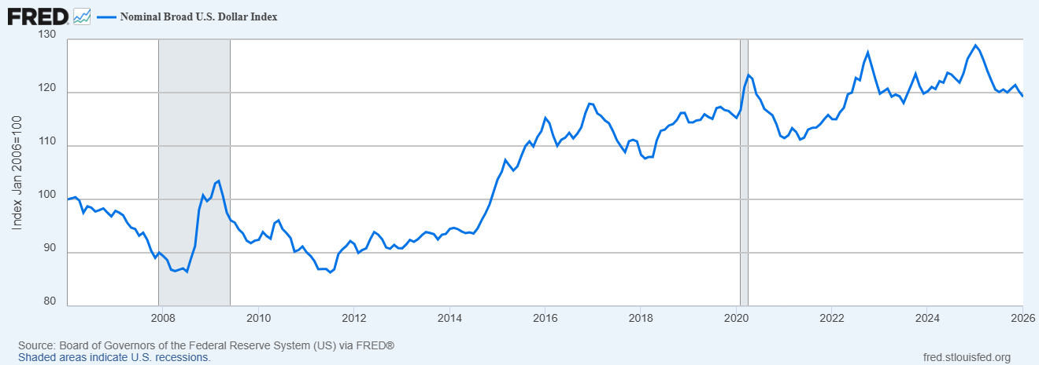

Interconnectedness Risk: Summary
The rising levels of interconnection between the U.S. insurance industry and other financial sectors across the globe (i.e., banking, capital markets, etc.) drove the Moderate-low assessment. Additionally, increasing levels of cross border reinsurance activity by private equity owned insurers and investment management of insurers investments by affiliated asset managers pose another point of interconnectedness.

Assessment Level: Moderate-Low | Trend: Increasing

When evaluating interconnectedness, state insurance regulators are mindful that risk can accumulate across activities and thus, typically focus on significant counterparty exposure.

Highlights include:

Financial Institution Exposure
Investments in financial institutions, although significant, have been decreasing slightly. Insurer investments in financial institutions (i.e., banks, non-affiliated insurers, etc.) within the stock and bond classes remained relatively stable from 2021 to 2025. As a percentage of C&IA, insurer investments in financial institutions totaled were 5.4% in 2025.

Derivatives are generally viewed as a risk mitigation tool as evidenced by 96% of derivative activity being held for hedging purposes. The connection to bank counterparties is the primary risk for this category. This is mitigated by the use of well capitalized banks that are highly rated by rating agencies.

Derivative Exposure
96% of derivatives are held for hedging purposes which is consistent with prior year use of derivatives. Additional risks of derivatives are noted in the Market risk section. Hedges are mostly interest rate hedges, and the majority of market risk is the margin calls that may result if interest rates move against insurers position.

FHLB/FABN Exposure
Another connection or transmission channel to the banking system and capital markets is FHLB loans and Funding Agreement Backed Notes (FABNs). The issuance of finding agreements that back FABNs by the Life industry has a clear connection to the fixed income capital markets. That connection has increased as both FHLB and FABNs grew at a significant pace over the past few years. This exposure also represents significant operating leverage in non-traditional insurance products for the industry, which may also have liquidity implications. At year-end 2025, FABN exposure is approximately 5% of the invested assets of the Life industry. The key risks introduced by FABN programs are leverage, credit risk, and rollover/liquidity risk. These risks are typically mitigated by asset liability management programs, predictability of these liabilities and the absence of put features in FABNs.

Source: FHLB Combined Financial Report and The Federal Reserve Bank of NY

Reinsurance Interconnection
Reinsurance represents another significant interconnection to alien insurers and sovereign nations. Total ceded offshore reserves increased by 16% or $110 billion. Total ceded premium increased 32.8% ($143.4 billion). The annuities line of business increased 28.3% ($61.4 billion) to $278.1 billion, and the A&H insurance line of business increased 42.1% ($32.4 billion) to $109 billion. Life insurance ceded premium increased 32.2% ($39.5 billion) to $162.3 billion. Most of the change in ceded premium was concentrated in 13 companies with increases or decreases or more than $5 billion. Of the 719 companies that reported ceded premiums, 88 companies with more than $100 million in ceded premiums reported changes of more than 25% from 2024.

Offshore reinsurance sidecars and captives have been commonly used in the property and casualty space to help mitigate risk, but they have become more prevalent in the life insurance industry in recent years. Captives and sidecars can provide additional risk capital, enhance earnings, increase underwriting capacity, and reduce risk exposure. Conversely, these reinsurance vehicles, if not adequately capitalized and supported, can increase counterparty credit risk, thus opening the potential to negatively affect an insurer's financial stability if the sidecar performs poorly.

Private Equity Interconnections
State insurance regulators continue to closely monitor the activities of insurers owned or affiliated with private equity firms and asset managers, due in part to the heightened potential for interconnection with capital markets, and other (re)-insurance companies and jurisdictions. PE owned insurers’ total cash and invested assets increased to approximately $704 billion at year end 2025, up from $487 billion at year-end 2020.

At year-end 2025, the number of private equity (PE)-owned U.S. insurers identified by the NAIC Capital Markets Bureau was 231 an increase from 137 in 2024. Total cash and invested assets for the 137 PE-owned insurers at year-end 2024 was approximately 16% based on year-end 2024 NAIC annual statement filings to $704.3 billion, representing 12.2% of all U.S. Life insurers’ total cash and invested assets.

Private Equity owned insurers continue to invest more heavily in structured securities, private credit, and other non-traditional insurance assets.

Securities Lending and Repurchase Agreement Exposure
Other transmission channels to bank counterparties and the capital markets include securities lending and repurchase agreement activity. Securities lent for U.S insurers continue to be consistent with historical averages, with life insurers continuing to comprise the bulk of the activity. Exposure to repos and reverse repos have traditionally been less than 1% of C&IA, and this trend continues.

Underwriting & Profitability Risk: Summary
Although the insurance industry generally demonstrates resilience in underwriting and profitability, specific trends related to long-term care insurance, natural catastrophe exposure, and health sector performance contributed to the overall moderate-low assessment. The risk is tempered by record performance in certain P&C lines and strong performance in certain Life segments.

Assessment Level: Moderate-Low | Trend: Stable

Underwriting & Profitability: Life Sector

The life insurance industry reported a 30.7% increase in overall profitability from year-end 2024 to $30.6 billion in 2025. The life industry reported a 6.0% ($86.2 billion) increase in total direct written premiums and deposits to $1.5 trillion in 2025. Total net written premiums and deposits increased 2.7% ($31.3 billion) to $1.2 trillion. On a net earned basis, the industry reported a 3.7% ($30.5 billion) decrease in net earned premiums to $792.9 billion. Total net annuity considerations increased 2.0% ($8.5 billion) to $442.9 billion for 2025. The increase was primarily driven by a 23.4% ($17.1 billion), increase in indexed annuities, a 4.8% ($5.3 billion), increase in fixed annuities, partially offset by a 31.3% ($16.7 billion), decrease in life contingent payout. Variable annuities with and without guarantees accounted for 39.1% of total annuity considerations.

The industry’s net investment yield increased 0.1 percentage point to 4.5%. Following significant increases in 2023 and 2024, the Federal Reserve decreased the federal funds interest rate in 2025 as follows:

- September 18—to 4.25% from 4.50%
- October 30—to 4.00% from 4.25%
- December 11—to 3.75% from 4.00%

However, rates continue to be elevated above the historically low values experienced from 2008 – 2022, and demand for life and retirement products continues to be high, leading to solid underwriting performance for the life insurance industry overall.

Long-term care insurance (LTCI) continues to pose risks for many insurers, with most of the exposure concentrated within life insurers. The primary challenges for insurers and state insurance regulators in LTCI markets come from older issue year policies. These policies were initially priced when LTCI experience used to calculate rates was not fully developed. As experience developed, it became apparent that the initial pricing assumptions for the number of policyholders qualifying for LTC benefits and the length of time claimants would remain on claim were understated. Additionally, actual policy lapse rates proved to be much lower than initially assumed, resulting in higher insurer exposure to claims payments. Misestimation of initial pricing assumptions has made it necessary for insurers to increase LTCI rates to ensure their future solvency and to incorporate expectations for approval of future rate increases into reserving assumptions.

Underwriting & Profitability: P&C Sector

The U.S. Property & Casualty (P&C) industry’s underwriting income jumped by over $40 billion in 2025 compared to 2024 due to a combination of strong premium growth and lower incurred losses, driven by a meaningful reduction in catastrophe losses, primarily in the second half of the year.
The underwriting gain was partially offset by lower investment income, driven by a significant drop in realized investment gains (generally attributed to large one-time transactions in 2024), resulting in a 10% decline in net income compared to last year. Net income and unrealized investment gains drove an increase in policyholders’ surplus to a new high of $1.27 trillion at December 31, 2025.

The U.S. P&C industry had its strongest underwriting performance in over two decades, due to improved pricing and lower claims costs on property lines. Premiums grew 8-10% annually over the last four years and while premiums increased at a lesser pace this year, lower insured losses from natural disasters and favorable prior year reserve development helped boost underwriting profits. Overall, net premium earned increased 5.5% while net losses and LAE decreased 1.4%, the first decrease in well over a decade, leading to a 4.7-point improvement in the net loss ratio to 66.5%. The expense ratio remained nearly flat at 25.8% as the 4.1% increase in net premiums written was outpaced by a 6.4% increase in other underwriting expenses incurred. Overall, the combined ratio improved 4.0 points to 92.9%.

Despite the positive results in 2025, the industry faces several headwinds in 2026. Slower premium growth could begin to tighten profit margins, challenges with social inflation continue to impact reserve adequacy within commercial liability lines, and continued losses from severe convective storms remain a volatile challenge for property underwriters.

Social Inflation
In addition to the ongoing development of asbestos and environmental claims, new exposures are emerging with the potential to result in casualty catastrophes or latent catastrophes. Of particular concern in this area is “Social Inflation,” which is used to describe the potential for rising costs of insurance claims resulting from increased litigation, broader definitions of liability, more plaintiff-friendly legal decisions, and larger compensatory jury awards.

Over the past decade, such factors have accounted for 57% of the increase in liability claims in the US. Since 2020, the number of nuclear verdicts (defined as awards over USD 10 million) in the U.S. have more than quadrupled, while the median verdict value has more than doubled to USD 51 million. Due in part to higher litigation awards, US liability lines exposed to bodily injury claims saw profitability deteriorate over the five years to 2024, with cumulative underwriting losses mounting to USD 43 billion. In 2024, the average award in cases against a corporate defendant in the US rose to USD 65.7 million, up from USD 41.7 million in 2023, according to data from LexisNexis, as reported by the Financial Times.

Not only does social inflation impact losses for insurers, it is also a driver of increased premiums and the high cost of insurance-auto in particular. Many states have implemented or are in the process of implementing tort reform measures in an effort to mitigate large verdicts.

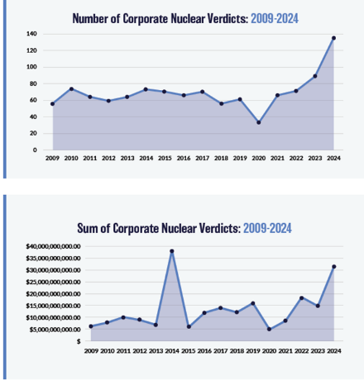
Source: https://marathonstrategies.com/report/corporate-verdicts-go-thermonuclear-2025-edition/

Natural Catastrophes
Insured losses from natural disasters in the U.S amounted to roughly $100 billion in 2025, slightly lower than the prior year. Losses in 2025 were different than prior years in that they were driven by wildfires and severe storms rather than tropical cyclone activity, as no hurricanes made landfall in the U.S. The Palisades and Eaton Wildfires in California, which occurred in the first quarter of 2025 were the costliest wildfires in world history and accounted for nearly half of all catastrophic losses incurred. Losses from severe convective storms totaled roughly $50 billion for the third year in a row, becoming the most common and destructive natural catastrophe in the U.S.

The Overall assessment of Natural Catastrophe Risk, primarily impacting property insurers, is Moderate-High. See separate Natural Catastrophe Risk Dashboard and Report for further details. The results of the Natural Catastrophe Risk Dashboard feed into this Macroprudential Risk Assessment as part of overall U.S. Insurance Macroprudential Supervision.
There is a public version of the Natural Catastrophe Risk Dashboard report, which may be found here:
https://content.naic.org/sites/default/files/natural-catastrophe-risk-dashboard-report-final.pdf

There is also a detailed Natural Catastrophe Risk Dashboard, which is regulator only.

Reserves
Total Loss and LAE reserves increased 5.1% to $1.03 trillion and was comprised of $869.2 billion unpaid losses and $162.9 billion unpaid LAE. Reserve leverage improved 4.8 points to 81.5% due to the increase in policyholders’ surplus.

The industry benefited significantly from prior-year reserve releases. There was a one-year redundancy of $20.0 billion, and a two-year redundancy of $13.5 billion. This followed several years of diminishing prior year reserve releases which stemmed primarily from adverse development in the commercial liability lines, driven by economic and social inflation. Workers’ compensation reserves continued to develop favorably; however, most of the turnaround can be attributed to the personal lines of business which, together accounted for $15.9 billion in favorable development.

Underwriting & Profitability: Health Sector

The health insurance industry profitability dropped considerably for the second year in a row with net earnings dropping from $9.3 billion to $6 billion and a profit margin dropping from 0.8% to just 0.4%. The combined ratio increased to 100.6% in 2025 compared to 100.1 % in 2024. These negative trends drove the Moderate-low Underwriting risk assessment.

In spite of the declining performance, the industry was still profitable overall as investment income of $14.8 billion (6.6% increase year over year) helped offset an $8.1 billion net underwriting loss (negative 526.7% year-over-year). Adjusted cash flow from operations was negative $3.4 billion, a figure that marks the lowest point in at least the past decade and the second year in a row of negative adjusted cash flow from operations.

The considerable decrease in cash flow is due primarily to continued high utilization with a 14.8% ($155 billion) increase in benefits and loss-related payments, while only growing net earned premiums by 13.2% ($153 billion).

Health Underwriting Performance

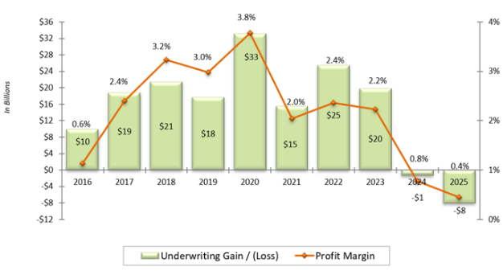
Note: Aggregate results include only health entities who file annual statements with the NAIC. Figures reflect filings received as of April 6, 2026, and may change due to additional filings or amendments.

Market Risk: Summary
Significant common stock, Level 3 assets, level 3 assets, Schedule BA assets, and derivative exposure were key drivers in determining the moderate-low assessment. level 3 assets continued growth and significant percentage of insurers investments was observed. Although equity markets continue to experience significant growth, the risk of an immediate downturn always exists and therefore could be significant risk to insurers as their allocation to equities is significant.
Assessment Level: Moderate-Low | Trend: Increasing

Market Risk: Common Stock Exposure
Common stocks remained the second-largest asset class in the U.S. insurance industry’s portfolio, increasing by nearly 11% to $1.3 trillion at year-end 2025. Common stock as a percentage of total cash and invested assets increased by about 50 b.p. to 13.6% from 13.1% in 2025.
The VIX index ended the year at 14.95, indicating lower than average equity volatility.
U.S. insurers’ unaffiliated publicly traded common stock holdings experienced a weighted average 12% increase in value in 2025, slightly underperforming the Standard & Poor’s 500 index’s (S&P 500) 17% return over the same period.

Market Risk: Bond Exposure
Bonds continued to represent the largest asset class of insurers, accounting for 60% of total cash and invested assets at year-end 2025, flat from year-end 2024. Over the longer term, insurers’ bond allocations have gradually declined from around 70% at year-end 2010, most likely due to companies seeking higher returns in other asset classes amid a prolonged low-interest rate environment that existed at the time.

The YLDVOL index was approximately 64 at year end, almost half of what it was in 2022, indicating lower than average expected rate volatility.

The U.S. insurance industry’s exposure to bonds totaled $5.7 trillion as of year-end 2025, an increase of 5.6% compared to the prior year. Corporate bonds remained by far the largest bond type in U.S. insurer investment portfolios. The second and third largest bond types were asset-backed securities (ABS) and other structured securities and municipal bonds.

Market Risk: Derivative & Other Asset Exposures
96% of derivatives are held for hedging purposes which is consistent with prior year use of derivatives. Additional risks of derivatives is noted in the interconnectedness dashboard. Hedges are mostly interest rate hedges and the majority of market risk is the margin calls that may result if interest rates move against insurers position.
Schedule BA assets, or other long-term investments, accounted for the fourth largest asset category within the U.S. insurance industry's investment portfolio, comprising 7.1% of total cash and invested assets as of year-end 2025. Insurers held $642 billion in Schedule BA assets, a sifnificant increase of 10.4% from the prior year. Valuation and volatility in private equity and hedge fund invesments were key drivers of the market risk Mod-low assessment.
The NAIC’s implementation of the principles based bond definition on January 1, 2025 possibly contributed to some of this growth as certain investments that no longer met the revised bond criteria may have been reclassified to be reported in Schedule BA instead of Schedule D. Life insurers were the largest holders of Schedule BA assets at year-end 2025, accounting for 65% of the industry’s exposure.

Level 3 Assets
Level III asset exposure continues modest growth, currently at 17% of cash and invested assets, which is significant. Level III concentration may contribute to valuation and liquidity risk. This is a new risk indicator in the market risk category, and the exposure will continue to be monitored. The Invested Assets Task Force has this topic on their agenda to analyze and research the exposure later in 2026.

Credit Risk: Summary
Overall bond credit quality remains high with an average credit rating of A+. The significant allocation to private credit, structured securities and mortgages drove the Moderate-High risk assessment, along with increased exposure to reinsurance credit risk. This was tempered by the overall high credit quality bond portfolio and decreasing allocation to structured securities.
Assessment Level: Moderate-High | Trend: Increasing

Credit: Bond Credit Quality
The share of bonds in the U.S. insurance industry’s investment portfolio was flat at approzimately 60% at year-end 2025.
Private Credit remains at the forefront of the most significant credit risk. However, defining and measuring the expsoure remains a challenge. But no matter how you define it, it appears to be a significant risk for the insurance industry. Using private letter ratings (PLRs) as a proxy for the exposure results in an allocation of approximately 8% of bonds being supported by PLRs.
RMBS,CMBS and other LBASS, decreased in exposure from 16.5% to 14.6% of bonds in 2025. CLOs were flat at approximately 5% of bonds.
Allocation to mortagages remained flat at about 9% of cash and invested assets. However, the allocation to residential mortgages increased.
Below-investment-grade bonds, or those with reported NAIC 3-6 designations, declined to 4.7% of total bond exposure, down from a peak of 6.1% in 2020, representing a positive development in terms of credit risk.

Private Credit Market

Private credit funds have experienced substantial growth in recent years, with AUM now of a comparable size to U.S. high yield corporate bond and leveraged loan markets. Insurers have significant exposure to private credit. However, lending to private credit funds is difficult to accurately measure due to limited data availability, although there have been recent efforts to improve insurers’ reporting. Competition between direct lenders and broadly syndicated leveraged loans (BSL) was observed in 2025, which resulted in tighter spreads. With strong investor demand and rapid growth of private credit, there have been concerns that increased competition for deals could spur managers to offer more relaxed structural terms, including covenant-lite loans, or choose riskier deals.
Starting in the third quarter of 2025, many private credit funds, of which insurers are investors, have experienced significant redemption requests. Many of the requests exceeded the funds’ 5% redemption limits. This caused some concern in the private credit fund market and the overall private credit market.
The chart below is the estimated size of the total private credit funds market in North America. Dry powder represents investors’ unfunded or contingent commitments to make additional investments into the private credit funds. Insurers do report contingent commitments in the Annual Statement, however commitments to fund private credit investments is not separately identified.

Source: Preqin

Credit: Foreign Bond Exposures
Other assets are also subject to credit risk monitoring by state insurance regulators including the subset of bonds that are either of sovereign or foreign entities. Additional observations include:
Sovereign/Foreign Bond Exposure and risk remains low, comprising only 2.3% of C&IA. Nonetheless it continues to be tracked and monitored.

Reinsurer Credit Risk
One measure of reinsurer credit risk is to assess the exposure to reinsurers located in a sovereign nation. In 2025, Life insurers, including separate accounts, ceded 48.6% offshore and 51.4% onshore Approximately 46% of reserve credit was ceded to Bermuda. Bermuda’s sovereign rating is A+-LT, stable by S&P; A2, Stable by Moody’s. The second highest national reserve credit was ceded to the Cayman Islands, which has an Aa3, stable sovereign rating by Moody’s. Fourth is Barbados, which has a B+ Sovereign rating by S&P and a B2 from Moody’s. The risk was assessed as Moderate-low due to these ratings.
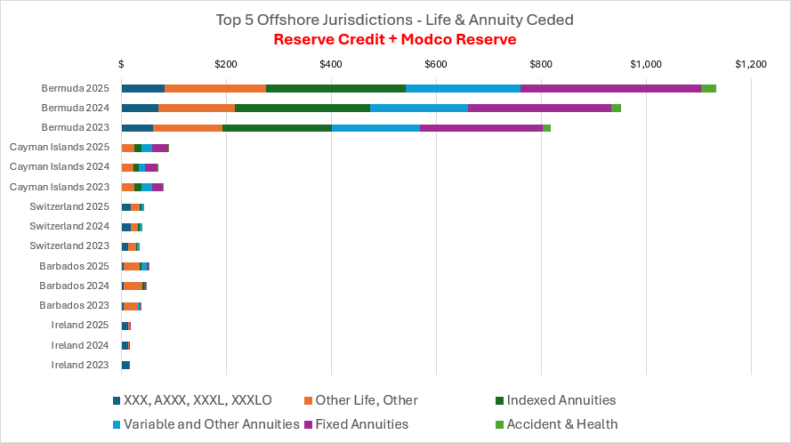

P&C insurers ceded approximately 44% of all reinsurance premiums in 2025 to sovereign nations but is more diversified in terms of the amounts and the number of countries leading to a Low risk assessment.

Liquidity Risk: Summary
While industry holdings of less liquid, private and complex assets continue to increase as discussed above, overall industry allocation to cash and short-term investments is the highest it has been in the last five years at 6.6% of total industry cash and invested assets. Industry allocation to U.S. Government securities is also the highest it has been in the last five years at 4.4% of total industry cash and invested assets. Property and Life liquidity and cash flow ratios are also at their highest (favorable) levels in years. These favorable risk indicators drove the Low risk assessment.
However, it should be noted that the Health industry indicators are not as favorable, as discussed in the Health section below.
Assessment Level: Low | Trend: Stable

Liquidity: P&C Sector
Net cash provided by operating activities increased 16.8% to $189.2 billion. Operating cash inflows increased by 4.0% due to a 4.3% increase in premiums collected net of reinsurance to $972.4 billion, and a 3.4% increase in net investment income (adjusted for affiliates) to $87.2 billion. Partially offsetting the increase in cash inflows was a 1.4% increase in cash outflows driven by a 6.3% increase in commissions and expenses paid, and a 0.4% increase in benefit and loss payments.
The industry liquidity ratio and the cash flow ratio both improved by 5+ % points to 132% and 19%, respectively. Liquid assets increased 7.7% due to growth in cash and invested assets, driven by a 7.0%, or $98.5 billion increase in bond holdings and an 11.3%, or $101.2 billion increase in common stocks. Adjusted liabilities grew at a lesser pace of 3.3%.

Note: some regulatory tools may present this formula with the numerator and denominator reversed.

Liquidity: Health Sector
The health insurance industry experienced back-to-back years of negative operating cash flow with a 57.6% ($1.2 billion) decrease to -$3.4 billion, which comes off the back of -$1.4 billion in 2024 and $27.4 billion in 2023. The considerable decrease in cash flow is due primarily to continued high utilization with a 14.8% ($155 billion) increase in benefits and loss-related payments, while only growing net earned premiums by 13.2% ($153 billion).
Liquid assets and receivables increased from $442.6 billion in 2024 to $477.6 billion on Dec. 31, 2025. This was offset by a 5.6% ($14.4 billion) increase in current liabilities to $272.8 billion from $258.4 billion. This resulted in an unfavorable decrease in the ratio of liquid assets and receivables to current liabilities to 152% from 171% and was the lowest recording of this ratio since at least 2009. Additionally, the cash flow to capital and surplus ratio was also at an all-time low, at -2%.

Liquidity: Life Sector
The life industry reported operating cash flow of $219.2 billion in 2025, up 28.4% ($48.5 billion) from $170.6 billion in the prior year. The increase was driven primarily by a 3.6% ($29.4 billion) increase in net premium and a 7.8% ($17.9 billion) increase in net investment income. Transfers to separate accounts were $(123.1) billion, compared with $(119.6) billion in 2024, while increases in benefits and loss payments of 0.9% ($7.7 billion) and commissions of 4.5% ($9.2 billion) partially offset the improvement in operating cash flow.
The industry experienced a modest 0.7% ($3.1 billion) increase in surrender benefits to $487.6 billion. The average surrenders-to premiums ratio increased 2.7 points to 61.1%, compared with 58.4% in 2024.

Liquidity: Additional Indicators

LST Stress Testing (LST) Results
The LST is a regulatory tool intended to aid regulators in identifying amounts of asset sales by insurers that could impact the markets under stressed environments while also providing regulators with insights on the liquidity position of insurers subject to the filing requirement. Per the most recent filings reviewed, the impact of modeled aggregate asset sales in the most severe stress scenario for the 26 large life insurers subject to the LST to the capital markets is not significant. Most insurers were able to absorb modeled cash flow deficits in stressed scenarios with cash on hand. In extreme stresses where modeled assets sales were required to satisfy cash flow deficits, the industry’s aggregate corporate investment grade bond sales necessary to satisfy deficits were only 3.1% of average daily trading volumes (ADTV) and only .04% of IG Corps Outstanding. Additionally, aggregate government bond sales to satisfy deficits were only .6% of ADTV and .07% of Treasuries Outstanding.

Industry wide Cash and Short-Term Investments
The industry has a significant allocation to Cash, Short-term investments, and U.S. Government Securities as sources of liquidity. Additionally, many insurers maintain a line of credit with the FHLB and lines of credit/revolvers with commercial banks.

Capital Adequacy Risk Summary
The assessment is driven by historically high capital levels even in the face of industry challenges, with P&C at an all-time high ACL ratio, and a low number of companies in receivership/liquidation proceedings:

Assessment Level: Low | Trend: Stable

Capital Adequacy: Life Sector
The life industry’s total capital and surplus increased 5.7% to $540.7 billion. The increase was driven primarily by $46.4 billion in net income, $13.6 billion in paid-in capital, and $14.3 billion in unrealized capital gains, partially offset by $35.8 billion in stockholder dividends. Additional observations include:
- Current aggregate RBC of 886% ACL continues to be well above the low point of the 2008 financial crisis (758%), and the industry continues to be very well capitalized overall as indicated by the historically low number of companies in RBC action levels (1.26%) and aggregate premium/reserve leverage positions.
- The industry wide capital levels are relatively consistent with rating agency upgrade/downgrade activity as well as industry outlooks, which generally assigned the life insurance sector a stable outlook at the end of 2025.
- RBC is a regulatory minimum capital requirement and may not reflect economic required capital risk for all activities including significant shifts of cross border reinsurance discussed in the credit risk section.

Capital Adequacy: P&C Sector
Industry aggregated policyholders’ surplus (adjusted to eliminate stacking) increased 11.9% from the prior year-end to a new all-time high of $1.27 trillion at December 31, 2025. The net profits of $150.6 billion and $47.5 billion in unrealized investment gains were partially offset by $5.7 billion in policyholder dividends. While P&C insurers are well positioned for future growth, 2025 continued to present challenges from inflation/tariffs, natural disasters, and social inflation that warrant the increase in Capital Adequacy.
Additional observations include:
- Current aggregate RBC of 643% ACL remains above the low point of 2008 (599%). The industry wide capital levels are relatively consistent with rating agency upgrade/downgrade activity as well as industry outlooks which generally assigned the P&C insurance sector a stable outlook at the end of 2025.

Capital Adequacy: Health Sector
Health entities reported a 4.9% ($10.5 billion) increase in capital and surplus (excluding affiliated amounts) to $223.9 billion from $213.4 billion in 2024. Although at first glance, the high capital levels appear inconsistent with underwriting risk and performance highlighted earlier, this is due to capital contributions from parent companies and decreased dividends The capital adequacy maintenance is due primarily to a large decline in dividends paid out from $19.3 billion in 2024 to $11.2 billion in 2025, and a 21.3% increase in paid-in surplus of $15.3 billion.
Additional observations include:
- Aggregate RBC was flat in 2025 at 589% ACL
- As of September 2025, the health insurance sector has a negative outlook by S&P

Emerging/Other Risk

Assessment Level: Moderate-Low | Trend: Increasing

The emerging risk category of the dashboard contains broad overarching risks, some of which may be covered in part in other risk categories. These risks may not lend themselves to specific risk indicators, do not cleanly or fully fit within another category and are generally a challenge to quantify. Therefore, the assessment of risks in this area may be more subjective in nature. Additionally, data or tools may not be in place to measure the risk. However, these risks are believed to be prevalent and warrant additional ongoing monitoring.

The following risk categories are included in the Emerging/Other Risk Category:

- Private Credit (see also Credit Risk)
- Offshore Reinsurance (see also Interconnectedness and Credit Risks)
- Artificial Intelligence
- Cybersecurity Risk
- Mortality risk

Many of these risks have been covered in part in other sections of this report and in the detailed risk dashboard. Additionally, many of these risks have an associated response initiative by state regulators via various NAIC task forces and working groups.

Artificial Intelligence
Artificial Intelligence (AI) risks can manifest in many ways for insurers, for example in underwriting, claims, and investments. The AI software sector, of which insurers invest, has grown to greater than 15% of the leveraged loan and private credit sectors; and has recently come under pressure from perceived impact of AI models. Deepfakes enabling insurance fraud and discriminatory underwriting practices are some other indicators to monitor.

Cybersecurity Risk
Demand for and writings of cyber insurance seems to have leveled off due to the steady direct premiums written over the last three years. Product coverage terms to improve underwriting performance continues to be an area of increased focus by insurers and appears to have led to lower loss ratios since 2021. Additionally, insurers operations continue to be subject to cyber-attacks that may threaten their ongoing operations.

Mortality/Aging risk
Mortality and aging may impact both Life and Health sectors and its impact is dependent on the line of busines. U.S. life expectancy for 2026 is 79.54, a 0.18% increase from 2025. U.S. life expectancy for 2025 was 79.40, a 0.18% increase from 2024. Additionally, the demographic shift to an older population, falling birth rates, rising healthcare costs and GLP-1 rudg impacts are key factor in this category.

Appendix A: Risk Assessment Scale

Risk Assessment Scale
Assessment levels are documented on a four-tier scale consisting of High, Moderate-High, Moderate-Low, or Low. Assessments are based on current and historical risk indicators and expert judgment.
Low | Moderate-Low | Moderate-High | High

Trend Scale
The trend is a historical trend and is indicative of the level of risk. Trend levels are documented on a five-tier scale consisting of Significant Increase, Increasing, Static, Decreasing, or Significant Decrease. Trends are based on the changes in risk indicators and expert judgment.
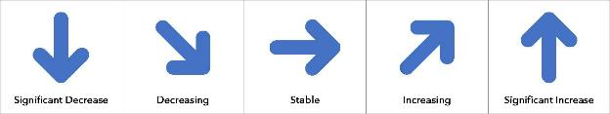

Appendix B: Insurance Industry; by the Numbers

Select industry data:

Life Industry

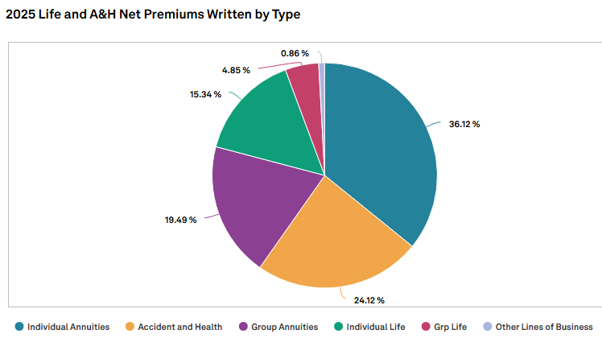
Source: S&P Market Intelligence

Life Industry

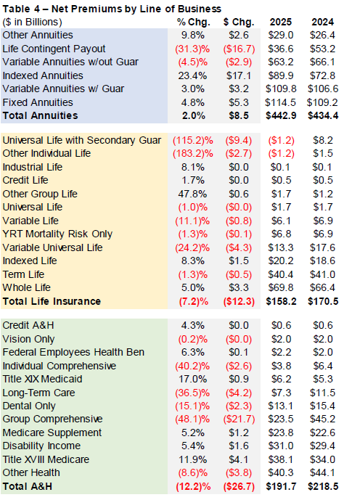
Source: NAIC Financial Regulatory Services Unit, 2025 Annual Life Industry Commentary

P&C Industry
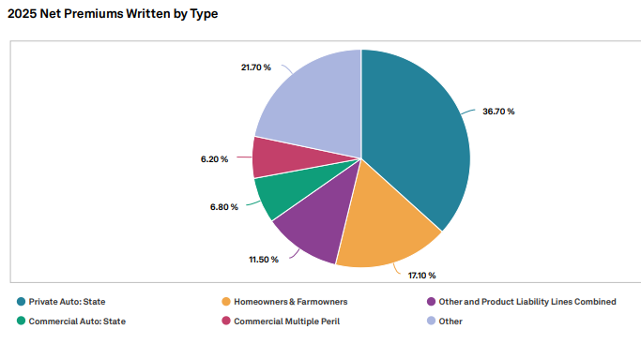
Source: S&P Market Intelligence
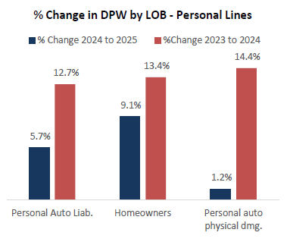
Source: NAIC Financial Regulatory Services Unit

P&C Industry
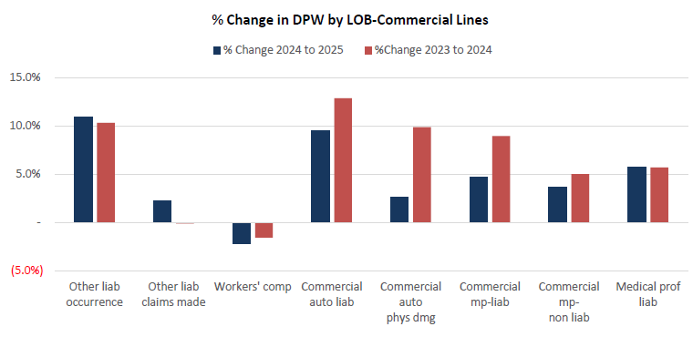
Source: NAIC Financial Regulatory Services Unit

Health Industry
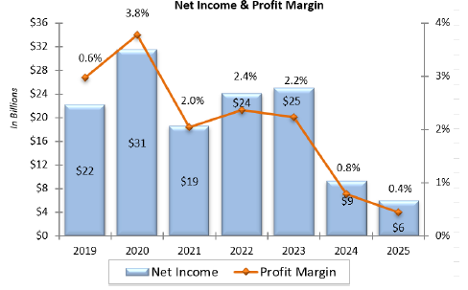
Source: NAIC Financial Regulatory Services Unit
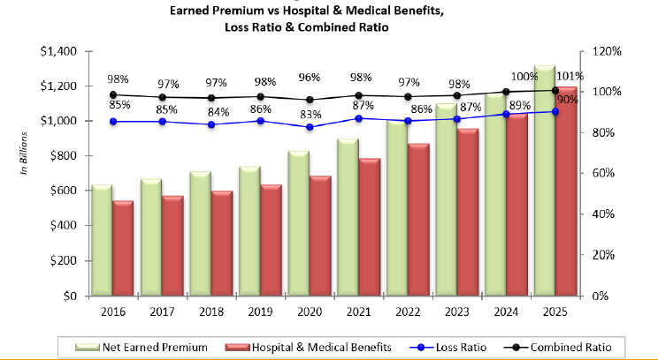
Source: NAIC Financial Regulatory Services Unit

For more information on the IAIS GME, as an integral element of the IAIS Holistic Framework, please visit iais.org.

