Placing an Order in Account Manager

Select the 'Product Catalog Search' icon on your homepage to be taken to the screen below. Then, you will then want to click 'Product Catalog Search' to be taken to the full catalog.
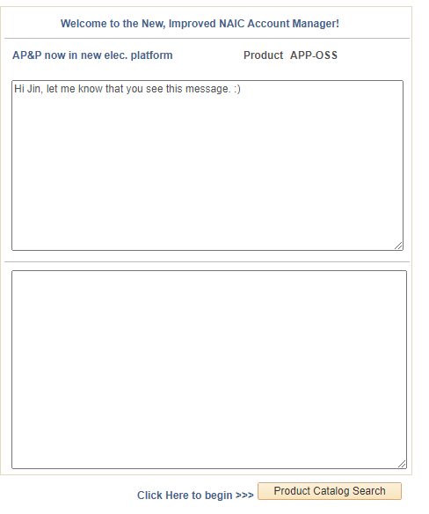

You can look through our products by hitting 'Search', or you can select a category or enter a keyword/product code. When you find a product that you would like to purchase, select 'Add to Cart'. When you are finished adding items to your cart, select 'Proceed to Checkout' in the blue link.
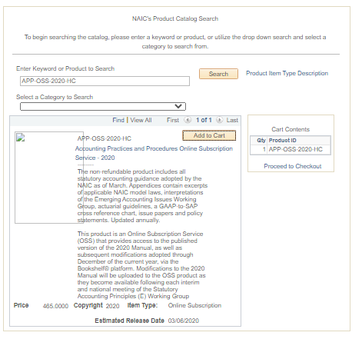
Once you select 'Proceed to Checkout', you will be taken to your cart. Here, you can remove items and change the quantity. To proceed, you will want to select the box next to 'Agree to Terms' and click the button 'Purchase Selected Items'.
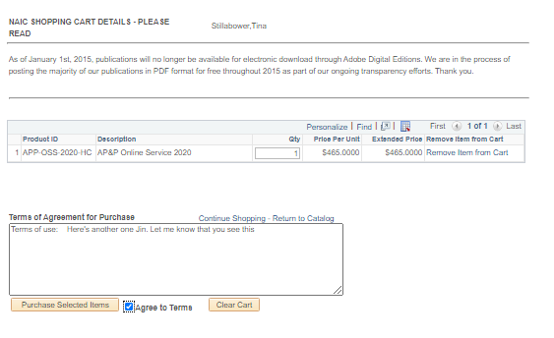
Next, you will want to select which company you are purchasing the publication for. If you are assigned to multiple companies, you will want to use the dropdown menu to select the appropriate company.

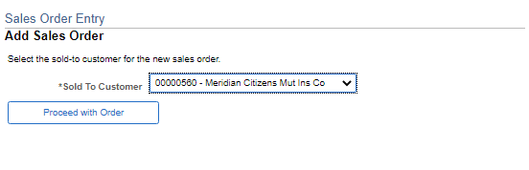

On the following screen, you will want to add your contact information including first and last name, email, and phone number. You can also change the shipping address by selecting the magnifying glass next to 'Ship to Address'. Click on the button 'Price Order' to see their order total.
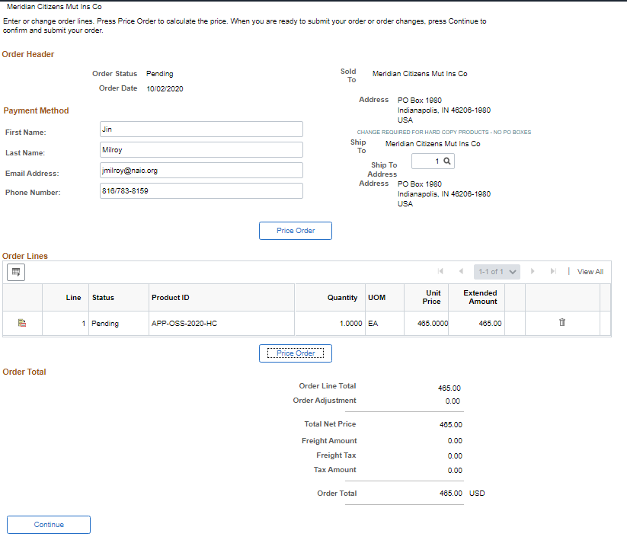

After clicking continue, you will be directed to the order confirmation screen. This is where you can review your details and verify that everything was entered correctly. You will want to 'Submit' to be taken to the payment screen.
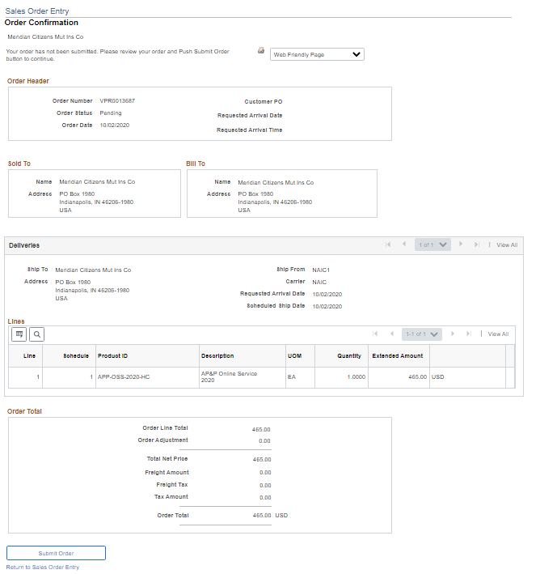

The final screen is where you can enter in their payment information to process the order.

