QTL/Financial Requirement Template Instructions
The information requested in this template will assist in determining a product’s compliance with benefit classification requirements and Quantitative Treatment Limitation and Financial Requirement (QTL) testing outcomes required under the Mental Health Parity and Addiction Equity Act (MHPAEA). As an initial step, identification of all covered services, both medical/surgical and MH/SUD, is critical for complete QTL and NQTL analyses. Classification of covered services must remain consistent across both types of analysis, thus must be established at the outset.

Covered Services Tab

Step 1. Provide the requested Company Name, Plan Name/ID, Plan Year, and Coverage Type (i.e., HMO, PPO, EPO, POS, etc.), and select the appropriate dropdown box (large group, small group, or individual) for the Plan Market information.
Cell | Notes on Response
C2 | Provide Company Name
C3 | Plan Name/ID (e.g., HIOS #)
C4 | Plan Year
E4 | Select from Dropdown (Small, Large, Individual)
F4 | Provide Coverage type

Step 2. Answer the following questions by selecting either Yes or No in the appropriate dropdown box:
- “Are outpatient services sub-classified into “office visit” and “other”?”
  - This question must be answered in order to populate the classification cells in column E.
- “Is there a tiered network?” If Yes, continue to the next question. If no, move to Step 3.
  - Tiered network refers to multiple levels of tiering with respect to contracted providers. Out-of-network is not considered a tier.
- “If yes, please select the number of tiers:” Select the appropriate number of tiers from the dropdown box.
- NOTE: This template does not automatically separate multiple networks for purposes of analysis. If the company chose to subclassify based on networks (pursuant to 45 C.F.R. §146.136(c)(3)(iii)(B)), the analysis will have to be completed manually.
Cell | Notes on Response
E6 | Select from Dropdown: Yes or No regarding outpatient sub-classification
E7 | Select from Dropdown: Yes or No regarding tiering
E8 | If Yes above, select number of tiers (excluding out-of-network)

Step 3. List all Covered Services in Column B
Cell | Notes on Response
Beginning with B10 | List all Covered Services
- All services included in Certificates of Coverage and Schedules of Benefits should be identifiable in the list of covered services.
- Covered services should have their own line based on network (in and out, as well as tiering if applicable), cost-sharing type, applicable visit or day limits, FR or QTL level, and classification.
Network: Include a separate covered service line for services that are covered in-network and out-of-network, e.g., one line for PCP office visit-in network, and a separate line for PCP office visit-out of network.
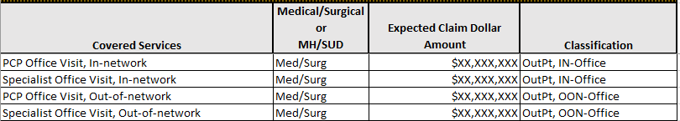
- Services should be separated by tier when there is more than one network tier, e.g., preferred specialist on one line, non-preferred specialist on a separate line.
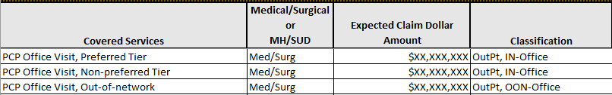
Cost-Sharing: Include a separate covered service line for services that have different cost sharing that is dependent upon site of service or diagnostic vs. preventive. For example, CDC-recommended immunizations are $0 cost-sharing but may be provided in a PCP’s office or at a pharmacy, while other immunizations (e.g., for travel) may be provided by a PCP but may have cost-sharing applied. Each instance would need to have its own line for reporting covered services.
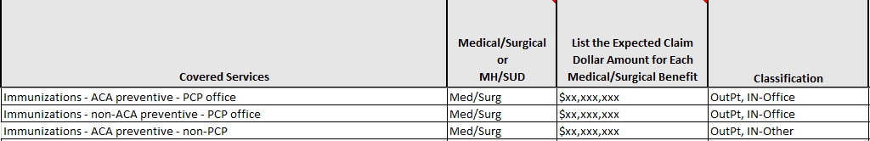
Classification: For purposes of MHPAEA analysis, classification of benefits, and any corresponding limitations, should be based on the underlying diagnosis, regardless of site of service or the system through which claims are processed. For example, occupational therapy may be appropriate for both medical/surgical and MH/SUD diagnoses, and processed through a medical claims system. For purposes of the analysis, however, the occupational therapy claims processed for underlying medical/surgical diagnoses should be classified as medical/surgical and occupational therapy processed for underlying MH/SUD (e.g., ADHD, Autism, as defined in product information) should be classified as MH/SUD.
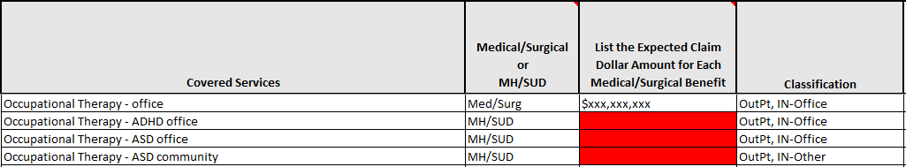
and
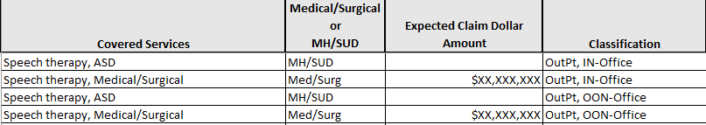

Step 4. Designate whether each covered service is Medical/Surgical or MH/SUD in Column C, taking the following into consideration:
- Services must be identified as medical/surgical or MH/SUD as defined under the terms of the plan and in accordance with applicable state and federal law. Any condition defined by the plan as being medical/surgical or MH/SUD must be consistent with generally recognized independent standards of current medical practice (e.g., the most current version of the ICD or State guidelines). For example, state law defines bipolar disorder, major depressive disorder, and anorexia nervosa as a mental illness, thus covered services used in the treatment of those diagnoses must be identified as MH/SUD in the MHPAEA analysis.
- Once defined as medical/surgical or MH/SUD, the Company’s definition must remain consistent for all MHPAEA analyses within the product being analyzed, i.e., QTL and NQTL analyses.
- NOTE: every medical/surgical service classification must have corresponding MH/SUD covered services
Cell | Notes on Response
Beginning with C10 | Select from Dropdown: Medical/surgical or MH/SUD for each Covered Service listed in Column B

Step 5. Enter Expected Claim Dollar Amounts in Column D for each listed covered service that is identified as medical/surgical.
- All covered medical/surgical services, including those services with zero-dollar cost sharing for members, must have an associated expected plan claim dollar amount listed. Also, expected claim dollar amounts must be based on the dollar amount of all plan payments for medical/surgical benefits in the classification expected to be paid under the plan for the plan year; expected claim dollar amounts are not cost sharing amounts paid by members.
Cell | Notes on Response
Beginning with D10 | List expected claim dollar amount for each Covered Service listed in Column B

Step 6. Choose the appropriate Classification or Sub-Classification in Column E by selecting the appropriate responses in the dropdown boxes.
- Services should be classified consistently regardless of ACA requirements, e.g., Mammography (preventive/screening) and Mammography (non-screening) should be included in the same classification since the service is the same regardless of whether it is an ACA covered preventive mammogram or a diagnostic mammogram.
- Location of service may be a permissible distinction, e.g., immunizations in PCP’s office may be placed in the outpatient, office visit subclassification while immunizations in a pharmacy may be placed in the outpatient, all other subclassification.
- Similar services should be classified together unless the location or other distinction can be identified, e.g., breastfeeding supplies and diabetic supplies may be in the same classification unless diabetic supplies are covered under pharmacy benefits and breastfeeding supplies are considered DME.
Cell | Notes on Response
Beginning with E10 | Select classification or sub-classification from dropdown for each Covered Service listed in Column B

Step 7. In Column F and Column G, provide citations in the form of page numbers and sections in both the Certificate of Coverage and Schedule of Benefits where the services included in each line of the listed Covered Services can be found.
- This information will allow examiners to determine the specific services from Certificates of Coverage and Schedules of Benefits that are included in each line of Covered Services.
Cell | Notes on Response
Beginning with F10 | List COC page number related to each Covered Service listed in Column B
Beginning with G10 | List SOB page number related to each Covered Service listed in Column B

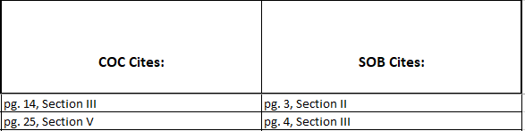

Step 8. In Column H, list NQTLs specific to the covered service in the corresponding line.

Do not include general NQTLs that apply to all services, such as medical necessity
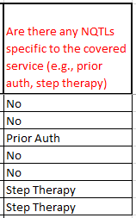

Analysis Tabs
Data entered in columns B through G will auto-populate the corresponding tabs for purposes of reporting QTLs and Financial Requirements.
For each tab, enter the corresponding cost-sharing or visit limit information in the lines with covered services. Where limits are not applied or the cost-sharing is $0, enter “N.”
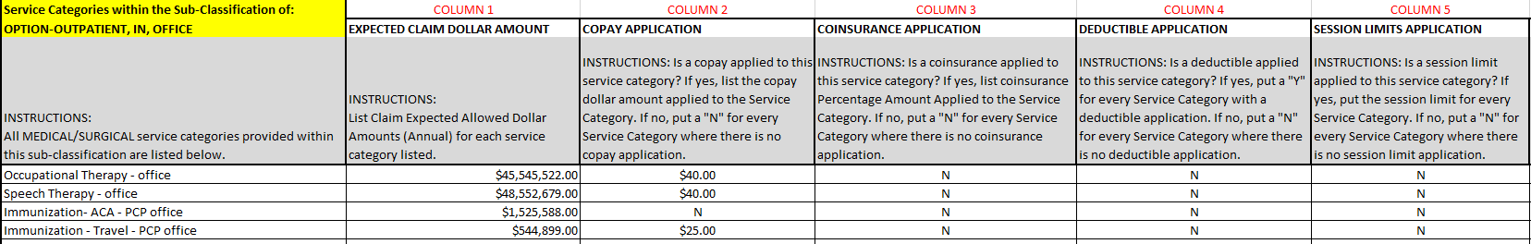
- Note that only medical/surgical services carry over to the calculation tabs.

When Columns 2-6 (D-H) are filled out, formulas will auto-calculate the substantially all and predominant level tests. The user will be prompted if the substantially all threshold is not met and which level is the predominant level, if applicable.

